**MULTILATERAL INTEROPERABILITY PROGRAMME (MIP)**





**MIP4 Information Exchange Specification (MIP4-IES)**

**Information Definition Overview**

**29 April 2021**

Release of this document to nations or agencies who are not participants in the Multilateral Interoperability Programme, including the media and general public, require the approval of the MIP Steering Group (MSG) in accordance with the MIP Programme Management Plan (MPMP). This document is the property of the MIP and the information contained in this document shall not be communicated, either directly or indirectly, to any person or agency not authorised to receive it.

**DOCUMENT CONTROL**

**Change Management**

|  |  |
| --- | --- |
| Change Control Authority | MIP Integrated Product Team 4 (IPT4) Change Manager, webmaster@mip-interop.org |
| Release Authority | MIP Program Management Group (PMG), pmgchair@mip-interop.org |
| Latest Public Release | [www.mip-interop.org](https://www.mip-interop.org) | Public Document Library | 07-MIP4-IES |
| Latest MIP Release | [www.mip-interop.org](https://www.mip-interop.org) | Members Only site | CM Portal | MIP4 (account required) |
| Current Working Draft (for comments) | [MIP4-IES Collaborative Environment](https://docs.google.com/document/d/1PU6YIuehAa5EEedk-FK5JB3klumGoIb9N2NxKmBD1WE/edit?usp=sharing) (account required) |

**Version History**

|  |  |  |  |
| --- | --- | --- | --- |
| **Version** | **Author** | **Date** | **Reason for Change** |
| 1.4.1 | IPT4 CM | 12 Sep 2017 | MIP4.0 official release [ref MSG-DL-26 at MSG20; July 2017]. Details of internal versions removed from Version History. |
| 1.7.0 | IPT4 IDT | 19 Apr 2018 | MIP4.1 official release. Details of internal versions removed from Version History. |
| 1.11.0 | IPT4 CM | 27 Aug 2019 | MIP4.2 official release. Details of internal versions  removed from Version History. |

|  |  |  |  |
| --- | --- | --- | --- |
| 1.18.1 | IPT4  IDT | 09 Oct 2020 | MIP4.3 official release. Details of internal versions removed from Version History. |
| 1.18.2 | IPT4 IDT | 09 Dec 2020 | The following CPs have been applied to the document:   * CP_4_76020 v2: Add Illustrations In XML Examples; * CP_4_76021 v1: Add Illustrations In ORBAT Examples; * CP_4_76030 v4: Update XML IDO |
| 1.18.3 | IPT4 IDT | 29 Apr 2021 | The following CPs have been applied to the document:   * CP_4_78020 v4: Redesign of the Annex A; * CP_4_78030 v2: Blacklisted elements |

**Table of Contents**

**1 Introduction** **10**

1.1 Purpose 10

1.2 Scope 10

1.3 Target Audience 11

**2 References** **12**

**3 Information Semantics and Structure** **13**

3.1 UML Class Diagrams 13

3.2 Alignment with Naming and Design Rules 13

3.3 Introduction of Super-Structure 14

3.6 Removal of unsupported content 14

**4 Information Requirements** **16**

**5 Design Approach** **20**

5.1 Design Goals 20

5.2 Design Constraints 21

5.2.1 Target Architecture 21

5.2.2 Low Bandwidth Architecture (possible future) 21

5.3 Using the Subviews for specific Business Objects (BOs) 21

**6 Key Information Concepts** **23**

6.1 Identification 23

6.1.1 Identification Overview 23

6.1.2 The Context 23

6.1.3 List of allowed ContextIdentifiers 24

6.1.4 Identification Rules 26

6.1.5 Examples 27

6.1.5.1 Exchange of a new Overlay containing two units 27

6.1.5.2 Addition of a new BSO 29

6.1.5.3 Modification of an existing BSO 30

6.1.6 Managing External System Identifiers 31

6.2 Identifiable Reference 31

6.3 Association 34

6.4 Concepts 34

6.5 Type Hierarchy 34

6.6 Managed Lists 36

6.7 Optional and Mandatory Elements 39

6.8 Explanation of Most Recent 40

**7 Information Management** **41**

7.1 Business Process 41

7.2 Extension 41

7.2.1 Overview 41

7.2.2 Addition of New Properties 41

7.2.3 Addition of New Types 42

7.3 Inter-version Compatibility 45

7.3.1 Extensibility 45

7.3.2 Deprecation 46

7.4 Duality of BattlespaceConceptType: Instance or Type 47

7.4.1 Use of BattlespaceConceptType 47

7.5 Expression of Erroneous Data 48

7.6 Minimal Representation 48

7.7 Date, Time and DateTime 49

7.8 Type-Location-Symbol Bindings 50

**8. Usage Examples** **50**

8.1 Instance and Type Behavior 50

8.2 Not Otherwise Specified 52

8.3 Unknown 53

8.4 Mutable Types 53

8.5 Alternate Identifier 55

8.6 Alternate Name 56

8.7 Identifiable References 57

8.8 Boundaries 57

8.9 Metadata 59

8.9.1 Actor Roles 59

8.9.2 ValidityTimePeriod 61

8.9.3 ActiveTimePeriod 61

8.10 Amplification 62

8.11 Airspace Control Means 63

8.12 Source 68

8.13 Use of Affiliation on Person 69

8.14 Extension 71

8.14.1 mustUnderstandIndicator 71

8.15 Overlay 73

8.16 OrganisationStructure 76

8.17 Friendly Order of Battle 76

8.17.1 Use Cases 76

8.17.1.1 Basic Use Case 76

8.17.1.2 Actors for Extended Use Cases 76

8.17.1.3 Establishing a Multinational Coalition ORBAT 76

8.17.1.4 Updating by Versioning the Multinational Coalition ORBAT 81

8.17.1.5 Stating Main Equipment 82

8.17.1.5.1 Variant 1 (only Type Name provided) 82

8.17.1.5.2 Variant 2 (Main equipment type/model not operational) 83

8.17.1.5.3 Variant 3 (Type Name initially not available) 83

8.17.1.6 Stating Manning of a Unit 83

8.17.2 Amplifying Information 83

8.17.2.1 Multiple Concurrent Friendly ORBATs 83

8.17.2.2 Use of Distribution List 83

8.17.2.3 Display of an ORBAT 84

8.17.3 Friendly ORBAT Examples 84

8.17.3.1 Overview 84

8.17.3.2 Basic Friendly ORBAT 84

8.17.3.3 Use of StaffConceptMetadata 85

8.17.3.4 Use of TextualTimePeriod 87

8.17.3.5 Use of RootUnit 87

8.17.3.6 Use of GeopoliticalAffiliation 88

8.17.3.7 Use of HostilityStatusCode PersonnelCount and MainEquipment 88

8.17.3.8 Expressing a generic EquipmentType using ModelName 89

8.17.3.9 Command and Control Associations 90

8.17.3.10 Example 92

8.18 Non-Friendly, Hierarchical Order of Battle 95

8.18.1 Basics 95

8.18.2 Structure of a Non-friendly, Hierarchical Order of Battle 95

8.18.3 Descriptive Information for a Non-Friendly, Hierarchical Order of Battle 95

8.18.4 Information Flow 96

8.18.5 Example 96

8.19 Task Organisation 99

8.19.1 Use Case Step 1 – Deployment 99

8.19.2 Use Case Step 2 – Outlining the Concept of an Operation 99

8.19.3 Use Case Step 3 – Planning an Operation 100

8.19.4 Use Case Step 4 – Executing the Operation 101

8.19.5 Task Organisation Examples 104

8.19.6 Display of a Task Organisation 105

**9 Requirements** **106**

9.1 Traceability 106

**Annex A: Concept and Its Subclasses** **108**

A.1 Introduction 108

A.2 Primitives 108

A.3 Concepts 109

A.3.1 Concept Metadata 110

A.3.2 BattlespaceConcept 110

A.3.2.1 Action 111

A.3.2.2 Address 113

A.3.2.3 Affiliation 113

A.3.2.4 Generic 114

A.3.2.5 Location 115

A.3.2.6 BattlespaceConcept Metadata 117

A.3.2.7 Mobility 117

A.3.2.8 Object 118

A.3.2.8.1 Actor 119

A.3.2.8.1.1 Organisation 120

A.3.2.8.1.1.2 MilitaryPost 124

A.3.2.8.1.1.3 Unit 125

A.3.2.8.1.2 Person 126

A.3.2.8.2 Facility 126

A.3.2.8.2.1 CulturalPropertyProtectionSite 127

A.3.2.8.3 Feature 128

A.3.2.8.3.1 ControlFeature 129

A.3.2.8.3.2 GeographicFeature 130

A.3.2.8.3.2.1 Vegetation 131

A.3.2.8.3.3 MeteorologicFeature 132

A.3.2.8.4 InformationResource 133

A.3.2.8.5 Materiel 134

A.3.2.8.5.1 ConsumableMateriel 135

A.3.2.8.5.2 Equipment 136

A.3.2.8.5.2.1 Aircraft 137

A.3.2.8.5.2.2 LandVehicle 138

A.3.2.8.5.2.3 Sensor 139

A.3.2.8.5.2.4 Vessel 140

A.3.2.8.5.2.5 Weapon 141

A.3.2.8.5.3 UnexplodedOrdnance 143

A.3.2.8.6 NetworkService 143

A.3.3 StaffConcept 144

A.3.3.1 StaffConcept Metadata 145

A.3.3.2 OrganisationStructure 146

A.3.3.3 Overlay 146

# 1 Introduction

## 1.1 Purpose

The purpose of this document is to introduce the information components of the MIP4 Information Exchange Specification (MIP4-IES) and show how it supports a range of information exchanges between command and control systems. Specifically, this document discusses the MIP4-IES Information Definition as encapsulated in XML Schemas and the behavior of MIP4-IES Instance Data encapsulated in XML.

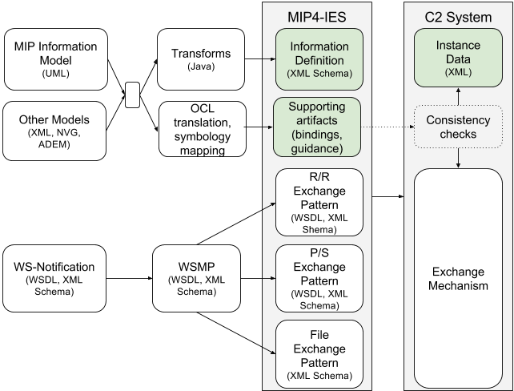

## 

## 1.2 Scope

The scope of this document includes a holistic technical discussion of the MIP4-IES information content, including its design and targeted use cases. The content is presented at a relatively high level and is intended to give a broad understanding to readers, prior to proceeding to the more detailed specifications.

The examples in this document are non-normative and they are intended to illustrate the purpose of the concept or the functionality being described. The normative technical details in the document will take precedence over these non-normative examples. The actual implementation shall be based on the normative technical details and technical artifacts.

## 

## 1.3 Target Audience

This document is targeted at those responsible for building and deploying Command and Control Information Systems (C2IS) that interface with partners in a federated environment.

This document presumes that the reader is aware of the operational and technical requirements involved in implementing the MIP4-IES.

# 

# 2 References

REF-ID-01 MIP4-IES Overview

REF-ID-02 MIP Information Model v5.1

REF-ID-03 NATO Vector Graphics (NVG) Protocol v2.0rev2, 22 May 2015

REF-ID-04 National Information Exchange Model (NIEM) v3.0 Naming and Design Rules

REF-ID-05 Code List Representation (Genericode) v1.0

REF-ID-06 Rule Based Validation - Schematron, ISO/IEC 19757-3:2006

REF-ID-07 Object Constraint Language (OCL) v2.0

REF-ID-08 Scalable Vector Graphics (SVG) v1.1

REF-ID-09 MIP4-IES Type-Location-Symbol Bindings

# 

# 3 Information Semantics and Structure

The MIP Information Model (MIM) provides the common semantic reference for the command and control domain. Information semantics and structure of the MIP4-IES have been derived from MIM. The structure has been transformed into a platform specific representation (XML Schema) required for information exchange. In a few cases, the MIM semantics have been augmented with those of other models to meet specific implementation requirements. The relation between the MIM and the MIP4IES XML schemas is described in the following sections. Please be aware that the following sections are intended to help the reader understand the relation, it is not a normative description of the transformation.

## 3.1 UML Class Diagrams

The MIM is described as a UML Class Model from which the XML schemas of MIP4IES 4.3 are generated through a model-driven approach. The MIM2XSD transformations applied to the MIM ensure that the resulting XML schemas follow consistent naming and design rules.

The following analogies can be made:

|  |  |
| --- | --- |
| UML Package | XML Namespace / XML Schema file |
| UML Class | XML ComplexType |
| UML Attribute | XML Element |
| UML Datatype | XML SimpleType |

## 3.2 Alignment with Naming and Design Rules

The MIP4-IES XML Schema aims to be as compliant as possible with various existing Naming and Design Rules, whilst carefully weighing the cost of the individual rules. Some rules have not been followed as they would have a large unwanted impact on implementations working with the schema. However the rules that were followed have an impact on the names of the UML concepts.

***UML packages*** are transformed in the a Hierarchy of Xml-Namespaces, each Xml-Namespace is described using a single Xml-Schema file, containing the Xml-Types, Xml-Elements required to reflect the UML classes, data types, attributes and associations used in the UML Package.  
***UML classes*** are transformed into Xml-ComplexTypes with identical names.  
***UML attributes*** are transformed to Xml-Elements. In order to make the names of the attributes unique, they have been prefixed with the name of the class in which they have been defined.  
***UML associations*** are transformed to Xml-Elements. Most associations are transformed into two Xml-Elements, one that is of the Xml-Type of the associated UML class, or UML association-class. The naming of the elements are as follows: “*[class-name][association-rolename]*” and “*[class-name][association-rolename]Ref*” respectively.

## 3.3 Introduction of Super-Structure

In the MIM, all classes are assumed to have an identity, whereas all <<datatype>>s are assumed to have no artificial identifier. Thus, during the transformations, a superstructure is introduced that derives classes from IdentifiableType and data types from NonIdentifiableType. The MIP4-IES includes a manually created ‘base’ Xml-Schema that contains an Xml-Type called IdentifiableType that contains the identifier. The schema transformation assigns this as the ‘base’ Xml-Type for the Concept and StaffConcept UML classes. Additionally, mechanisms are added to allow the extensibility and amplification of elements in XML (see sections 9.14 and 9.10).

## 3.6 Removal of unsupported content

The following UML Elements have been excluded from the MIM for technical or operational reasons. Note that the exclusion of a Package implies the exclusion of all classes, data types and sub-packages, the exclusion of a class or data type also implies that all subclasses and attributes that are referencing that class or element are excluded:

* Packages:
  + StaffConcept.CandidateTargetList
  + StaffConcept.PlanOrOrder
  + StaffConcept.Acknowledgement
  + BattlespaceConcept.Capability
* Classes and attributes:
  + From package “BattlespaceConcept.Metadata“:
    - Class LackingCodeValue
      * SemanticID: 9c5bded5-3141-4d75-9f33-21254995de1a
    - Class NilReason
      * SemanticID: 37adfe60-7206-4b3f-90d2-42398961f416
    - Class OtherNilReason
      * SemanticID: 5f9f2e52-6438-4773-83c1-7e3abdc8bbd6
    - Class OtherNilReasonCode
      * SemanticID: 0f925322-af3d-4fb1-976f-a550acb92c6d
  + From package “BattlespaceConcept.Object.InformationResource“
    - Attribute InformationResource.contentBinary
      * SemanticID: f9750dec-9d95-4fdb-a65f-3ce1e39149f9
  + From package “BattlespaceConcept.Location“
    - Class RelativeCoordinateSystem
      * SemanticID: b359118b-17da-4d09-b699-275718873c07
    - Class PointReference
      * SemanticID: 5521fae8-13a6-4e4e-a15d-6d38a0972533
    - Class ObjectReference
      * SemanticID: 469e2471-3984-4d01-b20e-5a466752e4f4
    - Class RelativePoint
      * SemanticID: 0faa9ccb-086a-41aa-9ec5-d69ff5dd145c
  + From package “BattlespaceConcept.Object“
    - Class Holding
      * SemanticID: 17d543f8-1c56-4068-bf83-d95b22d6ae82

The classes, data types, attributes and associations related to the excluded UML elements may still appear in some UML Diagrams used in this document and Annex A.

# 

# 4 Information Requirements

The MIP4-IES supports the exchange of information relevant to military operations and missions. The MIP4-IES defines information structures in support of Situational Awareness and Command and Control activities. The information structures required by these activities are demanding and span from simple to complex concepts. The following requirement statements are high-level but are intended to shape the information content of the MIP4-IES.

The MIP4-IES shall provide the means to exchange battlespace information of interest to Commanders and Staff for the purpose of contributing to a Common Operational Picture (COP) and to enable the achievement of Appreciation and Understanding of the battlespace.

This MIP4-IES will aspire to support the following requirements, knowing that the full achievement of some may be unattainable through this specification alone.

* Detect
  + things[1] that have been observed in the battlespace, but the nature or properties of these things are currently unknown or not otherwise specified.
  + Example:
    - Sensor reading (e.g. undefined radar blip)
    - Ambiguous signal intercept
    - Initial event report, without specific detail
    - Informant observation
* Classify
  + the classification of things in the battlespace. This classification allows users and systems to quickly understand and process information through a known taxonomy. The taxonomy supports general to specific classification of things, driven by the amount of information available. The classification of things can change over time, as more information becomes available.
  + Example:
    - Determination of a Unit’s or Organisation’s type and function
    - Classification of a specific type of weapon being observed
    - Determination of the purpose of a facility (e.g. minefield, ammunition depot, etc)
* Identify
  + the true identity and nature of things in the battlespace. This includes the ability to express enduring identifiers, source information, key characteristics and other amplifying information about things in the battlespace.
  + Example:
    - The unique identification of a specific Unit, individual or piece of equipment
    - The unique identification of a single event amongst many similar events.
* Action
  + the observed actions and behaviours of things. These observations support the enriched description of things and are a precursor to the understanding of their intent.
  + Example:
    - Classification of activities performed by a specific Unit (e.g. breaching operation)
* Associate
  + simple relationships between things in the battlespace and are expected or planned for. Once a thing is known precisely (detect, classify, identify), applying associations to other things allows us to further refine what is known, or may reasonably be inferred, about the individual thing.
  + Example:
    - Task Organisation, Order of Battle, functional relationships between organisations
    - Detailed Course of Action, including resources, objectives, tasks, desired effects and constraints
    - Incidents composed of multiple events, locations, actors and motivations.
    - Event/activity sequencing (forensics or planning)
* Intent[2]
  + the clear intent to influence or to alter the battlespace. Detect, Identify, Classify and Associate encompass the *who*, *what*, *when* and *where*. Intent encompass the *why* and *how*, required to achieve the intent. These expressions draw upon the current awareness, and extrapolate into a future new situation, defining how it is achieved.
  + Example
    - Plans / Orders
    - Multi-source intelligence analysis
* Situational Awareness
  + complex interrelationships between many things in the context of the battlespace. Through this rich set of relationships, the totality and reach of complex organisations become apparent. With the grasp of complex interrelationships, detailed and aggregated analysis becomes possible. The detail and completeness of information about the battlespace is sufficient to feed automated processing tools, such as modeling and simulation or tactical decision aids.
  + Example:
    - Ongoing missions and operations
    - Plans and Orders, including the Commander's intent
    - The location, status, command relationships and current tasking of all friendly forces
    - The current and anticipated location of enemy forces, including their current and anticipated activities or tasking
    - Incidents and related events, including related analysis for recurrence
    - Reserve resource readiness and availability
* Appreciation (Aspirational)
  + a full appreciation of the battlespace with sufficient detail to achieve full human and system understanding of the complex, and interrelated, things and actions in the battlespace, now and in the future. The recipient of appreciation requires no further information to make timely and effective decisions.

The requirements above are listed in the order of the ambition to support. First listed is of lowest ambition. The order of listing also applies to the completeness of a concept, as ‘Detect’ is the lowest level completeness, and ‘Appreciation’ is the highest level of completeness.

The order of ambition also supports known workflow where information is acquired and shared piecemeal. First describing the thing (what, when, where), then adding value through association (who, affiliations, instantiations), adding further value by determining the thing's action(s), and finally attempting to derive an intent or purpose from the action of the known thing.

Consider the diagram below which arranges the information requirements with respect to fidelity and coherence.

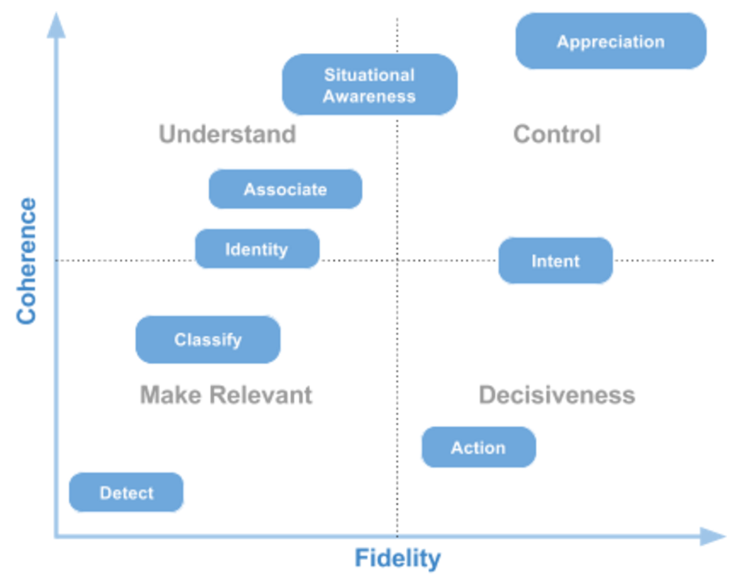

The horizontal axis illustrates the degree of fidelity of the information being conveyed. The vertical axis illustrates the coherence of the information being conveyed. The quadrants denote goals to which the information requirements support.

# 5 Design Approach

This section describes the key design goals and constraints influencing the transformation of the MIP Information Model semantics and structure into information constructs oriented towards information exchange.

## 5.1 Design Goals

**Simplicity** - The information constructs must be easy to understand and implement. The information constructs should be easy to validate and thus ensure their completeness and integrity. Misinterpretation of the information must be the rare case.

**Flexibility** - The information constructs must be flexible and allow adaptation for use within specific systems and operating contexts. These adaptations are in addition to the core semantics and would enable enhanced information exchange between a subset of MIP4-IES participants. However, these adaptations will not interfere with the understanding of systems that communicate using only the core semantics.

**Forward Compatible** - Forward compatibility is the ability to gracefully accept input intended for later versions of itself. Within minor version changes, the information constructs will be forward compatible.

**Backwards Compatible** - Backwards compatibility is the ability to successfully use data from earlier versions of the system. Within minor version changes, the information constructs will be backwards compatible.

**Compact** - The information constructs are intended to be used in a variety of operational contexts, including constrained networks. As such, the encoding of the information constructs should support the desire to keep the messages reasonably small. This design goal could be met in a number of ways, including the provision of multiple encodings.

**Efficient** - The information constructs are to be constructed and exchanged efficiently. The sending of duplicate information should be avoided. Large information constructs cannot be allowed to grow unbounded. It should be possible to decompose large constructs into a number of smaller constructs for transport, without losing meaning and purpose.

**Modular** - The information constructs must be delivered in easily understood and reusable modules. Each module will consist of a number of information constructs. The modular approach will allow implementers to utilise only those modules that meet their specific requirements. It is intended that the MIP4-IES information constructs will be delivered as a set of modules over time. Each delivered module will work with the preceding modules to provide additional functionality.

**Granular** - The information constructs contained within a module will be provided at a reasonably granular level. The granular definition of information constructs will allow implementers to utilise only those information constructs that meet their specific requirements.

**Minimal Representation** - All information constructs will share specific attributes. These specific attributes will constitute the minimal representation of the information construct. Such a design is useful when only simplistic handling of the information constructs is required. For example, marshalling all information constructs to a renderer for visualisation.

**Completeness** - All information constructs shall be as semantically rich and as complete as possible, providing reuse of these constructs to compose more complex information constructs in the future.

**NIEM** - Apply the NIEM Naming and Design Rules where appropriate (REF-ID-04) to improve the MIP4-IES XML Schemas and move the two technical solutions closer together.

## 5.2 Design Constraints

### 5.2.1 Target Architecture

The initial target architecture (REF-ID-01) for the exchange of information is defined as a set of Simple Object Access Protocol (SOAP) based web services operating within a Service Oriented Architecture (SOA). As such, the definition of the information constructs will be encoded using an eXtensible Markup Language (XML) schema. However, other architecture and encoding requirements may emerge over time.

### 5.2.2 Low Bandwidth Architecture (possible future)

The requirement to support a future architecture across constrained communication paths is within scope. One approach is leveraging on the XML Schemas, developed for the information content, to support small packet sizes and good compression ratios.

## 

## 5.3 Using the Subviews for specific Business Objects (BOs)

The MIP4-IES information schemas are separated in two folders. The “\artifacts\full” folder contains all the *full* set of elements and types that can be exchanged with other systems as part of a regular exchange of the current situation. See section 6.1.3 (List of allowed ContextIdentifiers) for a description of the available **Context**s that may be used by the systems.

The “\artifacts” folder also contains subfolders that each contain XML schemas that support specific operational capabilities. These capabilities are documented explicitly in section 9 (Usage Examples). These BOs include xml schemas that are subsets of the schemas provided in the “\artifacts\full” folder. These *subset* schemas define a valid subset of a *full* schema, reusing the exact same namespace, meaning that any *instance* elements that validate against a *subset* schema also validate against the *full* schema. The goal of these *subset* schemas is to provide an unambiguous, machine-processable description of the information that is to be exchanged in the context of the BO. So if a system only wants to implement a single BO (and not the *full* set of capabilities), it could use only the *subset* schemas and still be compliant for this BO.

For systems that implement multiple BOs or a *full* capability, it is advised to implement support based on the *full* set of schemas defined in the “\artifacts\full” folder.

During implementation and testing it is highly recommended to use XML schema validation on outgoing information to identify problems in the own implementation. When doing this, it is a best practice to use the subset schemas for validation of the supported BOs to ensure that only the information that is expected is actually included.

# 6 Key Information Concepts

The following key information concepts will be used throughout this document.

## **6.1 Identi**fication

### 6.1.1 Identification Overview

Every subtype of **ConceptType** inherits an identifying property called **ID** that is used as an artificial identifier for the real-world object. This means that two **ConceptType** *instance*s sharing the same **ID** shall be considered the same object in the battle space. This also means that updates to the same real-world object should be exchanged using the same **ID**. However, since the same real-world object can have different properties in different contexts (e.g. planned vs current), each context in which the **ConceptType** *instance* has been received has to be updated explicitly. This means that the **ID** must not be used as a primary key (e.g. in a database).

Note: A **ConceptType** *instance* may contain other **ConceptType** *instance*s nested inside. Of course, these will have their own **ID** values.

Caution: Since **ConceptType** *instance*s may later be correlated and fused, inequality of their **ID**s does not automatically imply different real-world objects. It may be the case that two **ConceptType** *instance*s originating from different systems may have each assigned a different **ID** to their representation of the same real-world object. A description of the required correlation and fusion processes is out of scope for this section.

Note: Since the **ID** needs to be globally unique, it would be a good idea to use Universally Unique Identifiers (UUIDs), specifically type 1 UUIDs. If a system uses an internal identification mechanism to generate **ID**s, it is essential to ensure **ID**s are guaranteed to be unique across all systems and exchanges.

### 6.1.2 The Context

When exchanging a **ConceptType** *instance*, this is always done within some operational context (e.g. as part of an overlay, as an order, etc.) Thus, MIP4-IES only allows the exchange of **ConceptType** *instance*s in a set of predefined contexts. There is no way to just exchange a **ConceptType** *instance* without specifying a (valid) context.

The **ContextType** allows for providing this context for a given **ConceptType**. This means that each **ConceptType** *instance* is to be interpreted in the context defined by the **ContextIdentifier** property of the **Context**. For nested objects, this means that the **Context**, the **ID**s of all nesting **ConceptType** instances and its ‘path’ to the root contribute to the Universal Resource Identifier (URI) of the *instance*.

Note: Even though this should be clear, please note that equality of **ContextIdentifers** is considered to be standard string equality (i.e. case sensitive).

Tip: the **ContextIdentifier** of the **Context** can be seen as a (partial) resource URL of a REST API.

To achieve the unambiguous definition of the allowed contexts and their meaning, a limited set of rules associated with the **ContextType** is needed. In particular, some **ContextIdentifier**s only make sense for some types of data.

### 6.1.3 List of allowed ContextIdentifiers

1. /Overlay: the **contextIdentifier Overlay** shall only be used if the data is of *type* **OverlayType** or one of its subtypes. It allows the Create/Read/Update/Delete (CRUD) operations on **Overlay**s as a whole. Note that the deletion of an Overlay also deletes all information within the Context “Overlay/{overlayID}/Content”. When sending the same Overlay (also after system restart) again, it is important to follow the general rules of using the identifier (same BSO=>same ID). What constitutes “same” in the context of an overlay depends on the national implementation.

If an **Overlay** (or subtype of Overlay) is exchanged in the "/Overlay" **Contex**t, then this replaces the previously received Overlay with the same id (if any) completely. There is no implicit merge operation. This means that all previously received content that was directly or indirectly (through **Content**, **ContentRef** or by receiving information in the "Overlay/{overlayId}/Content" context) is not considered to be part of the updated **Overlay**. The only content of the **Overlay** are the identifiables explicitly listed as content or **ContentRef**. In case of a **ContentRef**, the receiver is not required to request the information again if he already received it (e.g. prior to the update), unless he is performing a (re-)synchronization after connection loss.

When an **Overlay** is received that has one or more parent Overlays (i.e. **EnclosingOverlayRef**), then the fact that this **Overlay** is the child of one or more parent overlays shall be made visible to the user.

Note that the metadata of an Overlay does necessarily impact the interpretation of its content, e.g. a “Planned” Overlay does NOT imply all that this Overlay, including its content, is part of a Plan.

1. /Overlay/{OverlayID}/Content[3]: this **ContextIdentifier** MAY be used for any data that is a subtype of **BattlespaceConceptType** and, depending on the type of operation, creates/adds/modifies/removes the provided **ConceptType** *instance* to/in/from the overlay with the given OverlayID. The OverlayID shall refer to an existing (in the Provider system) **Overlay**. The referred to **Overlay** should be sent by the Provider system before sending the content. The Consumer may request the **Overlay** from the Provider if it does not already have it. When nesting overlays into each other (i.e. an instance of OverlayType (or subtype) is nested in another instance of OverlayType (or subtype)), the following rules apply:

(i) Both overlays shall be published with the “/Overlay” **ContextIdentifier**.

(ii) The nested overlay shall be included in the parent overlay by including an **IdentifiableReferenceType** as an **EnclosedOverlayRef** in the parent overlay.

(iii) The nested overlay shall have a reference to the parent overlay as an **EnclosingOverlayRef** .

(iv) The nested overlay may be removed from the parent overlay by sending an updated parent overlay with the **EnclosedOverlayRef** missing and sending an updated child overlay with the **EnclosingOverlayRef** missing. Note that this does not implicitly delete the nested overlay, it is still considered to be available in the “/Overlay” **ContextIdentifier**.

(v) If an overlay is “globally” deleted by deleting it from the “/Overlay” **ContextIdentifier**, it is also considered to be removed from all parent overlays, but the provider should also update all parent overlays to no longer include the child. If the deleted overlay references nested overlays, these are NOT considered implicitly deleted.

(vi) It is not allowed to nest an Overlay in itself directly or indirectly. An Overlay may be nested in multiple parent Overlays.

(vii) Updating information on the Overlay (e.g. changing the name) shall be done on the “/Overlay/” contextIdentifier. Note that this means that the whole content of the overlay needs to be included or referenced when updating.

Note: When exchanging Data via Request/Response or File Exchange pattern, the provider should include all information nested inside the **Overlay** instead of individual updates. This way, the consumer does not have to assemble the **Overlay**.

(c) /OrganisationStructure: This **ContextIdentifier** shall only be used for the StaffConcept **OrganisationStructure** or its subtypes. It allows CRUD operations on **OrganisationStructure**s as a whole. Note that due to the fact that **OrganisationStructures** are considered complete, immutable StaffConcepts, all instances of **IdentifiableReferenceTypes** contained nested within an OrganisationStructure must reference Identifiables within the same instance. This means that it is impossible to reference something outside the exchanged OrgansiationStructure. **OrganisationStructures** shall be exchanged using this contextIdentifier.

Caution: When receiving a **Context** with a given **contextIdentifier**, and this **contextIdentifier** refers to something that is not available to the Consumer (e.g. has not been received yet), then the data shall NOT be considered until the **Context** has been resolved. (Currently, this can only happen for the content of **Overlays**).

Note: As MIP4-IES evolves, new **Context**s may be identified and the list of **Context**s may be extended. Since a new **Context** always implies new functionality, this does not break backwards compatibility.

### 6.1.4 Identification Rules

The MIP4-IES is intended to facilitate the exchange of information in a federated environment. As such, the management of this information is distributed across multiple parties. In support of distributed information management, the following rules are established:

(a) A MIP4-IES **base:ID** created for the purpose of identity shall be globally unique within the federation (refer to §6.1.1 (Identification Overview)).

(b) A **base:ID** shall be used to uniquely identify a thing in the battlespace, this **ID** is applied to all **concept:Concept**s representing the thing.

(c) The **base:ID** shall uniquely identify a thing in the battlespace across all MIP4-IES systems in the federation.

(d) The combination of the **base:ContextIdentifier** and the **base:ID** of the **Concept** defines a unique instance of several pieces of information about the same **Concept** in different **Context**s (refer to §6.1.3 (List of allowed ContextIdentifiers)).

(e) The **base:ContextIdentifier** shall uniquely identify a context across all MIP4-IES systems in the federation.

### 6.1.5 Examples

Here is an example of a simple sequence of exchanges:

#### 6.1.5.1 Exchange of a new Overlay containing two units

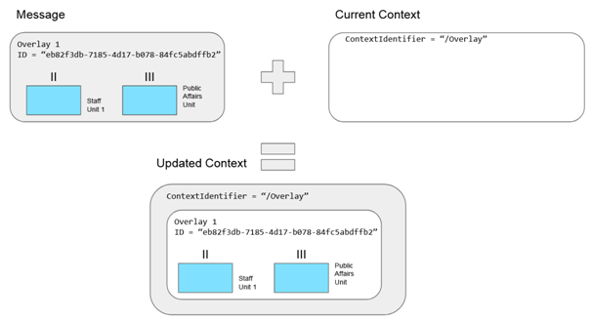

|  |
| --- |
| <?xml version="1.0" encoding="UTF-8"?>  <base:Context  xmlns:xsi="http://www.w3.org/2001/XMLSchema-instance"  xmlns:base="https://mip-interop.org/data/v4.3/Base"  xmlns:concept="https://mip-interop.org/data/v4.3/Concept"  xmlns:object="https://mip-interop.org/data/v4.3/BattlespaceConcept/Object"  xmlns:conceptmetadata="https://mip-interop.org/data/v4.3/Concept/Metadata"  xmlns:staffconcept="https://mip-interop.org/data/v4.3/StaffConcept"  xmlns:staffconceptmetadata="https://mip-interop.org/data/v4.3/StaffConcept/Metadata"  xmlns:battlespaceconcept="https://mip-interop.org/data/v4.3/BattlespaceConcept"  xmlns:organisation="https://mip-interop.org/data/v4.3/BattlespaceConcept/Object/Actor/Organisation"  xmlns:unit="https://mip-interop.org/data/v4.3/BattlespaceConcept/Object/Actor/Organisation/Unit"  xmlns:staffconceptoverlay="https://mip-interop.org/data/v4.3/StaffConcept/Overlay"  xsi:schemaLocation="https://mip-interop.org/data/v4.3/IES IES.xsd">  <base:ContextIdentifier>/Overlay/eb82f3db-7185-4d17-b078-84fc5abdffb2/Content</base:ContextIdentifier>  <base:Data xsi:type="staffconceptoverlay:OverlayType">  <base:ID>eb82f3db-7185-4d17-b078-84fc5abdffb2</base:ID>  <concept:ConceptName>Overlay 1</concept:ConceptName>  <staffconcept:StaffConceptMetadata>  <staffconceptmetadata:StaffConceptMetadataOriginator>  <conceptmetadata:OriginatorName>Originator</conceptmetadata:OriginatorName>  </staffconceptmetadata:StaffConceptMetadataOriginator>  </staffconcept:StaffConceptMetadata>  <staffconceptoverlay:OverlayContent xsi:type="unit:HeadquartersStaffUnitType">  <base:ID>4483ba36-9c1f-461e-8429-a4ed5755cbdd</base:ID>  <concept:ConceptName>Staff Unit 1</concept:ConceptName>  <battlespaceconcept:BattlespaceConceptIsTypeIndicator>false</battlespaceconcept:BattlespaceConceptIsTypeIndicator>  <battlespaceconcept:BattlespaceConceptMetadata xsi:nil="true"/>  <organisation:OrganisationHasCommandFunctionIndicator>false</organisation:OrganisationHasCommandFunctionIndicator>  <organisation:MilitaryOrganisationServiceCode>Army</organisation:MilitaryOrganisationServiceCode>  <unit:UnitEchelon xsi:type="object:ArmyEchelonType">  <object:ArmyEchelonCode>Battalion</object:ArmyEchelonCode>  </unit:UnitEchelon>  </staffconceptoverlay:OverlayContent>  <staffconceptoverlay:OverlayContent xsi:type="unit:BroadcastPublicAffairsUnitType">  <base:ID>7edb5b74-baff-4e97-b2c1-1b27390c02fc</base:ID>  <concept:ConceptName>Public Affairs Unit</concept:ConceptName>  <battlespaceconcept:BattlespaceConceptIsTypeIndicator>false</battlespaceconcept:BattlespaceConceptIsTypeIndicator>  <battlespaceconcept:BattlespaceConceptMetadata xsi:nil="true"/>  <organisation:OrganisationHasCommandFunctionIndicator>false</organisation:OrganisationHasCommandFunctionIndicator>  <organisation:MilitaryOrganisationServiceCode>Army</organisation:MilitaryOrganisationServiceCode>  <unit:UnitEchelon xsi:type="object:ArmyEchelonType">  <object:ArmyEchelonCode>RegimentOrGroup</object:ArmyEchelonCode>  </unit:UnitEchelon>  </staffconceptoverlay:OverlayContent>  </base:Data>  <base:ContextLastModificationDateTime>2020-11-05T16:33:00Z</base:ContextLastModificationDateTime>  </base:Context> |

#### 6.1.5.2 Addition of a new BSO

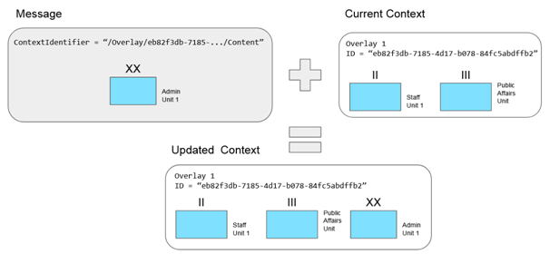

As shown in the following example, the **Context** of the new Unit points to the content of the **Overlay** previously exchanged.

|  |
| --- |
| <?xml version="1.0" encoding="UTF-8"?>  <base:Context  xmlns:xsi="http://www.w3.org/2001/XMLSchema-instance"  xmlns:base="https://mip-interop.org/data/v4.3/Base"  xmlns:concept="https://mip-interop.org/data/v4.3/Concept"  xmlns:object="https://mip-interop.org/data/v4.3/BattlespaceConcept/Object"  xmlns:materiel="https://mip-interop.org/data/v4.3/BattlespaceConcept/Object/Materiel"  xmlns:battlespaceconcept="https://mip-interop.org/data/v4.3/BattlespaceConcept"  xmlns:unit="https://mip-interop.org/data/v4.3/BattlespaceConcept/Object/Actor/Organisation/Unit"  xmlns:organisation="https://mip-interop.org/data/v4.3/BattlespaceConcept/Object/Actor/Organisation"  xsi:schemaLocation="https://mip-interop.org/data/v4.3/IES IES.xsd">  <base:ContextIdentifier>/Overlay/eb82f3db-7185-4d17-b078-84fc5abdffb2/Content</base:ContextIdentifier>  <base:Data xsi:type="unit:AdministrativeUnitType">  <base:ID>eb82f3db-7185-4d17-b078-84fc5abdffb2</base:ID>  <concept:ConceptName>Admin Unit 1</concept:ConceptName>  <battlespaceconcept:BattlespaceConceptIsTypeIndicator>false</battlespaceconcept:BattlespaceConceptIsTypeIndicator>  <battlespaceconcept:BattlespaceConceptMetadata xsi:nil="true"/>  <organisation:OrganisationHasCommandFunctionIndicator>false</organisation:OrganisationHasCommandFunctionIndicator>  <organisation:MilitaryOrganisationServiceCode>Army</organisation:MilitaryOrganisationServiceCode>  <unit:UnitEchelon xsi:type="object:ArmyEchelonType">  <object:ArmyEchelonCode>Division</object:ArmyEchelonCode>  </unit:UnitEchelon>  </base:Data>  <base:ContextLastModificationDateTime>2020-11-05T16:53:00Z</base:ContextLastModificationDateTime>  </base:Context> |

#### 6.1.5.3 Modification of an existing BSO

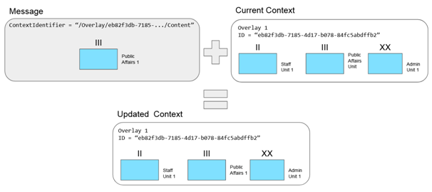

|  |
| --- |
| *<?xml version="1.0" encoding="UTF-8"?>*  *<base:Context*  *xmlns:xsi="http://www.w3.org/2001/XMLSchema-instance"*  *xmlns:base="https://mip-interop.org/data/v4.3/Base"*  *xmlns:concept="https://mip-interop.org/data/v4.3/Concept"*  *xmlns:object="https://mip-interop.org/data/v4.3/BattlespaceConcept/Object"*  *xmlns:organisation="https://mip-interop.org/data/v4.3/BattlespaceConcept/Object/Actor/Organisation"*  *xmlns:battlespaceconcept="https://mip-interop.org/data/v4.3/BattlespaceConcept"*  *xmlns:unit="https://mip-interop.org/data/v4.3/BattlespaceConcept/Object/Actor/Organisation/Unit"*  *xsi:schemaLocation="https://mip-interop.org/data/v4.3/IES IES.xsd">*  *<base:ContextIdentifier>/Overlay/eb82f3db-7185-4d17-b078-84fc5abdffb2/Content</base:ContextIdentifier>*  *<base:Data xsi:type="unit:BroadcastPublicAffairsUnitType">*  *<base:ID>7edb5b74-baff-4e97-b2c1-1b27390c02fc</base:ID>*  *<concept:ConceptName>Public Affairs 1</concept:ConceptName>*  *<battlespaceconcept:BattlespaceConceptIsTypeIndicator>false</battlespaceconcept:BattlespaceConceptIsTypeIndicator>*  *<battlespaceconcept:BattlespaceConceptMetadata xsi:nil="true"/>*  *<organisation:OrganisationHasCommandFunctionIndicator>false</organisation:OrganisationHasCommandFunctionIndicator>*  *<organisation:MilitaryOrganisationServiceCode>Army</organisation:MilitaryOrganisationServiceCode>*  *<unit:UnitEchelon xsi:type="object:ArmyEchelonType">*  *<object:ArmyEchelonCode>RegimentOrGroup</object:ArmyEchelonCode>*  *</unit:UnitEchelon>*  *</base:Data>*  *<base:ContextLastModificationDateTime>2020-11-05T16:53:00Z</base:ContextLastModificationDateTime>*  *</base:Context>* |

### 6.1.6 Managing External System Identifiers

When receiving a **BattlespaceConcept** from an external system, it is possible to modify it and resend it to another system. In order to support the possible correlation of the information it is recommended provide the external systems identifier.

The following rules apply only for the **battlespaceconcept:BattlespaceConcept**:

1. When a **BattlespaceConcept** is translated from an external system (e.g. FFI, Tactical Data Link), the external system identifiers should be maintained as **battlespaceconcept:AlternateIdentifier**.
2. When a **battlespaceconcept:BattlespaceConcept** is created by a system and shared through different protocols (e.g. FFI, Tactical Data Link), the external system identifiers for the non MIP4-IES protocols should be provided as **battlespaceconcept:AlternateIdentifier**.
3. When sharing **BattlespaceConcept**s, the **AlternateIdentifier** information should be maintained.

The external system identifier will be kept in the **AlternateIdentifier** as a **prim:Token** (e.g. a string). Thus the external identifier has to be serialized in order to be stored in a local system.

## 6.2 Identifiable Reference

A **base:IdentifiableReferenceType** represents a reference to a **concept:Concept** piece of information. The reference contains enough information to uniquely identify the **concept:Concept** for possible retrieval in the future. The optional ContextIdentifier shall be used to indicate the Context of the Information. If no ContextIdentifier is provided, the reference is considered to be local, i.e. within the Context in which the IdentifiableReference resides. This means the two following examples are equivalent:

|  |
| --- |
| <?xml version="1.0" encoding="UTF-8"?>  <base:Context  xmlns:xsi="http://www.w3.org/2001/XMLSchema-instance"  xmlns:base="https://mip-interop.org/data/v4.3/Base"  xmlns:concept="https://mip-interop.org/data/v4.3/Concept"  xmlns:unit="https://mip-interop.org/data/v4.3/BattlespaceConcept/Object/Actor/Organisation/Unit"  xmlns:battlespaceconcept="https://mip-interop.org/data/v4.3/BattlespaceConcept"  xmlns:organisation="https://mip-interop.org/data/v4.3/BattlespaceConcept/Object/Actor/Organisation"  xsi:schemaLocation="https://mip-interop.org/data/v4.3/IES IES.xsd">  <base:ContextIdentifier>/Overlay/613bcc43-5fd7-45ca-aee8-100cb34063fd/Content</base:ContextIdentifier>  <base:Data xsi:type="organisation:OrganisationType">  <base:ID>613bcc43-5fd7-45ca-aee8-100cb34063fd</base:ID>  <concept:ConceptName>Unit</concept:ConceptName>  <battlespaceconcept:BattlespaceConceptMetadata xsi:nil="true"/>  <organisation:OrganisationHasCommandFunctionIndicator>false</organisation:OrganisationHasCommandFunctionIndicator>  <organisation:OrganisationPointOfContactRef>  <base:ID>dd00f6aa-0ec9-43fb-b09a-1dfc6dea1303</base:ID>  <base:ContextIdentifier>/Overlay/dd00f6aa-0ec9-43fb-b09a-1dfc6dea1303/Content</base:ContextIdentifier>  </organisation:OrganisationPointOfContactRef>  </base:Data>  <base:ContextLastModificationDateTime>2020-11-05T16:53:00Z</base:ContextLastModificationDateTime>  </base:Context> |

Example 1

|  |
| --- |
| <base:Context  xmlns:xsi="http://www.w3.org/2001/XMLSchema-instance"  xmlns:base="https://mip-interop.org/data/v4.3/Base"  xmlns:concept="https://mip-interop.org/data/v4.3/Concept"  xmlns:unit="https://mip-interop.org/data/v4.3/BattlespaceConcept/Object/Actor/Organisation/Unit"  xmlns:battlespaceconcept="https://mip-interop.org/data/v4.3/BattlespaceConcept"  xmlns:organisation="https://mip-interop.org/data/v4.3/BattlespaceConcept/Object/Actor/Organisation"  xsi:schemaLocation="https://mip-interop.org/data/v4.3/IES IES.xsd">  <base:ContextIdentifier>/Overlay/613bcc43-5fd7-45ca-aee8-100cb34063fd/Content</base:ContextIdentifier>  <base:Data xsi:type="organisation:OrganisationType">  <base:ID>613bcc43-5fd7-45ca-aee8-100cb34063fd</base:ID>  <concept:ConceptName>Unit</concept:ConceptName>  <battlespaceconcept:BattlespaceConceptMetadata xsi:nil="true"/>  <organisation:OrganisationHasCommandFunctionIndicator>false</organisation:OrganisationHasCommandFunctionIndicator>  <organisation:OrganisationPointOfContactRef>  <base:ID>dd00f6aa-0ec9-43fb-b09a-1dfc6dea1303</base:ID>  </organisation:OrganisationPointOfContactRef>  </base:Data>  <base:ContextLastModificationDateTime>2020-11-05T16:53:00Z</base:ContextLastModificationDateTime>  </base:Context> |

Example 2

When requesting the referenced IdentifiableType, the ContextIdentifier needs to be provided, so if the actual IdentifiableReference is local, the ContextIdentifier has to be derived from the Context in which the IdentifiableReference is contained. Note that this does not always equal the exact ContextIdentifier that the information was received in.

For example, the following reference resolves to the contextIdentifier “/Overlay/2b672472-ce22-4807-897a-a38571495150/Content”

|  |
| --- |
| <base:Context  xmlns:xsi="http://www.w3.org/2001/XMLSchema-instance"  xmlns:base="https://mip-interop.org/data/v4.3/Base"  xmlns:concept="https://mip-interop.org/data/v4.3/Concept"  xmlns:unit="https://mip-interop.org/data/v4.3/BattlespaceConcept/Object/Actor/Organisation/Unit"  xmlns:overlay="https://mip-interop.org/data/v4.3/StaffConcept/Overlay"  xmlns:staffconcept="https://mip-interop.org/data/v4.3/StaffConcept"  xmlns:battlespaceconcept="https://mip-interop.org/data/v4.3/BattlespaceConcept"  xmlns:organisation="https://mip-interop.org/data/v4.3/BattlespaceConcept/Object/Actor/Organisation"  xsi:schemaLocation="https://mip-interop.org/data/v4.3/IES IES.xsd">  <base:ContextIdentifier>/Overlay</base:ContextIdentifier>  <base:Data xsi:type="overlay:OverlayType">  <base:ID>2b672472-ce22-4807-897a-a38571495150</base:ID>  <concept:ConceptName>Overlay</concept:ConceptName>  <staffconcept:StaffConceptMetadata xsi:nil="true"/>  <overlay:OverlayContentRef>  <base:ID>dd00f6aa-0ec9-43fb-b09a-1dfc6dea1303</base:ID>  </overlay:OverlayContentRef>  </base:Data>  <base:ContextLastModificationDateTime>2020-11-05T16:53:00Z</base:ContextLastModificationDateTime>  </base:Context> |

Example 3

The optional SemanticID element on the IdentifiableReferenceType is used to communicate to the consumer the type of the Identifiable instance referenced. This allows the consumer to, e.g. not request the referenced Identifiable because it knows it won’t be able to process it.

If a Provider is no longer providing a referenced IdentifiableType, the Provider shall update the Identifiable containing the IdentifiableRefence and remove the reference.

Note that it is possible that a Consumer is requesting a referenced IdentifiableType that the Provider is no longer providing (e.g. due to race conditions).

## 6.3 Association

A **base:AssociationType** is a **base:IdentifiableType** that expresses a relationship between two **concept:Concept**s. The **Association** conveys the relationship between the two **concept:Concept**s using predicate grammar.

## 6.4 Concepts

The totality of the information constructs are hereafter referred to as **concept:Concept** (see the diagram in Annex A.1). A **concept:Concept** represents the smallest unit of information that can be exchanged. Though **concept:Concept** *instance*s can be exchanged directly, they can also be incorporated into other **concept:Concept** *instance*s.

In order to update any piece of information of a **concept:Concept** previously exchanged, the whole **concept:Concept** *instance* containing updated information must be exchanged (unless otherwise specified).

## 6.5 Type Hierarchy

The complete set of business objects is formed into a semantically rich hierarchy of **ConceptTypes** which is exposed to implementers as top level elements in the XML schemas. It is not possible to convey the full type hierarchy here; consequently you will find the hierarchy of only the major concepts in the diagram in Annex A.2.

The **ConceptType** and the associated top level element in the XML schema share the same semantics. The **QName** or **xsi:type** associated with the top level element uniquely identifies the **ConceptType** and thus its underlying semantics (e.g. Bridge, Minefield, etc.).

The type hierarchy allows the sharing of **ConceptType**s at the desired level of specificity. For example, a **unit:TransportationAndSupplyUnit** is derived from the following **concept:ConceptType**s:

*ConceptType*

*BattleSpaceConceptType*

*ObjectType*

*ActorType*

*OrganisationType*

*GovernmentOrganisationType*

*MilitaryOrganisationType*

*UnitType*

*CombatServiceSupportUnitType*

*TransportationAndSupplyUnitType*

Depending on the circumstances, a known **TransportationAndSupplyUnit** may be shared as a **Unit**.

Generally, when shared, **ConceptType**s should be as semantically complete as possible. If the full semantics are not known, the intermediate semantics become useful to express what is known at the time.

Aside from the existence of hierarchies of XML **ComplexType**s, MIP4-IES allows for further subtyping of **ComplexType**s that are not extended by other **ComplexType**s, through the use of discriminating category-code attributes. Therefore, to fully qualify the semantic type of a MIP4-IES XmlElement, the value of the **discriminator** attribute, if present, shall be taken into account.

For example: to express a Missile Transportation Unit, it requires a **TransportationUnitType** element with **TransportationUnitTypeCategoryCode** set to ‘MissileTransportationUnit’.

**Discriminator** elements are identified using the **AppInfo** element MIMStereotype **‘discriminator’**.

Some **ComplexType**s can be considered as being abstract representations, i.e. they should not be instantiated and a concrete (non-abstract) subtype should be used instead. Instead of using the XML schema attribute ‘abstract’ to capture this, the information is captured in the appinfo as an **app:MIMStereotype** with the value ‘Abstract’. The reasons for this are partly technical (some tools have problems with nillable elements that refer to abstract *type*s) and partly operational (to support extensibility and the exchange of incomplete information). A Consumer shall be able to receive and process information (or at least not reject this information) that uses **ComplexType**s with an **app:MIMStereotype** value ‘Abstract’, while a Producer is encouraged to not directly instantiate these *type*s.

## 6.6 Managed Lists

When the enumerated values required by the MIP4-IES are subject to change at runtime, the values are provided separate from the XML schema in a Managed List. This allows the valid set of enumerated values to be managed within the context of a specific mission or operation. Systems implementing the MIP4-IES will have the ability to incorporate the authoritative set of Managed Lists, when made available.

Within the XML Schemas, Managed Lists are encoded as a token without further restriction. The Managed List itself is provided as a separate Genericode file (*.gc). The default Genericode file is documented within the XML schema as **xsd:affinfo,** part of the XmlElement subject to the Managed List. The XmlElement subject to the Managed List shall not be considered to be an unrestricted token.

In order to provide a predictable format, all genericode files will refer to the standardised ColumnSet “urn:int:nato:standard:mip:mip4ies:managedList:columnSet:1:0:0”. The columnset is located in the file “<https://mip-interop.org/gcs/2019/04/11/ManagedListColumns.gc>”.

It is expected that all interconnected MIP4-IES implementations will strive to use the same authoritative set of Managed Lists, and that these lists will be used to validate the content of Elements subject to Managed Lists. It is understood that in practice achieving simultaneous utilization of the same authoritative Managed List is difficult to accomplish. As such, implementations shall accommodate unexpected values when received.

Validation of Elements subject to a Managed List will generally require a second pass validation process. In support of using Schematron for the second pass validation, ContextValueAssociation (*.cva) files are provided in the validation section, to link the Genericode files to the specific Elements subject to a Managed List. These ContextValueAssociation files are provided alongside the Genericode files, with the same filename but different extensions.

Find below an example of the assignment of a Managed List (Classifiers_Generic_EthnicGroupCode.gc) to a specific Element (**EthnicAffiliationCode**) in the XML schema.

|  |
| --- |
| <?xml version="1.0" encoding="UTF-8"?>  <xsd:schema  xmlns:xsd="http://www.w3.org/2001/XMLSchema"  xmlns:affiliation="https://mip-interop.org/data/v4.3/BattlespaceConcept/Affiliation" xmlns:app="https://mip-interop.org/data/v4.3/AppInfo.xsd"  targetNamespace="https://mip-interop.org/data/v4.3/BattlespaceConcept/Affiliation">  <!-- BEGIN -->  <xsd:element name="EthnicAffiliationCode" type="affiliation:EthnicAffiliationCodeType" nillable="true">  <xsd:annotation>  <xsd:documentation xml:lang="en">The ethnic group.</xsd:documentation>  <xsd:appinfo>  <app:SemanticID>MIM:5dd9d7a9-2c85-4387-80f0-fe0ec244fdc6</app:SemanticID>  <app:ShortName>code</app:ShortName>  <app:ValueOrAmplification>1</app:ValueOrAmplification>  <app:MIMStereotype>instance</app:MIMStereotype>  <app:MIMStereotype>name</app:MIMStereotype>  <app:ManagedList>BattlespaceConcept_Generic_EthnicGroupCode.gc</app:ManagedList>  <app:DisplayName>code</app:DisplayName>  </xsd:appinfo>  </xsd:annotation>  </xsd:element>  <!-- END -->  <xsd:simpleType name="EthnicAffiliationCodeType">  <xsd:annotation>  <xsd:documentation xml:lang="en">The ethnic group.</xsd:documentation>  <xsd:appinfo>  <app:SemanticID>MIM:5dd9d7a9-2c85-4387-80f0-fe0ec244fdc6</app:SemanticID>  <app:ShortName>code</app:ShortName>  <app:ValueOrAmplification>1</app:ValueOrAmplification>  <app:MIMStereotype>instance</app:MIMStereotype>  <app:MIMStereotype>name</app:MIMStereotype>  <app:ManagedList>BattlespaceConcept_Generic_EthnicGroupCode.gc</app:ManagedList>  <app:DisplayName>code</app:DisplayName>  </xsd:appinfo>  </xsd:annotation>  <xsd:restriction base="xsd:token"/>  </xsd:simpleType>  </xsd:schema> |

A snippet of the Classifiers_Generic_EthnicGroupCode.gc file is provided below to further amplify the information contained in the Managed List.

|  |
| --- |
| <?xml version="1.0" encoding="utf-8"?>  <gc:CodeList  xmlns:gc="http://docs.oasis-open.org/codelist/ns/genericode/1.0/"  xmlns:xsi="http://www.w3.org/2001/XMLSchema-instance">  <Identification>  <ShortName>EthnicAffiliationCodeType</ShortName>  <Version>1.0</Version>  <CanonicalUri/>  <CanonicalVersionUri/>  </Identification>  <ColumnSetRef>  <CanonicalVersionUri>urn:int:nato:standard:mip:mip4ies:managedList:columnSet:1:0:0</CanonicalVersionUri>  <LocationUri>https://mip-interop.org/gcs/2019/04/11/ManagedListColumns.gc</LocationUri>  </ColumnSetRef>  <SimpleCodeList>  <Row>  <Value>  <SimpleValue>ABKHAZ</SimpleValue>  </Value>  <Value>  <SimpleValue>Abkhaz</SimpleValue>  </Value>  <Value>  <SimpleValue>The ethnic group of Abkhaz people.</SimpleValue>  </Value>  </Row>  </SimpleCodeList>  </gc:CodeList> |

Furthermore, the ContextValueAssociation example below demonstrates how the Classifiers_Generic_EthnicGroupCode.gc file is bound to the XML schema.

|  |
| --- |
| <?xml version="1.0" encoding="UTF-8"?>  <xsd:schema  xmlns:xsd="http://www.w3.org/2001/XMLSchema"  xmlns:affiliation="https://mip-interop.org/data/v4.3/BattlespaceConcept/Affiliation"  xmlns:app="https://mip-interop.org/data/v4.3/AppInfo.xsd"  targetNamespace="https://mip-interop.org/data/v4.3/BattlespaceConcept/Affiliation">  <!-- BEGIN -->  <xsd:element name="EthnicAffiliationCode" type="affiliation:EthnicAffiliationCodeType" nillable="true">  <xsd:annotation>  <xsd:documentation xml:lang="en">The ethnic group.</xsd:documentation>  <xsd:appinfo>  <app:SemanticID>MIM:5dd9d7a9-2c85-4387-80f0-fe0ec244fdc6</app:SemanticID>  <app:ShortName>code</app:ShortName>  <app:ValueOrAmplification>1</app:ValueOrAmplification>  <app:MIMStereotype>instance</app:MIMStereotype>  <app:MIMStereotype>name</app:MIMStereotype>  <app:ManagedList>BattlespaceConcept_Generic_EthnicGroupCode.gc</app:ManagedList>  <app:DisplayName>code</app:DisplayName>  </xsd:appinfo>  </xsd:annotation>  </xsd:element>  <!-- END -->  <xsd:simpleType name="EthnicAffiliationCodeType">  <xsd:annotation>  <xsd:documentation xml:lang="en">The ethnic group.</xsd:documentation>  <xsd:appinfo>  <app:SemanticID>MIM:5dd9d7a9-2c85-4387-80f0-fe0ec244fdc6</app:SemanticID>  <app:ShortName>code</app:ShortName>  <app:ValueOrAmplification>1</app:ValueOrAmplification>  <app:MIMStereotype>instance</app:MIMStereotype>  <app:MIMStereotype>name</app:MIMStereotype>  <app:ManagedList>BattlespaceConcept_Generic_EthnicGroupCode.gc</app:ManagedList>  <app:DisplayName>code</app:DisplayName>  </xsd:appinfo>  </xsd:annotation>  <xsd:restriction base="xsd:token"/>  </xsd:simpleType>  </xsd:schema> |

## 

## 6.7 Optional and Mandatory Elements

In the current schemas, almost all elements are nillable (i.e. there is a possibility to not provide the value). This is because of the operational requirement to allow for the exchange of incomplete information. However, some information elements are logically considered essential and consequently are mandated. This is expressed by the appinfo element **ValueOrAmplification** being present on the operationally mandatory element, in addition to its minOccurs value being greater than 0. By using **base:Amplification** instead of the actual value, a Provider is not forced to provide any otherwise mandated values or to work around schema validation by inserting ‘dummy’ values. If a Provider does not want to exchange the value of a mandated element, an **Amplification** SHALL be provided. Additionally, a Provider MAY choose to also provide an **Amplification** for an element for which a value is provided, in case e.g. the value could not be set correctly (for example, a Provider wanted to provide “Rose Garden” as a value, but the list of allowed values only included “Garden”).

The decision of setting a mandated value to nil and providing an **Amplification** should always be a conscious decision, because it may have a negative influence on interoperability. Therefore a system should not make this automatically, it should be an operator deciding to do so.

The **AmplificationLocationText** element SHALL be set to the local name of the element to which the **AmplificationText** applies. The following **base:AmplificationText** values are available (through a pattern restriction on **AmplificationTextType**):

1. Inapplicable: no value exists, or a value exists but is in the context meaningless, or the value exists but is not computable by the Provider.
2. Missing: a value exists but for unknown reasons is unavailable for the Provider.
3. Unknown: a value probably exists but it is not known to the Provider.
4. Withheld: a value exists but it must not be provided to the Consumer.
5. Other: (.*) Any other or truly no reason for not providing the value.

For usage of **AmplificationLocationTex**t, the following should be observed:

1. If the value of the **AmplificationLocationText** refers to a repeatable element, then the **AmplificationText** applies to ALL *instance*s of that element, if provided.
2. **AmplificationText** only refers to elements on the same level; there is no way to refer to a nested or parent element.

Even though XML distinguishes between an element being present and set to **xsi:nil=true** and an element not being present at all, for the use of **Amplification**, both of these cases are to be handled identically (i.e. they both represent a ‘missing value’).

## 6.8 Explanation of Most Recent

In order for a consumer to determine the order in which information on a specific **concept:ConceptType** in a **base:Context** is to be processed, it needs to have a way to sort the information according to some criteria. This is in particular relevant for information arriving via different communication channels (such as FileExchange and Request/Response). Since the exchange mechanism does not make any guarantees on the order of delivery of information, a consumer has to look at the **base:ContextLastModificationDateTime** of the received **Context** to figure out the order in which the information is to be applied. Whether outdated information is ignored, archived or somehow else applied is up to the Consumer.

The following rules apply to the **ContextLastModificationDateTime**:

1. The Provider shall set the **ContextLastModificationDateTime** whenever a **base:Context** element is constructed to distribute information. The Provider shall set the **ContextLastModificationDateTime** to a value greater than or equal to the last modification time of the **base:Data** element’s content. A common way to achieve this, is to use the Provider’s system time.
2. Note that if the **base:Data** element contains any nested **concept:ConceptType**s, then their modification time is to be considered when determining the **Context**’s **base:ContextLastModificationDateTime**.
3. The Consumer system shall use the **ContextLastModificationDateTime** to determine the most recent information of a **concept:ConceptType** in a **Context** (same **ID** and **ContextID**).
4. **Context**s containing information with **conceptmetadata:ReportingDataCategoryCode** set to ‘Erroneous’ have no impact on the statements above.
5. Since the **conceptmetadata:ValidityTimePeriod** and **conceptmetadata:ReportingDateTime** are user-created information, they shall not be used to derive the most recent information about a **concept:Concept**.

# 

# 7 Information Management

## 7.1 Business Process

The **battlespaceconcept:BattlespaceConcept**s defined by the MIP4-IES, are independent of any business processes. This is by design and allows the **battlespaceconcept:BattlespaceConcept**s to be incorporated into business processes as, and when, they are defined for a specific context. It is expected that these processes will be identified and defined over time.

Independent of a specific process, the **battlespaceconcept:BattlespaceConcept**s contribute to a generalised business process known as ‘need to share’. The specifics of what, when and with whome to be shared will be determined by a specific mission or operation.

## 7.2 Extension

### 7.2.1 Overview

The Extension.xsd XML Schema defines the ext:ExtensionType with the explicit purpose of allowing additional semantics to be provided, when required.

The **ext:ExtensionType** contains an attribute **mustUnderstandIndicator**. If **mustUnderstandIndicator** is set to True, the recipient of the **concept:Concept** shall only process the full **concept:Concept** if all the content within the **ExtensionType** is understood (i.e. the semantics are understood). This usually means that a recipient has prior knowledge of the XML schemas used to encode the contents of the **ExtensionType** and can validate this content when required.

### 7.2.2 Addition of New Properties

The **ext**:**ExtensionType** can be used to add new properties (attributes) to a **concept:ConceptType** without changing the baselined schema (which is required to support inter-version compatibility with previous MIP4 versions).

Example (**Extension** element as an **ExtensionType**):

|  |
| --- |
| <?xml version="1.0" encoding="UTF-8"?>  <facility:Airfield  xmlns:xsi="http://www.w3.org/2001/XMLSchema-instance"  xmlns:base="https://mip-interop.org/data/v4.3/Base"  xmlns:concept="https://mip-interop.org/data/v4.3/Concept"  xmlns:facility="https://mip-interop.org/data/v4.3/BattlespaceConcept/Object/Facility"  xmlns:battlespaceconcept="https://mip-interop.org/data/v4.3/BattlespaceConcept"  xmlns:ext="https://mip-interop.org/data/v4.3/Extension"  xsi:schemaLocation="https://mip-interop.org/data/v4.3/IES IES.xsd">  <ext:Extension ext:mustUnderstandIndicator="false">  <fac2:FlightSupportCategoryCode xmlns:fac2="http://example.com">IFR</fac2:FlightSupportCategoryCode>  </ext:Extension>  <base:ID>7fe836b6-dabf-431a-810a-13a59dafafb7</base:ID>  <concept:ConceptName>Airport</concept:ConceptName>  <battlespaceconcept:BattlespaceConceptIsTypeIndicator>true</battlespaceconcept:BattlespaceConceptIsTypeIndicator>  <battlespaceconcept:BattlespaceConceptMetadata/>  <facility:FacilityOperationalStatusCode>Operational</facility:FacilityOperationalStatusCode>  </facility:Airfield> |

In the above example, the 'Airfield' **facility** is extended (using the **Extension** block) with a new value of **fac2:FlightSupportCategoryCode**. This extension is not marked as **mustUnderstand**, therefore if a Consumer does not know how to interpret the schema in the **Extension** block, it is still able to process the remaining information about the **Airfield**. However, in the case where a Consumer is aware of the extended schema, it can process it to understand this additional property.

### 7.2.3 Addition of New Types

The **ExtensionType** can be used to extend the set of available *type*s without breaking inter-version compatibility. This is achieved by wrapping the information of the new *type* in the extension block of the first available existing *type* from which the new *type* is extended. This way, a Consumer that understands the new *type* in the extension point will process it (and ignore the information in the wrapper entity), but a Consumer that does not understand the new *type* will process the information in the wrapper entity instead.

It must be noted that:

(a) the above approach only applies to any **concept**:**ConceptType** that directly or indirectly extends a subtype of **ConceptType** from a previous namespace; and

(b) theoretically, this wrapping can occur multiple times if there are multiple *type*s extending the same entity over time.

For example, in the event a Producer needs to add a new **unitType** **AirTrafficControlUnit** as a specialisation of **CombatSupportUnit**, the resulting message will look like the snippet below:

|  |
| --- |
| <?xml version="1.0" encoding="UTF-8"?>  <unit:CombatSupportUnit xmlns:xsi="http://www.w3.org/2001/XMLSchema-instance"  xmlns:base="https://mip-interop.org/data/v4.3/Base"  xmlns:concept="https://mip-interop.org/data/v4.3/Concept"  xmlns:organisation="https://mip-interop.org/data/v4.3/BattlespaceConcept/Object/Actor/Organisation"  xmlns:unit="https://mip-interop.org/data/v4.3/BattlespaceConcept/Object/Actor/Organisation/Unit"  xmlns:battlespaceconcept="https://mip-interop.org/data/v4.3/BattlespaceConcept"  xmlns:object="https://mip-interop.org/data/v4.3/BattlespaceConcept/Object"  xmlns:ext="https://mip-interop.org/data/v4.3/Extension"  xsi:schemaLocation="https://mip-interop.org/data/v4.3/IES IES.xsd">  <ext:Extension ext:mustUnderstandIndicator="false">  <unit:AirTrafficControlUnit  xmlns:xsi="http://www.w3.org/2001/XMLSchema-instance"  xmlns:base="https://mip-interop.org/data/v4.3/Base"  xmlns:concept="https://mip-interop.org/data/v4.3/Concept"  xmlns:object="https://mip-interop.org/data/v4.3/BattlespaceConcept/Object"  xmlns:organisation="https://mip-interop.org/data/v4.3/BattlespaceConcept/Object/Actor/Organisation"  xmlns:unit="https://mip-interop.org/data/v4.3/BattlespaceConcept/Object/Actor/Organisation/Unit"  xsi:schemaLocation="https://mip-interop.org/data/v4.3/IES IES.xsd">  <base:ID>cacf04d5-8741-4ee8-a095-d2dc84ac80c1</base:ID>  <concept:ConceptName>ATC ALPHA</concept:ConceptName>  <battlespaceconcept:BattlespaceConceptIsTypeIndicator>true</battlespaceconcept:BattlespaceConceptIsTypeIndicator>  <battlespaceconcept:BattlespaceConceptMetadata/>  <organisation:OrganisationHasCommandFunctionIndicator>true</organisation:OrganisationHasCommandFunctionIndicator>  <organisation:OrganisationOperationalStatusCode>MarginallyOperational</organisation:OrganisationOperationalStatusCode>  <organisation:MilitaryOrganisationServiceCode>CoastGuard</organisation:MilitaryOrganisationServiceCode>  <unit:UnitEchelon/>  <unit:UnitFormalAbbreviatedName>ALPHA</unit:UnitFormalAbbreviatedName>  <unit:UnitUsesUnmannedVehiclesIndicator>true</unit:UnitUsesUnmannedVehiclesIndicator>  </unit:AirTrafficControlUnit>  </ext:Extension>  <base:ID>cacf04d5-8741-4ee8-a095-d2dc84ac80c1</base:ID>  <concept:ConceptName>Air Traffic Control Unit ATC ALPHA</concept:ConceptName>  <battlespaceconcept:BattlespaceConceptIsTypeIndicator>true</battlespaceconcept:BattlespaceConceptIsTypeIndicator>  <battlespaceconcept:BattlespaceConceptMetadata/>  <organisation:OrganisationHasCommandFunctionIndicator>true</organisation:OrganisationHasCommandFunctionIndicator>  <organisation:MilitaryOrganisationServiceCode>CoastGuard</organisation:MilitaryOrganisationServiceCode>  <unit:UnitEchelon/>  </unit:CombatSupportUnit> |

In order to avoid inconsistency within the exchanged information:

1. In the situation where the Consumer is able to understand the **Extension**, the Consumer shall only process the *type* within the **Extension** (using the attributes of the new *type*) and not merge with the wrapper entity (wrapper type’s attributes).
2. In order to clearly express that the new type replaces the wrapper, the Producer will use the same 3-part identifier for both.
3. The new *type*’s attributes and the wrapper‘s attributes may not be identical in number and values, it is the Producer’s responsibility to ensure the information is aligned (to the best extent possible) between the wrapper and the new type. This means information will be repeated in both wrapper and new type, for information elements that exist in the wrapper even though the value of the value of certain information elements may not be identical. As an example, the “name” property of the “wrapper” **CombatSupportUnit** might be set to “air traffic control unit - NAME” to indicate the type of the unit, whereas in the new type AirTrafficControlUnit does not need this additional information and will use just “NAME”.

**7.2.4 Addition of Both Types and Properties**

Both the cases described in the previous paragraphs may be combined. In case both a new *type* and a new property are added, and the Producer intends to provide the property for both the wrapper entity and the new entity, the resulting message will look like the example below:

|  |
| --- |
| <?xml version="1.0" encoding="UTF-8"?>  <unit:CombatSupportUnit  xmlns:xsi="http://www.w3.org/2001/XMLSchema-instance"  xmlns:base="https://mip-interop.org/data/v4.3/Base"  xmlns:concept="https://mip-interop.org/data/v4.3/Concept"  xmlns:battlespaceconcept="https://mip-interop.org/data/v4.3/BattlespaceConcept"  xmlns:organisation="https://mip-interop.org/data/v4.3/BattlespaceConcept/Object/Actor/Organisation"  xmlns:unit="https://mip-interop.org/data/v4.3/BattlespaceConcept/Object/Actor/Organisation/Unit"  xmlns:ext="https://mip-interop.org/data/v4.3/Extension"  xsi:schemaLocation="https://mip-interop.org/data/v4.3/IES IES.xsd">  <ext:Extension ext:mustUnderstandIndicator="false">  <unit:AirTrafficControlUnit>  <ext:Extension ext:mustUnderstandIndicator="false">  <unit:UnitIsTaskForceIndicator>false</unit:UnitIsTaskForceIndicator>  </ext:Extension>  <base:ID>cacf04d5-8741-4ee8-a095-d2dc84ac80c1</base:ID>  <concept:ConceptName>Air Traffic Control</concept:ConceptName>  <battlespaceconcept:BattlespaceConceptIsTypeIndicator>false</battlespaceconcept:BattlespaceConceptIsTypeIndicator>  <battlespaceconcept:BattlespaceConceptMetadata xsi:nil="true"></battlespaceconcept:BattlespaceConceptMetadata>  <organisation:OrganisationHasCommandFunctionIndicator>false</organisation:OrganisationHasCommandFunctionIndicator>  <organisation:MilitaryOrganisationServiceCode>AirForce</organisation:MilitaryOrganisationServiceCode>  <unit:UnitEchelon/>  </unit:AirTrafficControlUnit>  </ext:Extension>  <base:ID>cacf04d5-8741-4ee8-a095-d2dc84ac80c1</base:ID>  <concept:ConceptName>Air Traffic Control</concept:ConceptName>  <battlespaceconcept:BattlespaceConceptIsTypeIndicator>false</battlespaceconcept:BattlespaceConceptIsTypeIndicator>  <battlespaceconcept:BattlespaceConceptMetadata xsi:nil="true"></battlespaceconcept:BattlespaceConceptMetadata>  <organisation:OrganisationHasCommandFunctionIndicator>true</organisation:OrganisationHasCommandFunctionIndicator>  <organisation:MilitaryOrganisationServiceCode>AirForce</organisation:MilitaryOrganisationServiceCode>  <unit:UnitEchelon/>  </unit:CombatSupportUnit> |

## 7.3 Inter-version Compatibility

### 7.3.1 Extensibility

All **concept**:**Concept**s include the feature of extensibility. This is implemented through the **ext**:**Extension** element, which can contain any additional information deemed as necessary by the Provider.

The extensibility feature supports the following use cases:

1. Within a Community of Interest (CoI) using the MIP4-IES, another CoI (e.g. a sub-CoI) forms to share information, within a **concept:Concept**, that is in addition to the MIP4-IES defined semantics.
2. A **concept**:**Concept** is translated from an external source and certain information was passed through within the **ext**:**Extension** element for the purpose of completeness and potential use downstream.
3. Correction of errors within the MIP4-IES XML Schemas.
4. Extension of the MIP4-IES XML Schemas to add new features applicable to the entire MIP4-IES CoI.
5. Support the ability for multiple versions of the MIP4-IES to coexist and exchange information.

### 7.3.2 Deprecation

The MIP4-IES XML schemas support the concept of deprecation of semantics. This is accomplished through the **AppInfo** element **Deprecated**. When the use of a particular element is no longer desired, the XML schema will be updated to include the **AppInfo** **Deprecated** element. This is considered a documentation change and will not have a corresponding change to the namespace of the XML schema. The use of **Deprecated** elements is discouraged, but not forbidden.

It is expected that the **AppInfo** **Deprecated** element will contain human readable text identifying alternate means to convey the intended semantics of the deprecated element.

|  |
| --- |
| <?xml version="1.0" encoding="UTF-8"?>  <xsd:schema  xmlns:xsd="http://www.w3.org/2001/XMLSchema"  xmlns:staffconceptoverlay="https://mip-interop.org/data/v4.3/StaffConcept/Overlay"  xmlns:app="https://mip-interop.org/data/v4.3/AppInfo.xsd"  targetNamespace="https://mip-interop.org/data/v4.3/StaffConcept/Overlay">  <!-- BEGIN -->  <xsd:element name="DomainPicture" type="staffconceptoverlay:DomainPictureType" nillable="true">  <xsd:annotation>  <xsd:documentation xml:lang="en">An Overlay containing information on a specific sphere of operational activity.</xsd:documentation>  <xsd:appinfo>  <app:SemanticID>MIM:f6950c73-a3d0-40cc-bcf4-e2b457b292dc</app:SemanticID>  <app:DisplayName>Domain picture</app:DisplayName>  </xsd:appinfo>  </xsd:annotation>  </xsd:element>  <!-- END -->  <xsd:complexType name="DomainPictureType">  <xsd:annotation>  <xsd:documentation xml:lang="en">An Overlay containing information on a specific sphere of operational activity.</xsd:documentation>  <xsd:appinfo>  <app:SemanticID>MIM:f6950c73-a3d0-40cc-bcf4-e2b457b292dc</app:SemanticID>  <app:DisplayName>Domain picture</app:DisplayName>  </xsd:appinfo>  </xsd:annotation>  </xsd:complexType>  </xsd:schema> |

## 7.4 Duality of BattlespaceConceptType: Instance or Type

### 7.4.1 Use of BattlespaceConceptType

The **BattlespaceConceptType** introduces the ability to behave as either an *instance* or *type*. An *instance* is a **BattlespaceConceptType** that behaves as a proxy to a subject in the real world. A *type* is a **BattlespaceConceptType** that behaves as a proxy to a class of subjects in the real world. Whether a **BattlespaceConceptType** behaves as an *instance* or *type* is controlled by the **IsTypeIndicator**, which is mandatory. If the **IsTypeIndicator** is set to ‘True’, the **BattlespaceConceptType** behaves as a *type*, otherwise (including the situation where the **isTypeIndicator** is set to nil or has no value), the **BattlespaceConceptType** behaves as an *instance*.

Reusing the same concept, **BattlespaceConceptType**, for both *type* and *instance* behavior, is an optimisation within the MIP4-IES XML schemas which reduces duplication of shared semantics.

With respect to **BattlespaceConceptType** behavior:

1. **BattlespaceConceptType** shall not behave as both an *instance* and a *type* simultaneously.
2. When behaving as a *type*, only elements with stereotype ‘type’ apply and should be populated, elements without stereotype ‘type’ should be ignored.
3. When behaving as a *type*, a **GeographicLocationType** (e.g. **LocationType**) shall not be specified.
4. When behaving as a *type*, mandatory elements that do not have the stereotype ‘type’ shall be set to ‘nil’ with AmplificationText=’Inapplicable’.
5. **A BattlespaceConceptType** shall not be converted from an *instance* to a *type*, nor from a *type* to an *instance*.

7.4.2 Specifying the Type of an Instance

It is possible to associate a *type* of a **battlespaceconcept**:BattlespaceConcept with an *instance*. This is accomplished by setting the **battlespaceconcept:BattlespaceConceptTypeReference** on an *instance* to refer to the associated *type*.

With respect to **BattlespaceConceptTypeReference**:

1. The **battlespaceconcept**:**BattlespaceConceptType** referenced by a **BattlespaceConceptTypeReference** element shall have the **IsTypeIndicator** set to ‘True’.
2. A **BattlespaceConceptType** with **IsTypeIndicator** set to ‘True’, shall not set **BattlespaceConceptTypeReference**.
3. A **BattlespaceConceptType** with **IsTypeIndicator** set to ‘False’, may set **BattlespaceConceptTypeReference**.
4. The **ComplexType** of the *type* and *instance* **BattlespaceConceptType**s shall be identical.
5. When behaving as an *instance* and **BattlespaceConceptTypeReference** is specified, the *type* attributes shall also be expressed on the *instance*.
6. The attributes of the referenced *type* shall not be used to override or enhance attributes of the *instance*.
7. As a consequence, if a *type* is modified, all the *instance*s referring to the *type* need to be updated as well.

## 7.5 Expression of Erroneous Data

The**ConceptMetata***.xsd* allows the representation of erroneous data through the **conceptmetadata**:**ReportingDataCategoryCodeType** when set to *‘*Erroneous’.

Setting **conceptmetadata**.**ReportingDataCategoryCodeType**to ‘Erroneous*’* for a **ConceptType** means *“the referenced information is considered to be wrong”*. Furthermore, all attributes of the **ConceptType**, with the exception of the metadata (defined in subclasses of class **concept**:**Concept**),shall be considered to be invalid.

If the Consumer does not understand the notion of erroneous data, these data can be ignored.

## 7.6 Minimal Representation

The **concept**:**ConceptType**s defined in the MIP4-IES encode the rich semantics and structure of the MIP Information Model (MIM). These **ConceptTypes** are required to achieve current and future information exchange requirements. However, many systems do not require rich semantics and structure. Instead these systems require simple semantics, possibly just enough to present an **Identifiable** to a user. To support this use case, key attributes (e.g. type, name, identity, location, …) are held constant across a set of **concept**:**ConceptType**s. This allows a Consumer to process all **concept**:**ConceptType**s in a uniform way, independent of the specific semantics (e.g. **BridgeType**, **PersonType**, …) of the **concept**:**ConceptType**.

The attribute Name constitutes the minimal representation of a Concept.

The collection of these key attributes constitutes the minimal representation of a **battlespaceconcept**:**BattleSpaceConcept**.

|  |  |
| --- | --- |
| **Key Attribute Type** | **Semantics** |
| **battlespaceconcept:BattleSpaceConceptAdditionalInformationText** | Short textual information about the **Object**, intended to accompany the graphical representation of the **Object**. |
| **battlespaceconcept:BattleSpaceConceptAlternateIdentifier** | An alternate identifier that can be used to refer to the **BattlespaceConcept** when exchanged via different interfaces. |
| **battlespaceconcept:BattleSpaceConceptAlternateName** | A designation of the **BattlespaceConcept** that may be used instead of its usual name. |
| **battlespaceconcept:BattleSpaceConceptGeographicLocation** | The geometric definition of the **BattlespaceConcept**. |
| **battlespaceconcept:BattleSpaceConceptHostilityCode** | The perceived hostility status of an **Object**. |
| **battlespaceconcept:BattleSpaceConceptMetadata** | Descriptive information about information of the **BattlespaceConcept**. |
| **battlespaceconcept:BattleSpaceConceptStaffCommentsText** | A short comment about the **Object** provided by the commander's staff, intended to accompany the graphical representation of the **Object**. |

Using just the key attributes all types derived from **ConceptType** are easily translated to a simpler encoding (e.g. Keyhole Markup Language (KML), NVG, etc.) for further processing.

## 7.7 Date, Time and DateTime

All representations of Date, Time and DateTime are locked to Zulu and enforced by the XML Schemas.

The expression of partial dates (e.g. Year 2016) or partial times is not supported. Common sense shall be applied when interpreting the actual values.

## 7.8 Type-Location-Symbol Bindings

The MIP4-IES is agnostic of a particular military symbology specification. That said, the translation of a **concept**:**Concept** to its geospatial representation using military symbology is very important. Even more important, is that multiple representations of the same **concept**:**Concept** convey the same meaning. The guidance document MIP4-IES Type-Location-Symbol Bindings (REF-ID-09) contains suggested mappings to various Symbology standards.

# 8. Usage Examples

## 8.1 Instance and Type Behavior

As discussed in §7.4 (Duality of BattleSpaceConceptType: Instance or Type), XML Messages derived from **concept:ConceptType** have a dual behavior. One behavior is as an *instance* that represents a specific thing in the real world. The other behavior is as a *type* that represents a class of real world things.

The XML Schemas defining the messages document the specific behavior of an element in the **xsd:appinfo** section using the **app:MIMStereotype** element.

|  |
| --- |
| <?xml version="1.0" encoding="UTF-8"?>  <xsd:schema  xmlns:xsd="http://www.w3.org/2001/XMLSchema"  targetNamespace="https://mip-interop.org/data/v4.3/BattlespaceConcept/Object"  xmlns:object="https://mip-interop.org/data/v4.3/BattlespaceConcept/Object"  xmlns:app="https://mip-interop.org/data/v4.3/AppInfo.xsd">  <!-- BEGIN -->  <xsd:element name="ObjectTypeName" type="object:ObjectTypeNameType" nillable="true">  <xsd:annotation>  <xsd:documentation xml:lang="en">The type name of the Object.</xsd:documentation>  <xsd:appinfo>  <app:SemanticID>MIM:118fa93e-4551-41d6-ba11-3ff5ae508699</app:SemanticID>  <app:ShortName>typeName</app:ShortName>  <app:Remarks>The type name shall only be specified if the existing taxonomy does not allow to classify the Object at a sufficient level of detail.&#xD;  The type name must not be confused with the model name available for Materiel. The type name is used to classify the Object (e.g., 'High Frequency Radio') whereas the model name denotes the product (e.g., 'HF-9000D').</app:Remarks>  <app:MIMStereotype>name</app:MIMStereotype>  <app:MIMStereotype>type</app:MIMStereotype>  <app:DisplayName>type name</app:DisplayName>  </xsd:appinfo>  </xsd:annotation>  </xsd:element>  <!-- END -->  <xsd:simpleType name="ObjectTypeNameType">  <xsd:annotation>  <xsd:documentation xml:lang="en">The type name of the Object.</xsd:documentation>  <xsd:appinfo>  <app:SemanticId>MIM:118fa93e-4551-41d6-ba11-3ff5ae508699</app:SemanticId>  <app:ShortName>typeName</app:ShortName>  <app:Remarks>The type name shall only be specified if the existing taxonomy does not allow to classify the Object at a sufficient level of detail.&#xD;  The type name must not be confused with the model name available for Materiel. The type name is used to classify the Object (e.g., 'High Frequency Radio') whereas the model name denotes the product (e.g., 'HF-9000D').</app:Remarks>  <app:MIMStereotype>name</app:MIMStereotype>  <app:MIMStereotype>type</app:MIMStereotype>  <app:DisplayName>type name</app:DisplayName>  </xsd:appinfo>  </xsd:annotation>  <xsd:restriction base="xsd:token">  <xsd:minLength value="1"/>  <xsd:maxLength value="100"/>  </xsd:restriction>  </xsd:simpleType>  </xsd:schema> |

With respect to *type* and *instance* values, the **app:MIMStereotype** should be interpreted as follows:

|  |  |  |
| --- | --- | --- |
| **app:MIMStereotype value** | | **Behavior** |
| **instance** | **type** |
| Absent | Absent | The element applies to *instances* only. |
| Absent | Present | The element applies to *types* only. |
| Present | Absent | The element applies to *instances* only. |
| Present | Present | The element applies to both *types* and *instances*. |

When **battlespaceconcept:BattlespaceConceptIsTypeIndicator** is set to false, only the sub-elements that support the type behavior shall be used. Furthermore, if a mandatory sub-element supporting the instance behavior is omitted, the base:Amplification (See Amplification), with AmplificationText ‘Inapplicable’, shall be provided instead.

When a concept:ConceptType exhibiting the type behavior is updated by the Provider, all instance concept:ConceptTypes referencing the type concept:ConceptType must also be updated by the Provider. The InstanceType reference between the concept:ConceptTypes does not trigger synchronization of type related sub-elements.

When the core:IsInstanceIndicator is set to true, the sub-elements supporting the type behavior will also be populated to the extent possible. This supports the goal of providing information content that is referentially complete. The InstanceType may also be populated to identify a specific type behavior common to a set of instances.

## 8.2 Not Otherwise Specified

The term Not Otherwise Specified (NOS) is commonly used in the MIP4-IES specification. The semantics of NOS indicate that it is not possible to further classify the information being provided.

Within the XML Schemas, the classification ‘NOS’ is handled in one of two ways. First, through a hierarchy of xsd:complexTypes. Second, through the extension of existing sets of coded values.

A hierarchy of xsd:complexType(s) may flow from any information concepts captured within the XML Schemas, but it is particularly apparent for those xsd:complexType(s) derived from concept:ConceptType. For example, the type hierarchy for unit:CombatUnitType is as follows:

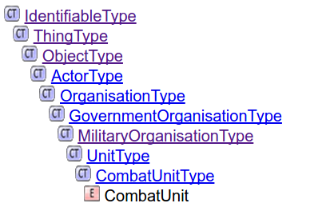

The example reveals that the unit:CombatUnitType is a specialization of unit:UnitType, which is a specialization of organisation:MilitaryOrganisationType, etc. If a provider cannot, or will not, classify an observed organisation as a unit:CombatUnitType, they can fall back to one of the generalizations within the type hierarchy (e.g. unit:UnitType, organisation:OrganisationType, etc.).

For what concerns the extension of existing sets of coded values, the following example shows how it is possible to provide a value not contained in the mobility:LandMobilitycategoryCode:

|  |
| --- |
| <?xml version="1.0" encoding="UTF-8"?>  <unit:MilitaryPoliceUnit  xmlns:xsi="http://www.w3.org/2001/XMLSchema-instance"  xmlns:base="https://mip-interop.org/data/v4.3/Base"  xmlns:concept="https://mip-interop.org/data/v4.3/Concept"  xmlns:ext="https://mip-interop.org/data/v4.3/Extension"  xmlns:mobility="https://mip-interop.org/data/v4.3/BattlespaceConcept/Mobility"  xmlns:prim="https://mip-interop.org/data/v4.3/Primitives"  xmlns:organisation="https://mip-interop.org/data/v4.3/BattlespaceConcept/Object/Actor/Organisation"  xmlns:battlespaceconcept="https://mip-interop.org/data/v4.3/BattlespaceConcept"  xmlns:unit="https://mip-interop.org/data/v4.3/BattlespaceConcept/Object/Actor/Organisation/Unit"  xsi:schemaLocation="https://mip-interop.org/data/v4.3/IES IES.xsd">  <base:ID>cacf04d5-8741-4ee8-a095-d2dc84ac80c1</base:ID>  <concept:ConceptName>IDT</concept:ConceptName>  <battlespaceconcept:BattlespaceConceptIsTypeIndicator>false</battlespaceconcept:BattlespaceConceptIsTypeIndicator>  <battlespaceconcept:BattlespaceConceptMetadata xsi:nil="true"/>  <organisation:OrganisationHasCommandFunctionIndicator>true</organisation:OrganisationHasCommandFunctionIndicator>  <organisation:MilitaryOrganisationServiceCode>CivilService</organisation:MilitaryOrganisationServiceCode>  <unit:UnitEchelon/>  <unit:UnitGeneralMobility xsi:type="mobility:LandMobilityType">  <base:Amplification>  <base:AmplificationLocationText>LandMobilityCategoryCode</base:AmplificationLocationText>  <base:AmplificationText>Other:JetPack</base:AmplificationText>  </base:Amplification>  <mobility:LandMobilityCategoryCode xsi:nil="true"/>  </unit:UnitGeneralMobility></unit:MilitaryPoliceUnit> |

## 8.3 Unknown

The term Unknown is commonly used within the MIP community. The semantics of Unknown indicate that the desired information is not known by the provider.

Indication that a value is unknown by the information provider is exchanged using the syntax described in Amplification (see section 9.10).

## 8.4 Mutable Types

A thing in the battlespace is uniquely identified (see 6.1 Identification). However, our understanding of the thing is allowed to change over time. With respect to the XML instance data this may manifest itself in one of the following ways:

* the type derived ConceptType (e.g. object:ObjectType changes to equipment:EquipmentType) will change over time
* type elements (See 12.1 Instance and Type Behavior), as opposed to instance elements, within the concept:ConceptType will change over time

Such changes are allowed within the MIP4-IES as long as the concept:ConceptType is referring to the same real-world thing. In these cases the identifying attributes of the concept:ConceptType should remain constant.

Example: Initial observation of an Object without further classification

|  |
| --- |
| <?xml version="1.0" encoding="UTF-8"?>  <object:Object  xmlns:base="https://mip-interop.org/data/v4.3/Base"  xmlns:xsi="http://www.w3.org/2001/XMLSchema-instance"  xmlns:concept="https://mip-interop.org/data/v4.3/Concept"  xmlns:battlespaceconcept="https://mip-interop.org/data/v4.3/BattlespaceConcept"  xmlns:object="https://mip-interop.org/data/v4.3/BattlespaceConcept/Object"  xsi:schemaLocation="https://mip-interop.org/data/v4.3/IES IES.xsd">  <base:ID>98a630cb-1c93-4eef-ab3a-c95cd4c7c74f</base:ID>  <concept:ConceptName>OBJ000765</concept:ConceptName>  <battlespaceconcept:BattlespaceConceptMetadata/>  </object:Object> |

Example: Further classification of the object as a vehicle, including a Name change. The old Name is preserved as an AlternateName.

|  |
| --- |
| <?xml version="1.0" encoding="UTF-8"?>  <vehicle:Automobile  xmlns:xsi="http://www.w3.org/2001/XMLSchema-instance"  xmlns:base="https://mip-interop.org/data/v4.3/Base"  xmlns:concept="https://mip-interop.org/data/v4.3/Concept"  xmlns:materiel="https://mip-interop.org/data/v4.3/BattlespaceConcept/Object/Materiel"  xmlns:battlespaceconcept="https://mip-interop.org/data/v4.3/BattlespaceConcept"  xmlns:ext="https://mip-interop.org/data/v4.3/Extension"  xmlns:vehicle="https://mip-interop.org/data/v4.3/BattlespaceConcept/Object/Materiel/Equipment/Vehicle"  xsi:schemaLocation="https://mip-interop.org/data/v4.3/IES IES.xsd">  <base:ID>98a630cb-1c93-4eef-ab3a-c95cd4c7c74f</base:ID>  <concept:ConceptName>Abandoned Vehicle</concept:ConceptName>  <battlespaceconcept:BattlespaceConceptIsTypeIndicator>false</battlespaceconcept:BattlespaceConceptIsTypeIndicator>  <battlespaceconcept:BattlespaceConceptAlternateName>OBJ000765</battlespaceconcept:BattlespaceConceptAlternateName>  <battlespaceconcept:BattlespaceConceptMetadata xsi:nil="true"/>  <materiel:MaterielOperationalStatusCode>NotOperational</materiel:MaterielOperationalStatusCode>  </vehicle:Automobile> |

## 

## 8.5 Alternate Identifier

While the MIP4-IES is expected to be implemented broadly, it is also expected that boundaries exist with other interoperability specifications (e.g. MTF FFI, NVG, etc.). Information traversing specification boundaries suffer from translation or mapping of their identifying attributes. For a one way translation, this is not a big concern. However, in a complex environment, data loops occur and a provider may receive their own data with new identifying attributes. The initial provider will reprocess the old data as new and may subsequently propagate the data. These information loops are undesired as they waste resources and reduce the overall quality of information presented to the user. In extreme cases they cause systems and networks to fail.

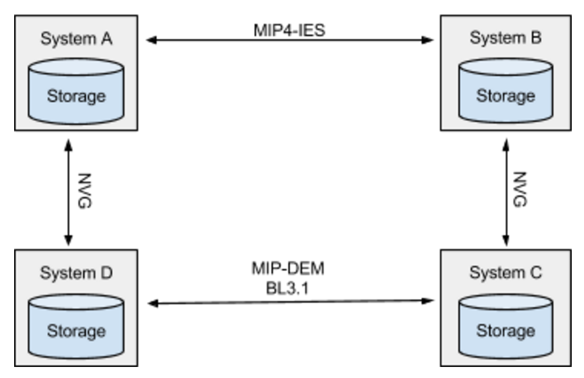

The above simple illustration is fraught with opportunity to create a data loop.

To improve the chances of information traversing specification boundaries remaining identifiable and unambiguous, the MIP4-IES has included the ability to specify AlternateIdentfiers and to associate them with other information exchange standards.

The usage concept is that battlespaceconcept:BattelspaceConceptAlternateIdentifier(s) are created at the boundary between two specifications. The provider and consumer in these instances should document and retain all identifiers and relevant source information. When further propagating the information, the battlespaceconcept:BattelspaceConceptAlternateIdentifier are also propagated.

When preparing information for propagation across a boundary the AlternateIdentfiers should be consulted, and reused, prior to creating a new identifier for the target specification domain. The recipient of information from another specification domain should do the same, review the alternate identifiers to determine if one of them has precedence over the one given.

Example: a MIP4-IES message with AlternateIdentifiers for MIP-DEM BL3.1 and NVG

|  |
| --- |
| <?xml version="1.0" encoding="UTF-8"?>  <vehicle:Automobile  xmlns:xsi="http://www.w3.org/2001/XMLSchema-instance"  xmlns:base="https://mip-interop.org/data/v4.3/Base"  xmlns:concept="https://mip-interop.org/data/v4.3/Concept"  xmlns:materiel="https://mip-interop.org/data/v4.3/BattlespaceConcept/Object/Materiel"  xmlns:battlespaceconcept="https://mip-interop.org/data/v4.3/BattlespaceConcept"  xmlns:vehicle="https://mip-interop.org/data/v4.3/BattlespaceConcept/Object/Materiel/Equipment/Vehicle"  xsi:schemaLocation="https://mip-interop.org/data/v4.3/IES IES.xsd">  <base:ID>4ea911fe-2544-4830-ba70-c69d50fe11b1</base:ID>  <concept:ConceptName>IDT</concept:ConceptName>  <battlespaceconcept:BattlespaceConceptIsTypeIndicator>false</battlespaceconcept:BattlespaceConceptIsTypeIndicator>  <battlespaceconcept:BattlespaceConceptAlternateIdentifier>  <battlespaceconcept:AlternateIdentifierIdentifier>urn:cop:Sty7+qjr5hG7rUYYAafFhg==</battlespaceconcept:AlternateIdentifierIdentifier>  <battlespaceconcept:AlternateIdentifierStandardCode>NVG</battlespaceconcept:AlternateIdentifierStandardCode>  </battlespaceconcept:BattlespaceConceptAlternateIdentifier>  <battlespaceconcept:BattlespaceConceptAlternateIdentifier>  <battlespaceconcept:AlternateIdentifierIdentifier>10903003226000001234</battlespaceconcept:AlternateIdentifierIdentifier>  <battlespaceconcept:AlternateIdentifierStandardCode>MIP31</battlespaceconcept:AlternateIdentifierStandardCode>  </battlespaceconcept:BattlespaceConceptAlternateIdentifier>  <battlespaceconcept:BattlespaceConceptMetadata/>  <materiel:MaterielOperationalStatusCode xsi:nil="true"/>  </vehicle:Automobile> |

## 8.6 Alternate Name

For many reasons, the Name associated with a ConceptType changes or has alternate forms. The MIP4-IES allows for Name to change as desired. However, MIP4-IES also allows for all forms of Name to be retained as AlternateNames and propagated to consumers. The retention and sharing of AlternateNames improves the correlation and fusion activities and supports consistent mapping of the content across boundaries with other specifications (e.g. MIP-DEM Baseline 3.1).

Example: Common and legal name of a person

|  |
| --- |
| <?xml version="1.0" encoding="UTF-8"?>  <person:Person  xmlns:xsi="http://www.w3.org/2001/XMLSchema-instance"  xmlns:base="https://mip-interop.org/data/v4.3/Base"  xmlns:battlespaceconcept="https://mip-interop.org/data/v4.3/BattlespaceConcept"  xmlns:concept="https://mip-interop.org/data/v4.3/Concept"  xmlns:person="https://mip-interop.org/data/v4.3/BattlespaceConcept/Object/Actor/Person"  xsi:schemaLocation="https://mip-interop.org/data/v4.3/IES IES.xsd">  <base:ID>730c9870-ebad-11e6-93c9-471d01a7c586</base:ID>  <concept:ConceptName>Jimmy Neutron</concept:ConceptName>  <battlespaceconcept:BattlespaceConceptIsTypeIndicator>false</battlespaceconcept:BattlespaceConceptIsTypeIndicator>  <battlespaceconcept:BattlespaceConceptAlternateName>James Isaac Neutron</battlespaceconcept:BattlespaceConceptAlternateName>  <battlespaceconcept:BattlespaceConceptMetadata xsi:nil="true"/>  <person:PersonMilitaryStatusCode xsi:nil="true"/>  </person:Person> |

## 8.7 Identifiable References

base:IdentifiableReferenceType(s) are used to create loose coupling between concept:ConceptType(s) and allow them to be exchanged independently of each other while retaining the ability to combine them later when all concept:ConceptType(s) are available or to express circular references.

The base:IdentifiableReferenceType contains the ID of the referenced concept:Concept and the optional contextID of the base:Context containing information on the concept:Concept. If no contextID is provided, this means that the referenced concept:Concept is in the same context as the concept:Concept that includes the reference. Note that a reference may point to a concept:Concept within the same xml document or it may be needed to resolve it in the local system or by retrieving it from the provider. The Provider shall be able to also provide the referenced concept:Concept.

base:ComplexType provides the consumer with additional information before retrieving the referenced concept:ConceptType. The type of the referenced concept:Concept is encoded as an optional semantic id in the app:SemanticID element. If the consuming system does not understand or process that type of concept:ConceptType, the unnecessary retrieval can be avoided.

## 8.8 Boundaries

A boundary between Organisations is represented by controlfeature:OrganisationBoundary. The echelon level associated with a boundary is indicated by the object:ArmyEchelonCode element and the labels to the left and right of the boundary are specified by cfeat:LeftOrganisationName and cfeat:RightOrganisationName elements. The left and right sides of the boundary are determined when progressing from the first point to subsequent points of line indicating the boundary position.

Example: Boundary between two organisations

|  |
| --- |
| <?xml version="1.0" encoding="UTF-8"?>  <controlfeature:OrganisationBoundary  xmlns:xsi="http://www.w3.org/2001/XMLSchema-instance"  xmlns:base="https://mip-interop.org/data/v4.3/Base"  xmlns:unit="https://mip-interop.org/data/v4.3/BattlespaceConcept/Object/Actor/Organisation/Unit"  xmlns:battlespaceconcept="https://mip-interop.org/data/v4.3/BattlespaceConcept"  xmlns:object="https://mip-interop.org/data/v4.3/BattlespaceConcept/Object"  xmlns:concept="https://mip-interop.org/data/v4.3/Concept"  xmlns:location="https://mip-interop.org/data/v4.3/BattlespaceConcept/Location"  xmlns:controlfeature="https://mip-interop.org/data/v4.3/BattlespaceConcept/Object/Feature/ControlFeature"  xsi:schemaLocation="https://mip-interop.org/data/v4.3/IES IES.xsd">  <base:ID>5767eff8-9120-42b1-8a19-8ad32886c601</base:ID>  <concept:ConceptName>Boundary 1</concept:ConceptName>  <battlespaceconcept:BattlespaceConceptIsTypeIndicator>false</battlespaceconcept:BattlespaceConceptIsTypeIndicator>  <battlespaceconcept:BattlespaceConceptGeographicLocation xsi:type="location:LocationType">  <location:LocationGeometry xsi:type="location:LineType">  <location:LinePoint xsi:type="location:AbsolutePointType">  <location:AbsolutePointLatitudeCoordinate>  <location:LatitudeCoordinateCoordinate>34.526982</location:LatitudeCoordinateCoordinate>  </location:AbsolutePointLatitudeCoordinate>  <location:AbsolutePointLongitudeCoordinate>  <location:LongitudeCoordinateCoordinate>69.154783</location:LongitudeCoordinateCoordinate>  </location:AbsolutePointLongitudeCoordinate>  </location:LinePoint>  <location:LinePoint xsi:type="location:AbsolutePointType">  <location:AbsolutePointLatitudeCoordinate>  <location:LatitudeCoordinateCoordinate>34.502778</location:LatitudeCoordinateCoordinate>  </location:AbsolutePointLatitudeCoordinate>  <location:AbsolutePointLongitudeCoordinate>  <location:LongitudeCoordinateCoordinate>69.110924</location:LongitudeCoordinateCoordinate>  </location:AbsolutePointLongitudeCoordinate>  </location:LinePoint>  <location:LinePoint xsi:type="location:AbsolutePointType">  <location:AbsolutePointLatitudeCoordinate>  <location:LatitudeCoordinateCoordinate>34.489216</location:LatitudeCoordinateCoordinate>  </location:AbsolutePointLatitudeCoordinate>  <location:AbsolutePointLongitudeCoordinate>  <location:LongitudeCoordinateCoordinate>69.078823</location:LongitudeCoordinateCoordinate>  </location:AbsolutePointLongitudeCoordinate>  </location:LinePoint>  </location:LocationGeometry>  </battlespaceconcept:BattlespaceConceptGeographicLocation>  <battlespaceconcept:BattlespaceConceptHostilityCode>AssumedFriend</battlespaceconcept:BattlespaceConceptHostilityCode>  <battlespaceconcept:BattlespaceConceptMetadata/>  <controlfeature:ControlFeatureEchelon xsi:type="object:ArmyEchelonType">  <object:ArmyEchelonCode>Brigade</object:ArmyEchelonCode>  </controlfeature:ControlFeatureEchelon>  <controlfeature:OrganisationBoundaryLeftOrganisationName>52(DEU)Bde</controlfeature:OrganisationBoundaryLeftOrganisationName>  <controlfeature:OrganisationBoundaryRightOrganisationName>6(USA)</controlfeature:OrganisationBoundaryRightOrganisationName>  </controlfeature:OrganisationBoundary> |
|  |

## 8.9 Metadata

### 8.9.1 Actor Roles

The MIP Information Model defines roles for some objects. For example, the MIP Information Model defines the role Reporter for the Actor. This means that any Actor can report something.

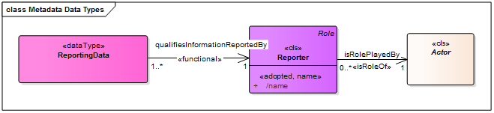

The name of the Actor must be provided when specifying an Actor role. An optional ActorReference (See 12.7 Identifiable References) may also be provided allowing the consumer to retrieve the full details of the Actor, if desired.

The current Actor roles are:

* conceptmetadata:Observer
* conceptmetadata:Reporter

So in the case of a self-reporting Unit, the ActorReference should point to the Identifier of the Unit itself.

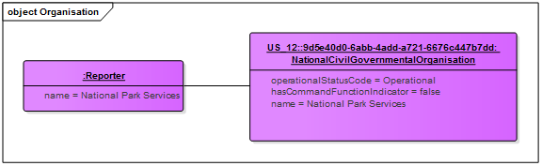

Example: Reporter reference for a self-reporting Actor

|  |
| --- |
| <?xml version="1.0" encoding="UTF-8"?>  <organisation:NationalCivilGovernmentalOrganisation  xmlns:xsi="http://www.w3.org/2001/XMLSchema-instance"  xmlns:base="https://mip-interop.org/data/v4.3/Base"  xmlns:app="https://mip-interop.org/data/v4.3/AppInfo"  xmlns:battlespaceconcept="https://mip-interop.org/data/v4.3/BattlespaceConcept"  xmlns:concept="https://mip-interop.org/data/v4.3/Concept"  xmlns:conceptmetadata="https://mip-interop.org/data/v4.3/Concept/Metadata"  xmlns:organisation="https://mip-interop.org/data/v4.3/BattlespaceConcept/Object/Actor/Organisation"  xsi:schemaLocation="https://mip-interop.org/data/v4.3/IES IES.xsd">  <base:ID>77a6e416-ebb8-11e6-b263-8a2701a7c586</base:ID>  <concept:ConceptName>US_12</concept:ConceptName>  <battlespaceconcept:BattlespaceConceptIsTypeIndicator>false</battlespaceconcept:BattlespaceConceptIsTypeIndicator>  <battlespaceconcept:BattlespaceConceptMetadata>  <conceptmetadata:ConceptMetadataReportingData>  <conceptmetadata:ReportingDataCategoryCode>Reported</conceptmetadata:ReportingDataCategoryCode>  <conceptmetadata:ReportingDataObservationDateTime>2020-04-05T16:53:00Z</conceptmetadata:ReportingDataObservationDateTime>  <conceptmetadata:ReportingDataReportingDateTime>2020-04-05T17:05:00Z</conceptmetadata:ReportingDataReportingDateTime>  <conceptmetadata:ReportingDataReporter>  <conceptmetadata:ReporterName>National Park Services</conceptmetadata:ReporterName>  <conceptmetadata:ReporterActorReference>  <base:ID>77a6e416-ebb8-11e6-b263-8a2701a7c586</base:ID>  <app:SemanticID>MIM:03924031-0e07-4030-a39c-52f0fa816e69</app:SemanticID>  </conceptmetadata:ReporterActorReference>  </conceptmetadata:ReportingDataReporter>  </conceptmetadata:ConceptMetadataReportingData>  </battlespaceconcept:BattlespaceConceptMetadata>  <organisation:OrganisationHasCommandFunctionIndicator>true</organisation:OrganisationHasCommandFunctionIndicator>  </organisation:NationalCivilGovernmentalOrganisation> |

### 8.9.2 ValidityTimePeriod

It is important to understand that ValidityTimePeriod is only an operational concept and is not used to trigger e.g. the removal of information.

### 8.9.3 ActiveTimePeriod

The active time period is used to display the corresponding W and W1 fields of APP6.

In the example depicted below, concerning the Unspecified Control Point, an example with W=080700ZMAY08 and W1=120700ZMAY08.

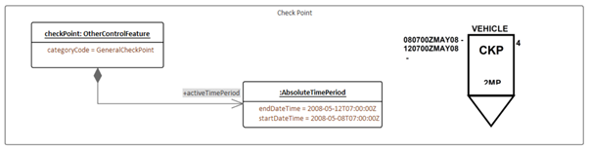

Another example below, using Air Corridor, where the terms 'DTG Start' and 'DTG End' indicate the Date-Time Group for start and end of activity.

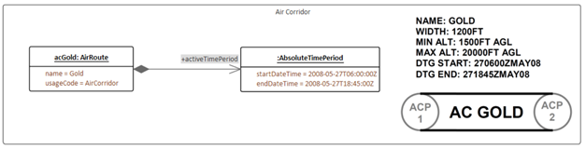

The third and final example (No Fire Line) depicts that when four fields seem to be indicated, in fact there are only two fields (W and W1) even though they are depicted both at the beginning and at the end of the drawn line.

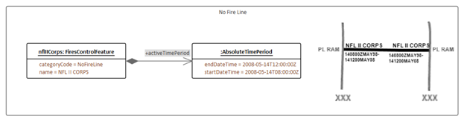

## 8.10 Amplification

This section provides some examples of the intended usage of Amplification (see section 6.7).

The following example shows how to handle the case where a mandatory element, like concept:ConceptName is not available, but the incomplete concept:Concept must be shared.

|  |
| --- |
| <person:Person  xmlns:xsi="http://www.w3.org/2001/XMLSchema-instance"  xmlns:base="https://mip-interop.org/data/v4.3/Base"  xmlns:person="https://mip-interop.org/data/v4.3/BattlespaceConcept/Object/Actor/Person"  xmlns:concept="https://mip-interop.org/data/v4.3/Concept"  xmlns:battlespaceconcept="https://mip-interop.org/data/v4.3/BattlespaceConcept"  xsi:schemaLocation="https://mip-interop.org/data/v4.3/IES IES.xsd">  <base:Amplification>  <base:AmplificationLocationText>ConceptName</base:AmplificationLocationText>  <base:AmplificationText>Unknown</base:AmplificationText>  </base:Amplification>  <base:ID>692bf0d5-742f-4d04-a85d-13fc8ca364af</base:ID>  <concept:ConceptName xsi:nil="true"/>  <battlespaceconcept:BattlespaceConceptMetadata/>  <person:PersonMilitaryStatusCode>Civilian</person:PersonMilitaryStatusCode>  </person:Person> |

The following example shows how to handle the case where a consumer wants to express a code which is not available in the MIP4IES schema:

|  |
| --- |
| <person:Person  xmlns:xsi="http://www.w3.org/2001/XMLSchema-instance"  xmlns:base="https://mip-interop.org/data/v4.3/Base"  xmlns:person="https://mip-interop.org/data/v4.3/BattlespaceConcept/Object/Actor/Person"  xmlns:concept="https://mip-interop.org/data/v4.3/Concept"  xmlns:battlespaceconcept="https://mip-interop.org/data/v4.3/BattlespaceConcept"  xsi:schemaLocation="https://mip-interop.org/data/v4.3/IES IES.xsd">  <base:Amplification>  <base:AmplificationLocationText>PersonCharacteristicCode</base:AmplificationLocationText>  <base:AmplificationText>Other:Special Contractor</base:AmplificationText>  </base:Amplification>  <base:ID>692bf0d5-742f-4d04-a85d-13fc8ca364af</base:ID>  <concept:ConceptName>John Smith</concept:ConceptName>  <battlespaceconcept:BattlespaceConceptMetadata/>  <person:PersonCharacteristicCode>Contractor</person:PersonCharacteristicCode>  <person:PersonMilitaryStatusCode>Civilian</person:PersonMilitaryStatusCode>  </person:Person> |

## 8.11 Airspace Control Means

Airspace Control Means (ACM) are a subset of Control Features (controlfeature:ControlFeatureType) that reserves airspace for airspace users, restricts the action of airspace users, controls the actions of airspace users, and/or requires airspace users to accomplish specific actions (see the diagram Annex A.3).

Technically, an ACM is represented as a ControlFeature for which the element ‘airspaceControlMeans’ is specified. For instance, it is possible to define a ControlFeature of type ‘KillZone’ that plays the role of an AirspaceControlMeans of type ‘AirDefenceArea’. When showing a ControlFeature on a map, element ‘airspaceControlMeans’ must be taken into account, since ACMs may be represented differently from the underlying ControlFeature. It is important to note that symbology standards (e.g. APP6 or MIL-STD 2525) may have different representations for the ControlFeature and its AirspaceControlMeans usage (e.g. LandingZone and RestrictedOperationsZone) and thus great care has to be taken to preserve the operational meaning.

There are additional consistency rules to be respected in order to get an operationally correct ACM. These rules translate in the XML instance of a ControlFeatureType having the AirspaceControlMeans element present and of an AirspaceControlMeansType determined by the table below.

|  |  |  |
| --- | --- | --- |
| **Concept** | **CategoryCode or usageCode** | **Allowed AirspaceControlMeansType** |
| AirControlFeature | TransitCorridor, SafeLane | AirCorridorOrRoute |
| AirRoute | AirRoute, StandardUseArmyAircraftFlightRoute, TemporaryMinimumRiskRoute, TransitRoute, SpecialCorridor, MinimumRiskRoute | AirCorridorOrRoute |
| AirControlFeature | AirDefenceIdentificationZone, BufferZone, BaseDefenceZone, WeaponsFreeZone, HighDensityAirspaceControlZone, LandMissileEngagementZone, LandFighterEngagementZone, JointEngagementZone, KillZone, HighAltitudeMissileEngagementZone, ShortRangeAirDefenceEngagementZone, LowAltitudeMissileEngagementZone | AirDefenceArea |
| C2ControlFeature | JointOperationsArea | AirDefenceArea |
| AirControlFeature | CarrierControlZone, CoordinatedAirDefenceArea, CrossoverZone, MaritimeFighterEngagementZone, MaritimeMissileEngagementZone, SafetySector, ShipControlZone, MissileArc, IdentificationSafetyRange, AirDefenceActionArea, FalconRadialsArea, FireUmbrella, PositiveIdentificationRadarAdvisoryZone | AirDefenceOperationsArea |
| AirRoute | ApproachCorridor | AirDefenceOperationsArea |
| OtherControlFeature | AmphibiousDefenceZone, AmphibiousObjectiveArea | AirDefenceOperationsArea |
| AirControlFeature | ClassAAirspace, ClassBAirspace, ClassCAirspace, ClassDAirspace, ClassEAirspace, ClassFAirspace, ClassGAirspace, FlightInformationRegion, TerminalControlArea, DangerArea, ProhibitedArea, RestrictedArea, TerminalRadarServiceArea, WarningArea, ControlZone, ControlArea, ReducedCoordinationAirspace, TemporarySegregatedArea | AirTrafficControlAirspace |
| AirRoute | AdvisoryRoute, Airway, AirTrafficServicesRoute, AreaNavigationRoute, ConditionalRoute | AirTrafficControlAirspace |
| C2ControlFeature | CrossBorderArea | AirTrafficControlAirspace |
| AirControlFeature | AltitudeReservationArea, CoordinationLevel, RestrictedFireCorridor, TraverseLevel, IdentificationFriendFoeSwitchOnLine, IdentificationFriendFoeSwitchOffLine, AirspaceBoundary, AirspaceCoordinationArea | Procedural |
| C2ControlFeature | DeepBattleSynchronisationLine, ForwardLineOfTroops, GroundAreaOfResponsibility, SafeAreaForEvasion | Procedural |
| OtherControlFeature | ForwardEdgeOfTheBattleArea, MinimumRiskLevel | Procedural |
| FiresControlFeature | CoordinationFireLine, FireSupportCoordinationLine, FreeFireArea, RestrictedFireArea, RestrictedFireLine | Procedural |
| AirControlFeature | AirControlPoint, AirContactPoint, EntryOrExitGate, HandOverGate, MarshallingGate, MarshalPoint, IdentificationSafetyPoint | AirspaceControlReferencePoint |
| OtherControlFeature | Bullseye, SearchAndRescuePoint | AirspaceControlReferencePoint |
| AirControlFeature | AirToAirRefuellingArea, AirborneEarlyWarningArea, ElectronicCombatArea, LandingZone, AirborneCommandAndControlArea, DropZone, ReconnaissanceArea, UnmannedAerialVehicleAirspace, SpecialElectronicMissionArea, SpecialOperationsForcesAirspace, CloseAirSupportHoldingArea, CombatAirPatrolArea, RestrictedOperationsArea | RestrictedOperationsZone |
| OtherControlFeature | TrainingArea | RestrictedOperationsZone |
| C2ControlFeature | PickupZone | RestrictedOperationsZone |
| AirControlFeature | AirspaceControlArea, AirspaceControlSubareaOrSector, ForceAirCoordinationArea, NoFlyZone, SurfaceToSurfaceMissileSystemArea, AlertArea, MilitaryOperationsArea, KillBox | SpecialUseAirspace |
| SustainmentControlFeature | ForwardArmingAndRefuellingPoint | SpecialUseAirspace |
| FiresControlFeature | NoFireArea | SpecialUseAirspace |
| C2ControlFeature | ForwardOperatingLocation | SpecialUseAirspace |

E.g. if the ControlFeature is a BaseDefenceZoneType (BDZ) then the type of airspaceControlMeans should equal AirDefenceAreaType (ADA), if present. Note that a provider might send other control features with ACM usages as well.

Example of an ACM requiring a UsageCode and detailed type

|  |
| --- |
| <?xml version="1.0" encoding="UTF-8"?>  <controlfeature:AirControlFeature  xmlns:xsi="http://www.w3.org/2001/XMLSchema-instance"  xmlns:battlespaceconcept="https://mip-interop.org/data/v4.3/BattlespaceConcept"  xmlns:base="https://mip-interop.org/data/v4.3/Base"  xmlns:concept="https://mip-interop.org/data/v4.3/Concept"  xmlns:controlfeature="https://mip-interop.org/data/v4.3/BattlespaceConcept/Object/Feature/ControlFeature"  xsi:schemaLocation="https://mip-interop.org/data/v4.3/IES IES.xsd">  <base:ID>aba2bf06-bc32-40bd-bd94-7ada4ee6ee3a</base:ID>  <concept:ConceptName>BDZ</concept:ConceptName>  <battlespaceconcept:BattlespaceConceptIsTypeIndicator>false</battlespaceconcept:BattlespaceConceptIsTypeIndicator>  <battlespaceconcept:BattlespaceConceptMetadata/>  <controlfeature:ControlFeatureAirspaceControlMeans xsi:type="controlfeature:AirspaceControlMeansType">  <controlfeature:AirspaceControlMeansCategoryCode>AirDefenceArea</controlfeature:AirspaceControlMeansCategoryCode>  <controlfeature:AirspaceControlMeansTransitInstructionText>ADA</controlfeature:AirspaceControlMeansTransitInstructionText>  </controlfeature:ControlFeatureAirspaceControlMeans>  <controlfeature:AirControlFeatureCategoryCode>BaseDefenceZone</controlfeature:AirControlFeatureCategoryCode>  </controlfeature:AirControlFeature> |

Example of an ACM usageonly

|  |
| --- |
| <?xml version="1.0" encoding="UTF-8"?>  <controlfeature:ControlFeature  xmlns:xsi="http://www.w3.org/2001/XMLSchema-instance"  xmlns:battlespaceconcept="https://mip-interop.org/data/v4.3/BattlespaceConcept"  xmlns:base="https://mip-interop.org/data/v4.3/Base"  xmlns:concept="https://mip-interop.org/data/v4.3/Concept"  xmlns:controlfeature="https://mip-interop.org/data/v4.3/BattlespaceConcept/Object/Feature/ControlFeature"  xsi:schemaLocation="https://mip-interop.org/data/v4.3/IES IES.xsd">  <base:ID>94d97734-cb72-48aa-839e-09c008d62344</base:ID>  <concept:ConceptName>ROZ</concept:ConceptName>  <battlespaceconcept:BattlespaceConceptMetadata/>  <controlfeature:ControlFeatureAirspaceControlMeans xsi:type="controlfeature:AirspaceControlMeansType">  <controlfeature:AirspaceControlMeansCategoryCode>RestrictedOperationsZone</controlfeature:AirspaceControlMeansCategoryCode>  </controlfeature:ControlFeatureAirspaceControlMeans>  </controlfeature:ControlFeature> |

## 8.12 Source

Source refers to the originator of an Identifiable, either system or actor, as determined by a specific implementation through the **staffconceptmetadata:Originator** of the StaffConcept the information is part of. A specific system may receive Data from multiple source systems in different contexts. When an Identifiable is provided by a Source, the Identifiable is considered immutable by the recipient. Only the provider of the information (i.e. the system(s) “owning” the context) can update that information on the Identifiable. However, the recipient can augment the information and re-distribute the Identifiable in their own context. The **base:ID** should remain the same to ensure that the new Identifiable is recognizable as another interpretation of the one previously reported by another Source.

Example of avoiding overwriting:

There is a possibility that both systems use different **concept:ConceptNames** and the intention is to prevent one system from overwriting the **ConceptName** in the other system. Since the identifiables are published with different **ContextIdentifiers** (i.e. in different Overlays), they do not overwrite each other; since they use the same ID, receiver systems can still relate the different Identifiables.

The following example demonstrates where System_2 has different **concept:ConceptName** associated with the **controlfeature:ObjectiveArea** than System_1.

Source: System_1

|  |
| --- |
| <?xml version="1.0" encoding="UTF-8"?>  <base:Context  xmlns:base="https://mip-interop.org/data/v4.3/Base"  xmlns:xsi="http://www.w3.org/2001/XMLSchema-instance"  xmlns:concept="https://mip-interop.org/data/v4.3/Concept"  xmlns:battlespaceconcept="https://mip-interop.org/data/v4.3/BattlespaceConcept"  xmlns:controlfeature="https://mip-interop.org/data/v4.3/BattlespaceConcept/Object/Feature/ControlFeature"  xsi:schemaLocation="https://mip-interop.org/data/v4.3/IES IES.xsd">  <base:ContextIdentifier>/Overlay/OVERLAYID1/Content</base:ContextIdentifier>  <base:Data xsi:type="controlfeature:C2ControlFeatureType">  <base:ID>5767eff8-9120-42b1-8a19-8ad32886c601</base:ID>  <concept:ConceptName>OBJ BRAV</concept:ConceptName>  <battlespaceconcept:BattlespaceConceptIsTypeIndicator>false</battlespaceconcept:BattlespaceConceptIsTypeIndicator>  <battlespaceconcept:BattlespaceConceptMetadata/>  <controlfeature:C2ControlFeatureCategoryCode>ObjectiveArea</controlfeature:C2ControlFeatureCategoryCode>  </base:Data>  <base:ContextLastModificationDateTime>2020-11-05T16:53:00Z</base:ContextLastModificationDateTime>  </base:Context> |

Source: System_2

|  |
| --- |
| <?xml version="1.0" encoding="UTF-8"?>  <base:Context  xmlns:base="https://mip-interop.org/data/v4.3/Base"  xmlns:xsi="http://www.w3.org/2001/XMLSchema-instance"  xmlns:concept="https://mip-interop.org/data/v4.3/Concept"  xmlns:battlespaceconcept="https://mip-interop.org/data/v4.3/BattlespaceConcept"  xmlns:controlfeature="https://mip-interop.org/data/v4.3/BattlespaceConcept/Object/Feature/ControlFeature"  xsi:schemaLocation="https://mip-interop.org/data/v4.3/IES IES.xsd">  <base:ContextIdentifier>/Overlay/other-overlayID-system2/Content</base:ContextIdentifier>  <base:Data xsi:type="controlfeature:C2ControlFeatureType">  <base:ID>5767eff8-9120-42b1-8a19-8ad32886c601</base:ID>  <concept:ConceptName>OBJ BRAVO</concept:ConceptName>  <battlespaceconcept:BattlespaceConceptIsTypeIndicator>false</battlespaceconcept:BattlespaceConceptIsTypeIndicator>  <battlespaceconcept:BattlespaceConceptMetadata/>  <controlfeature:C2ControlFeatureCategoryCode>ObjectiveArea</controlfeature:C2ControlFeatureCategoryCode>  </base:Data>  <base:ContextLastModificationDateTime>2020-11-05T16:53:00Z</base:ContextLastModificationDateTime>  </base:Context> |

## 8.13 Use of Affiliation on Person

Persons do have some Attributes which can be used to describe e.g. the ethnicity or nationality of the Person and also has the generic Affiliation construct which can be used to describe other, more generic, affiliations. Here is an example showing a Person of Kurdish ethnicity with two nationalities (German and Turkish) having an Affiliation (e.g. through personal or professional ties) with the United States of America and the group of African Americans.

MIM Example:

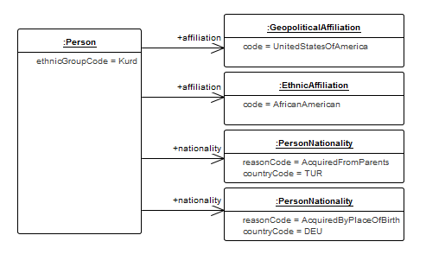

XML Example:

|  |
| --- |
| <?xml version="1.0" encoding="UTF-8"?>  <person:Person  xmlns:base="https://mip-interop.org/data/v4.3/Base"  xmlns:xsi="http://www.w3.org/2001/XMLSchema-instance"  xmlns:concept="https://mip-interop.org/data/v4.3/Concept"  xmlns:affiliation="https://mip-interop.org/data/v4.3/BattlespaceConcept/Affiliation"  xmlns:battlespaceconcept="https://mip-interop.org/data/v4.3/BattlespaceConcept"  xmlns:object="https://mip-interop.org/data/v4.3/BattlespaceConcept/Object"  xmlns:person="https://mip-interop.org/data/v4.3/BattlespaceConcept/Object/Actor/Person"  xsi:schemaLocation="https://mip-interop.org/data/v4.3/IES IES.xsd">  <base:ID>5767eff8-9120-42b1-8a19-8ad32886c601</base:ID>  <concept:ConceptName>Name</concept:ConceptName>  <battlespaceconcept:BattlespaceConceptIsTypeIndicator>true</battlespaceconcept:BattlespaceConceptIsTypeIndicator>  <battlespaceconcept:BattlespaceConceptMetadata/>  <object:ObjectAffiliation xsi:type="affiliation:GeopoliticalAffiliationType">  <affiliation:GeopoliticalAffiliationCode>UnitedStatesOfAmerica</affiliation:GeopoliticalAffiliationCode>  </object:ObjectAffiliation>  <object:ObjectAffiliation xsi:type="affiliation:EthnicAffiliationType">  <affiliation:EthnicAffiliationCode>AfricanAmerican</affiliation:EthnicAffiliationCode>  </object:ObjectAffiliation>  <person:PersonEthnicGroupCode>Kurd</person:PersonEthnicGroupCode>  <person:PersonMilitaryStatusCode>Civilian</person:PersonMilitaryStatusCode>  <person:PersonNationality>  <person:PersonNationalityCountryCode>TUR</person:PersonNationalityCountryCode>  <person:PersonNationalityReasonCode>AcquiredFromParents</person:PersonNationalityReasonCode>  </person:PersonNationality>  <person:PersonNationality>  <person:PersonNationalityCountryCode>DEU</person:PersonNationalityCountryCode>  <person:PersonNationalityReasonCode>AcquiredByPlaceOfBirth</person:PersonNationalityReasonCode>  </person:PersonNationality>  </person:Person> |

## 8.14 Extension

The Extension concept allows for the encoding of additional data using well defined semantics.

Example: Adding documentation using xsd semantics as an extension

|  |
| --- |
| <?xml version="1.0" encoding="UTF-8"?>  <ext:Extension  xmlns:xsi="http://www.w3.org/2001/XMLSchema-instance"  xmlns:xsd="http://www.w3.org/2001/XMLSchema"  xmlns:ext="https://mip-interop.org/data/v4.3/Extension"  xsi:schemaLocation="https://mip-interop.org/data/v4.3/IES IES.xsd"  ext:mustUnderstandIndicator="true">  <xsd:documentation>Equipment that is designed to operate on land routes (other than rail) with a primary role of transporting personnel, equipment or supplies.</xsd:documentation>  </ext:Extension> |

### 

### 8.14.1 mustUnderstandIndicator

The ext:ExtensionType contains an attribute, ext:mustUnderstandIndicator, to specify whether the sub-elements of ext:ExtensionType must or may be processed. When ext:mustUnderstandIndicator is set to false, the sub-elements may be processed at the discretion of the consumer.

Example: ext:mustUnderstandIndicator is false

|  |
| --- |
| <?xml version="1.0" encoding="UTF-8"?>  <ext:Extension  xmlns:xsi="http://www.w3.org/2001/XMLSchema-instance"  xmlns:xsd="http://www.w3.org/2001/XMLSchema"  xmlns:ext="https://mip-interop.org/data/v4.3/Extension"  xsi:schemaLocation="https://mip-interop.org/data/v4.3/IES IES.xsd"  ext:mustUnderstandIndicator="false">  <xsd:documentation>Equipment that is designed to operate on land routes (other than rail) with a primary role of transporting personnel, equipment or supplies.</xsd:documentation>  </ext:Extension> |

When ext:mustUnderstandIndicator is set to true, the sub-elements must be processed by the consumer. If the consumer is unable to process the sub-elements, either automatically or manually, the entire concept:Concept should be discarded to avoid misinterpretation of its content.

Example: ext:mustUnderstandIndicator is true

|  |
| --- |
| <?xml version="1.0" encoding="UTF-8"?>  <facility:Airfield  xmlns:base="https://mip-interop.org/data/v4.3/Base"  xmlns:xsi="http://www.w3.org/2001/XMLSchema-instance"  xmlns:concept="https://mip-interop.org/data/v4.3/Concept"  xmlns:ext="https://mip-interop.org/data/v4.3/Extension"  xmlns:battlespaceconcept="https://mip-interop.org/data/v4.3/BattlespaceConcept"  xmlns:facility="https://mip-interop.org/data/v4.3/BattlespaceConcept/Object/Facility"  xsi:schemaLocation="https://mip-interop.org/data/v4.3/IES IES.xsd">  <ext:Extension ext:mustUnderstandIndicator="true" xmlns:example="http://example.com">  <example:MandatoryExtension>An extension that must be understood</example:MandatoryExtension>  </ext:Extension>  <ext:Extension ext:mustUnderstandIndicator="false" xmlns:example="http://example.com">  <example:OptionalExtension>An extension that does not have to be understood</example:OptionalExtension>  </ext:Extension>  <base:ID>5767eff8-9120-42b1-8a19-8ad32886c601</base:ID>  <concept:ConceptName>Airport</concept:ConceptName>  <battlespaceconcept:BattlespaceConceptIsTypeIndicator>true</battlespaceconcept:BattlespaceConceptIsTypeIndicator>  <battlespaceconcept:BattlespaceConceptMetadata/>  <facility:FacilityOperationalStatusCode>Operational</facility:FacilityOperationalStatusCode>  </facility:Airfield> |

The extension structure allows for the encoding of multiple extensions in a single extension element or multiple extension elements. Care should be taken to separate optional extensions from mandatory extensions. When combined into a single extension element, the optional extensions become mandatory and will prevent some consumers from processing the concept:Concept, even though all the mandatory extensions are understood.

Example, unexpected Extension usage:

|  |
| --- |
| <?xml version="1.0" encoding="UTF-8"?>  <facility:Airfield  xmlns:base="https://mip-interop.org/data/v4.3/Base"  xmlns:xsi="http://www.w3.org/2001/XMLSchema-instance"  xmlns:concept="https://mip-interop.org/data/v4.3/Concept"  xmlns:ext="https://mip-interop.org/data/v4.3/Extension"  xmlns:battlespaceconcept="https://mip-interop.org/data/v4.3/BattlespaceConcept"  xmlns:facility="https://mip-interop.org/data/v4.3/BattlespaceConcept/Object/Facility"  xsi:schemaLocation="https://mip-interop.org/data/v4.3/IES IES.xsd">  <ext:Extension ext:mustUnderstandIndicator="true">  <ext:Extension ext:mustUnderstandIndicator="false"/>  </ext:Extension>  <base:ID>5767eff8-9120-42b1-8a19-8ad32886c601</base:ID>  <concept:ConceptName>Airport</concept:ConceptName>  <battlespaceconcept:BattlespaceConceptIsTypeIndicator>true</battlespaceconcept:BattlespaceConceptIsTypeIndicator>  <battlespaceconcept:BattlespaceConceptMetadata/>  <facility:FacilityOperationalStatusCode>Operational</facility:FacilityOperationalStatusCode>  </facility:Airfield> |

## 

## 8.15 Overlay

The following example provides situational information which is required to be exchanged.

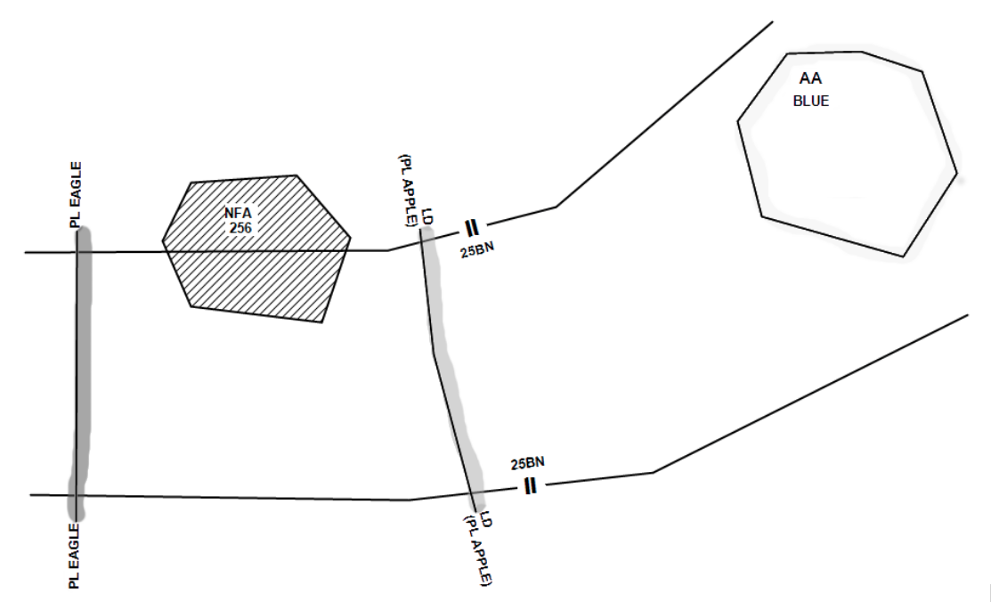

The situational information is encoded as a set of Overlays for exchange (see the diagram in Annex A.4). The following diagram shows the distribution of the situational information across the top level Overlay (Situational Information) and four sub-Overlays.

### 

The four sub-Overlays divide the situational information into multiple groupings. A staffconceptoverlay:OverlayContent is used to assign an individual overlay content in an Overlay.

This XML example represents the diagram from above:

|  |
| --- |
| <?xml version="1.0" encoding="UTF-8"?>  <staffconceptoverlay:Overlay  xmlns:base="https://mip-interop.org/data/v4.3/Base"  xmlns:xsi="http://www.w3.org/2001/XMLSchema-instance"  xmlns:concept="https://mip-interop.org/data/v4.3/Concept"  xmlns:staffconcept="https://mip-interop.org/data/v4.3/StaffConcept"  xmlns:object="https://mip-interop.org/data/v4.3/BattlespaceConcept/Object"  xmlns:conceptmetadata="https://mip-interop.org/data/v4.3/Concept/Metadata"  xmlns:battlespaceconcept="https://mip-interop.org/data/v4.3/BattlespaceConcept"  xmlns:battlespaceconceptmetadata1="https://mip-interop.org/data/v4.3/BattlespaceConcept/Metadata"  xmlns:staffconceptoverlay="https://mip-interop.org/data/v4.3/StaffConcept/Overlay"  xmlns:staffconceptmetadata="https://mip-interop.org/data/v4.3/StaffConcept/Metadata"  xmlns:unit="https://mip-interop.org/data/v4.3/BattlespaceConcept/Object/Actor/Organisation/Unit"  xmlns:controlfeature="https://mip-interop.org/data/v4.3/BattlespaceConcept/Object/Feature/ControlFeature"  xmlns:organisation="https://mip-interop.org/data/v4.3/BattlespaceConcept/Object/Actor/Organisation"  xsi:schemaLocation="https://mip-interop.org/data/v4.3/IES IES.xsd">  <base:ID>eb82f3db-7185-4d17-b078-84fc5abdffb2</base:ID>  <concept:ConceptName>Overlay 1</concept:ConceptName>  <staffconcept:StaffConceptMetadata>  <staffconceptmetadata:StaffConceptMetadataOriginator>  <conceptmetadata:OriginatorName>Originator</conceptmetadata:OriginatorName>  </staffconceptmetadata:StaffConceptMetadataOriginator>  </staffconcept:StaffConceptMetadata>  <!-- Boundary -->  <staffconceptoverlay:OverlayContent xsi:type="controlfeature:OrganisationBoundaryType">  <base:ID>eb82f3db-7185-4d17-b078-84fc5abdffb2</base:ID>  <concept:ConceptName>Boundary</concept:ConceptName>  <battlespaceconcept:BattlespaceConceptMetadata></battlespaceconcept:BattlespaceConceptMetadata>  <controlfeature:OrganisationBoundaryLeftOrganisationName>Boundary</controlfeature:OrganisationBoundaryLeftOrganisationName>  </staffconceptoverlay:OverlayContent>  <!-- Assembly Area -->  <staffconceptoverlay:OverlayContent xsi:type="controlfeature:ControlFeatureType">  <base:ID>eb82f3db-7185-4d17-b078-84fc5abdffb2</base:ID>  <concept:ConceptName>Assembly Area</concept:ConceptName>  <battlespaceconcept:BattlespaceConceptMetadata></battlespaceconcept:BattlespaceConceptMetadata>  <controlfeature:ControlFeatureSubjectIntersectingControlFeature xsi:type="controlfeature:C2ControlFeatureType">  <base:ID>eb82f3db-7185-4d17-b078-84fc5abdffb2</base:ID>  <concept:ConceptName>GeneralAssemblyArea</concept:ConceptName>  <battlespaceconcept:BattlespaceConceptMetadata></battlespaceconcept:BattlespaceConceptMetadata>  <controlfeature:C2ControlFeatureCategoryCode>GeneralAssemblyArea</controlfeature:C2ControlFeatureCategoryCode>  </controlfeature:ControlFeatureSubjectIntersectingControlFeature>  </staffconceptoverlay:OverlayContent>  <!-- Lines of Departure -->  <staffconceptoverlay:OverlayContent xsi:type="controlfeature:ControlFeatureType">  <base:ID>eb82f3db-7185-4d17-b078-84fc5abdffb2</base:ID>  <concept:ConceptName>ControlFeature</concept:ConceptName>  <battlespaceconcept:BattlespaceConceptMetadata></battlespaceconcept:BattlespaceConceptMetadata>  <controlfeature:ControlFeatureSubjectIntersectingControlFeature xsi:type="controlfeature:C2ControlFeatureType">  <base:ID>eb82f3db-7185-4d17-b078-84fc5abdffb2</base:ID>  <concept:ConceptName>Lines of Departure</concept:ConceptName>  <battlespaceconcept:BattlespaceConceptMetadata></battlespaceconcept:BattlespaceConceptMetadata>  <controlfeature:C2ControlFeatureCategoryCode>AttackPosition</controlfeature:C2ControlFeatureCategoryCode>  </controlfeature:ControlFeatureSubjectIntersectingControlFeature>  </staffconceptoverlay:OverlayContent>  <!-- Phase Lines -->  <staffconceptoverlay:OverlayContent xsi:type="controlfeature:ControlFeatureType">  <base:ID>eb82f3db-7185-4d17-b078-84fc5abdffb2</base:ID>  <concept:ConceptName>Phase Lines</concept:ConceptName>  <battlespaceconcept:BattlespaceConceptMetadata></battlespaceconcept:BattlespaceConceptMetadata>  <controlfeature:ControlFeatureSubjectIntersectingControlFeature xsi:type="controlfeature:C2ControlFeatureType">  <base:ID>eb82f3db-7185-4d17-b078-84fc5abdffb2</base:ID>  <concept:ConceptName>Lines of Departure</concept:ConceptName>  <battlespaceconcept:BattlespaceConceptMetadata></battlespaceconcept:BattlespaceConceptMetadata>  <controlfeature:C2ControlFeatureCategoryCode>CoordinatingPoint</controlfeature:C2ControlFeatureCategoryCode>  </controlfeature:ControlFeatureSubjectIntersectingControlFeature>  </staffconceptoverlay:OverlayContent>  </staffconceptoverlay:Overlay> |

In a federation only the creator (owner) of an overlay shall update that overlay. Other parties inside the federation shall refrain from updating overlays that they do not have the ownership for.

## 8.16 OrganisationStructure

Like the case when sharing Overlays inside a federation only the creator (owner) of an OrganisationStructure shall update that OrganisationStructure. Other parties inside the federation shall refrain from updating OrganisationStructures that they do not have the ownership for.(see the diagram in Annex A.5).

## 8.17 Friendly Order of Battle

### 8.17.1 Use Cases

#### 8.17.1.1 Basic Use Case

A Producer provides a Consumer with the current state of a Friendly ORBAT. It is delivered as a single information product containing all relevant details of the Units in the Friendly ORBAT, including the command relationships between Units.

#### 8.17.1.2 Actors for Extended Use Cases

For the following extended Use Cases, the following Actors apply:

* A Multinational Coalition Command, leading a multinational mechanised infantry division.
* Nation A, part of the multinational coalition.
* Nation B, part of the multinational coalition.

#### 8.17.1.3 Establishing a Multinational Coalition ORBAT

Step 1:

In its own C2IS, the Multinational Coalition Command creates the root organisation of the Friendly ORBAT. Nothing so far has been exchanged.



Step 2:

As Troop Contributing Nation (TCN), Nation A creates its own ORBAT as its contribution. By use of ‘Start Time’ (not depicted), Nation A states when (Start Time) its contribution will be actually formed and available to the coalition.

In order to indicate its operational capabilities at the time of contribution, Nation A may state information about main equipment(s) and manning as:

* For each main equipment:
  + At least one selected equipment type. In case that one type is insufficient for describing the operational capability, additional equipment types may be specified.
  + If required, text stating the specific model of the equipment type.
  + If required, a number of the operational equipment at time of contribution. The value ‘0’ may be provided in order to emphasise that an otherwise expected equipment will not be available.
* For manning, Nation A may state the number (‘0’ included) of:
  + Officers
  + Non-commissioned officers
  + Privates and enlisted

Information about main equipment(s) and manning may be provided for the root organisation, in the case of Nation A at the Brigade level. Information may also be provided for the subordinary units. As for the quantity of equipment in a given unit, the number is aggregated from any subordinary units.

Nation A and the Multinational Coalition Command agree about the command relationship (in this case “Operational Command”).

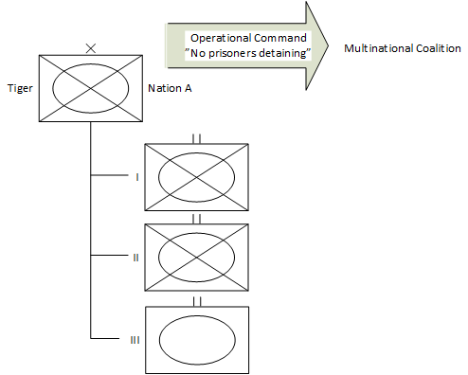

The above diagram illustrates Nation A’s ORBAT as contribution. Although only depicted down to battalion level, the ORBAT may very well be down to lowest echelon levels.

After completeness of the above, Nation A sends its ORBAT along with national caveats (e.g. not detaining prisoners) to the coalition command

Step 3:

The Multinational Coalition Command merges Nation A’s contribution (Start Time, informing when the coalition ORBAT will be effective, is not depicted) into its own ORBAT, still not disseminated. The agreed command relationship and National A’s caveats are set by the coalition command.

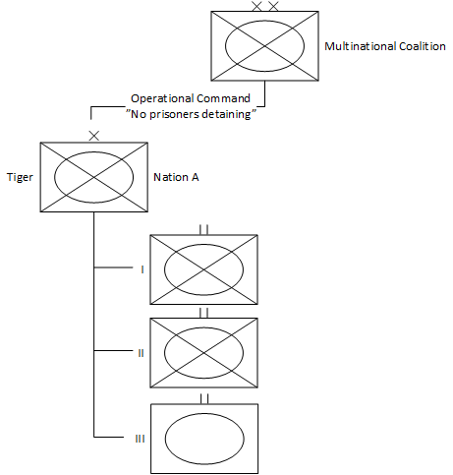

The above diagram illustrates the Coalition ORBAT, still under development (i.e. not disseminated). The ORBAT may include lowest possible echelons.

Step 4:

As TCN, Nation B provides its ORBAT to the Multinational Coalition Command along with Start Time, politically agreed command relationship and national caveats.

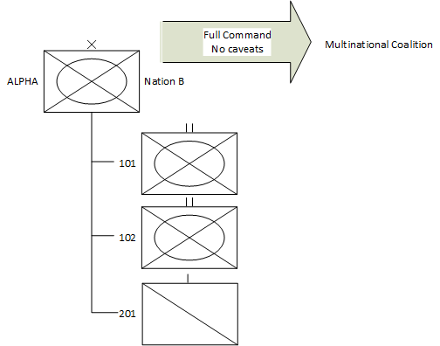

Step 5:

Multinational Coalition Command:

1. Merges Nation B’s ORBAT into own ORBAT and sets the agreed command relationship and national caveats
2. Provides (optional) information about main equipment(s) and manning.
3. Sets the Start Time and provides a name for the now combined ORBAT.
4. Disseminates the Multinational Coalition ORBAT to Nation A, Nation B and to possibly other relevant actors.

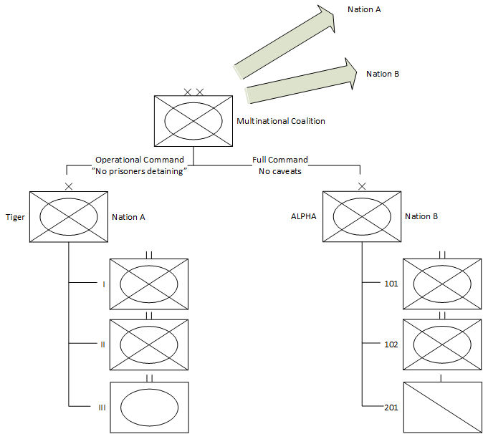

The diagram above illustrates the Multinational Coalition ORBAT disseminated to Nation A and Nation B. The ORBAT possibly details to lowest possible echelon level (not depicted).

End state:

* The Multinational Coalition Command, Nation A and Nation B all have the coalition ORBAT with coalition Start Time set and knowledge about each other’s capabilities.

The state of the National ORBATs within the national system boundaries are independent of the Coalition ORBAT - i.e. a subsequent change to one does not automatically result in a change to the other.

#### 8.17.1.4 Updating by Versioning the Multinational Coalition ORBAT

Trigger: Nation A is no longer able to contribute with an armoured battalion.

Step 1:

Nation A updates the ORBAT of Tiger Brigade. By incrementing the version number (e.g. ‘2’) of the ORBAT, Nation A indicates that the updated ORBAT should replace the previous version.

Nation A sends the new version of the ORBAT to the Multinational Coalition Command.

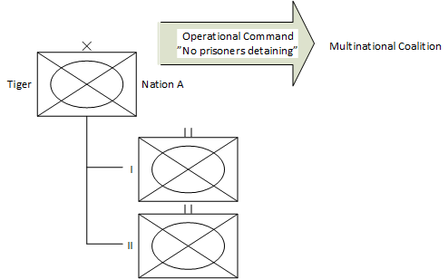

Step 2:

The Multinational Coalition Command sees that Nation A has sent a new version of its ORBAT.

The current Multinational ORBAT is still unaffected.

Step 3:

By applying the latest version of Tiger Brigade’s ORBAT, the Multinational Coalition Command updates its ORBAT into a new version.

The Multinational Coalition Command disseminates the latest version of its ORBAT.

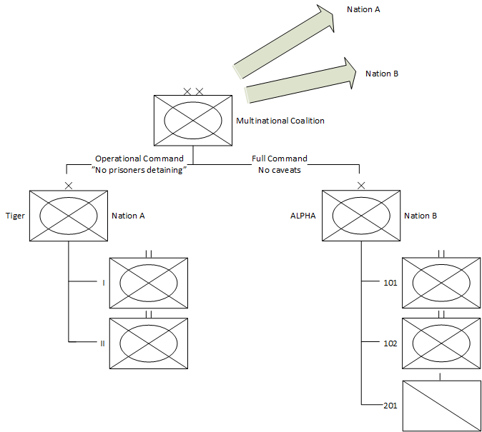

End state:

* The Multinational Coalition Command, Nation A and Nation B all have the latest version of the Multinational Coalition ORBAT.
* The state of the ORBAT within the national system boundary is independent of the Coalition ORBAT - i.e. a subsequent change to one does not automatically result in a change to the other.

#### 8.17.1.5 Stating Main Equipment

##### 8.17.1.5.1 Variant 1 (only Type Name provided)

The nation wants to state that one of the Main Equipment of a unit is Medium Battle Tank, but the nation does not wish to be specific about neither model nor operational quantity at the start time of the ORBAT:

* + Main Equipment Type Name: The nation selects “Medium Battle Tank”.
  + Model: The nation does not provide any information.
  + Quantity: The nation does not provide any information.

##### 8.17.1.5.2 Variant 2 (Main equipment type/model not operational)

Although the nation as a national contribution is expected to provide Warrior infantry fighting vehicles, none will be available at the start time of the ORBAT. Consequently, the nation provides the following information:

* + Main Equipment Type Name: The nation selects “Infantry Fighting Vehicle”.
  + Model: The nation enters (i.e. types) “Warrior”.
  + Quantity: The nation enters ‘0’ explicitly to warn its coalition that none will be operational.

##### 8.17.1.5.3 Variant 3 (Type Name initially not available)

The nation will be capable of contributing with 20 (operational) flatbed wagons for tank transport:

* + Main Equipment Type Name: If a specific equipment type has not been pre-defined, it is possible for the nation to specify the required type.
  + Model: The nation opts not to providing any information.
  + Quantity: The nation enters ‘20’.

#### 8.17.1.6 Stating Manning of a Unit

To indicate the manning for a given unit, subordinate units included (aggregated), in own ORBAT, the actors enters following information:

* Officers: The nation enters ‘0’ to explicitly state that none will be available (operational).
* Non-commissioned officers: The nation does not know the number and consequently does not provide any.
* Privates and enlisted: The nation enters ‘150’.

### 8.17.2 Amplifying Information

#### 8.17.2.1 Multiple Concurrent Friendly ORBATs

From an information perspective, there is nothing preventing a Producer from making more than one Friendly ORBATs available concurrently, each with a unique Identifier.

#### 8.17.2.2 Use of Distribution List

When disseminating a staffconceptorganisationstructure:FriendlyORBAT or a staffconceptorganisationstructure:TaskOrganisation, a Provider may opt to add a distribution list. For the recipients, the Provider may specify:

● DistributedForAction. For the specific expected action, Provider may inform recipients via alternative means, such as email or phone.

● DistributedForInformation.

In case a distribution list has been applied, the Provider may also opt to add a request for acknowledgement from the recipients, with the following meaning:

● Acknowledgement from a recipient mentioned “For Action”: The recipient will comply.

● Acknowledgement from a recipient mentioned “For Information”: The recipient has read and understood the information.

Note that the acknowledgement will not be exchanged via MIP and there is no expected system behaviour attached to the reception of an acknowledgment request.

#### 8.17.2.3 Display of an ORBAT

The order of the sibling unit in an ORBAT may have operational relevance. In order to keep the same visualization among different systems the order of sibling units in any part of the hierarchy should be interpreted as “left to right” or “up to down”. It must be taken into account that due to the selected exchange mechanism or national systems requirements, different systems may display the same ORBAT using a different order for the sibling units as long as the association among the units within the ORBAT is respected.

### 8.17.3 Friendly ORBAT Examples

#### 8.17.3.1 Overview

The snippets contained in this paragraph provide examples for the staffconceptorganisationstructure:FriendlyORBAT schema.

#### 8.17.3.2 Basic Friendly ORBAT

The following section depicts the creation of an staffconceptorganisationstructure :FriendlyORBATType for which the identifier and the name are provided.

|  |
| --- |
| <?xml version="1.0" encoding="UTF-8"?>  <staffconceptorganisationstructure:FriendlyORBAT  xmlns:base="https://mip-interop.org/data/v4.3/Base"  xmlns:xsi="http://www.w3.org/2001/XMLSchema-instance"  xmlns:app="https://mip-interop.org/data/v4.3/AppInfo"  xmlns:concept="https://mip-interop.org/data/v4.3/Concept"  xmlns:staffconcept="https://mip-interop.org/data/v4.3/StaffConcept"  xmlns:conceptmetadata="https://mip-interop.org/data/v4.3/Concept/Metadata"  xmlns:battlespaceconcept="https://mip-interop.org/data/v4.3/BattlespaceConcept"  xmlns:staffconceptmetadata="https://mip-interop.org/data/v4.3/StaffConcept/Metadata"  xmlns:staffconceptorganisationstructure="https://mip-interop.org/data/v4.3/StaffConcept/OrganisationStructure"  xmlns:organisation="https://mip-interop.org/data/v4.3/BattlespaceConcept/Object/Actor/Organisation"  xsi:schemaLocation="https://mip-interop.org/data/v4.3/IES IES.xsd">  <base:ID>0f0d20fa-7e04-4ded-8361-f8acfc32909f</base:ID>  <concept:ConceptName>TestOrbat</concept:ConceptName>  <staffconcept:StaffConceptMetadata xsi:nil="true"/>  <staffconceptorganisationstructure:OrganisationStructureRootOrganisationRef xsi:nil="true"/>  <staffconceptorganisationstructure:OrganisationStructureRootOrganisation xsi:nil="true"/>  </staffconceptorganisationstructure:FriendlyORBAT> |

It must be noted that to specify the meta:BaseMetadata associated with a staffconceptorganisationstructure:FriendlyORBAT, the staffconceptmetadata:StaffConceptMetadataType shall be used.

#### 8.17.3.3 Use of StaffConceptMetadata

The following snippet shows an example of usage of staffconceptmetadata:StaffConceptMetadataType:

|  |
| --- |
| <?xml version="1.0" encoding="UTF-8"?>  <staffconceptorganisationstructure:OrderOfBattle  xmlns:base="https://mip-interop.org/data/v4.3/Base"  xmlns:xsi="http://www.w3.org/2001/XMLSchema-instance"  xmlns:app="https://mip-interop.org/data/v4.3/AppInfo"  xmlns:concept="https://mip-interop.org/data/v4.3/Concept"  xmlns:generic="https://mip-interop.org/data/v4.3/BattlespaceConcept/Generic"  xmlns:staffconcept="https://mip-interop.org/data/v4.3/StaffConcept"  xmlns:conceptmetadata="https://mip-interop.org/data/v4.3/Concept/Metadata"  xmlns:battlespaceconcept="https://mip-interop.org/data/v4.3/BattlespaceConcept"  xmlns:staffconceptmetadata="https://mip-interop.org/data/v4.3/StaffConcept/Metadata" xmlns:confidentialitymetadatalabel="urn:nato:stanag:4774:confidentialitymetadatalabel:1:0"  xmlns:staffconceptorganisationstructure="https://mip-interop.org/data/v4.3/StaffConcept/OrganisationStructure"  xmlns:organisation="https://mip-interop.org/data/v4.3/BattlespaceConcept/Object/Actor/Organisation"  xsi:schemaLocation="https://mip-interop.org/data/v4.3/IES IES.xsd">  <base:ID>0f0d20fa-7e04-4ded-8361-f8acfc32909f</base:ID>  <concept:ConceptName>Brigade</concept:ConceptName>  <staffconcept:StaffConceptMetadata>  <conceptmetadata:ConceptMetadataMetadataConfidentialityLabel>  <confidentialitymetadatalabel:ConfidentialityInformation>  <confidentialitymetadatalabel:PolicyIdentifier>Unmarked</confidentialitymetadatalabel:PolicyIdentifier>  <confidentialitymetadatalabel:Classification>Unmarked</confidentialitymetadatalabel:Classification>  </confidentialitymetadatalabel:ConfidentialityInformation>  <confidentialitymetadatalabel:CreationDateTime>2019-12-24T10:00:00.000Z</confidentialitymetadatalabel:CreationDateTime>  </conceptmetadata:ConceptMetadataMetadataConfidentialityLabel>  <conceptmetadata:ConceptMetadataValidityTimePeriod xsi:type="generic:AbsoluteTimePeriodType">  <generic:AbsoluteTimePeriodEndDateTime>2019-12-24T10:00:00.000Z</generic:AbsoluteTimePeriodEndDateTime>  <generic:AbsoluteTimePeriodStartDateTime>2019-04-09T16:38:00.000Z</generic:AbsoluteTimePeriodStartDateTime>  </conceptmetadata:ConceptMetadataValidityTimePeriod>  <staffconceptmetadata:StaffConceptMetadataIsAcknowledgementRequiredIndicator>false</staffconceptmetadata:StaffConceptMetadataIsAcknowledgementRequiredIndicator>  <staffconceptmetadata:StaffConceptMetadataIssuingDateTime>2019-12-31T09:41:52.000Z</staffconceptmetadata:StaffConceptMetadataIssuingDateTime>  <staffconceptmetadata:StaffConceptMetadataVersionValue>1.0</staffconceptmetadata:StaffConceptMetadataVersionValue>  <staffconceptmetadata:StaffConceptMetadataRecipient>  <staffconceptmetadata:RecipientDistributionReasonCode>DistributedForInformation</staffconceptmetadata:RecipientDistributionReasonCode>  <staffconceptmetadata:RecipientName>TIGER BRIGADE</staffconceptmetadata:RecipientName>  </staffconceptmetadata:StaffConceptMetadataRecipient>  <staffconceptmetadata:StaffConceptMetadataOriginator>  <conceptmetadata:OriginatorName>JOINT FORCE COMMAND</conceptmetadata:OriginatorName>  </staffconceptmetadata:StaffConceptMetadataOriginator>  </staffconcept:StaffConceptMetadata>  <staffconceptorganisationstructure:OrganisationStructureRootOrganisationRef>  <base:ID>0f0d20fa-7e04-4ded-8361-f8acfc32909f</base:ID>  <app:SemanticID>MIM:7c992ebb-f7cf-491c-bf37-ac9d1256ba64R</app:SemanticID>  </staffconceptorganisationstructure:OrganisationStructureRootOrganisationRef>  <staffconceptorganisationstructure:OrganisationStructureRootOrganisation>  <base:ID>424d2da3-2c5b-4115-c41e-6c7b9d82726e</base:ID>  <concept:ConceptName>Joint Force Command</concept:ConceptName>  <battlespaceconcept:BattlespaceConceptIsTypeIndicator>true</battlespaceconcept:BattlespaceConceptIsTypeIndicator>  <battlespaceconcept:BattlespaceConceptMetadata>  <conceptmetadata:ConceptMetadataReportingData>  <conceptmetadata:ReportingDataCategoryCode>Inferred</conceptmetadata:ReportingDataCategoryCode>  <conceptmetadata:ReportingDataObservationDateTime>2019-12-24T09:41:52.000Z</conceptmetadata:ReportingDataObservationDateTime>  <conceptmetadata:ReportingDataReportingDateTime>2019-12-24T09:51:52.000Z</conceptmetadata:ReportingDataReportingDateTime>  <conceptmetadata:ReportingDataReporter>  <conceptmetadata:ReporterName>JOINT FORCE COMMAND</conceptmetadata:ReporterName>  </conceptmetadata:ReportingDataReporter>  </conceptmetadata:ConceptMetadataReportingData>  </battlespaceconcept:BattlespaceConceptMetadata>  <organisation:OrganisationHasCommandFunctionIndicator>true</organisation:OrganisationHasCommandFunctionIndicator>  </staffconceptorganisationstructure:OrganisationStructureRootOrganisation>  </staffconceptorganisationstructure:OrderOfBattle> |

#### 8.17.3.4 Use of TextualTimePeriod

It is also possible to specify the generic:TimePeriod using generic:TextualTimePeriodType and providing a textual description of the validity time period, as shown in the following snippet:

|  |
| --- |
| <?xml version="1.0" encoding="UTF-8"?>  <conceptmetadata:ConceptMetadataValidityTimePeriod  xmlns:xsi="http://www.w3.org/2001/XMLSchema-instance"  xmlns:conceptmetadata="https://mip-interop.org/data/v4.3/Concept/Metadata"  xmlns:generic="https://mip-interop.org/data/v4.3/BattlespaceConcept/Generic"  xsi:schemaLocation="https://mip-interop.org/data/v4.3/IES IES.xsd"  xsi:type="generic:TextualTimePeriodType">  <generic:TextualTimePeriodDescriptionText>When reaching Phase Line LISA</generic:TextualTimePeriodDescriptionText>  </conceptmetadata:ConceptMetadataValidityTimePeriod> |

#### 8.17.3.5 Use of RootUnit

To express the structure of the ORBAT a staffconceptorganisationstructure:OrganisationStructureRootOrganisation is set, the root unit encapsulates the other orgstruct:Unit composing the ORBAT.

|  |
| --- |
| <?xml version="1.0" encoding="UTF-8"?>  <staffconceptorganisationstructure:OrganisationStructureRootOrganisation  xmlns:base="https://mip-interop.org/data/v4.3/Base"  xmlns:xsi="http://www.w3.org/2001/XMLSchema-instance"  xmlns:object="https://mip-interop.org/data/v4.3/BattlespaceConcept/Object"  xmlns:concept="https://mip-interop.org/data/v4.3/Concept"  xmlns:battlespaceconcept="https://mip-interop.org/data/v4.3/BattlespaceConcept"  xmlns:staffconceptorganisationstructure="https://mip-interop.org/data/v4.3/StaffConcept/OrganisationStructure"  xmlns:unit="https://mip-interop.org/data/v4.3/BattlespaceConcept/Object/Actor/Organisation/Unit"  xmlns:organisation="https://mip-interop.org/data/v4.3/BattlespaceConcept/Object/Actor/Organisation"  xsi:schemaLocation="https://mip-interop.org/data/v4.3/IES IES.xsd"  xsi:type="unit:InfantryUnitType">  <base:ID>92f6f338-42a4-4bd4-9182-2acc1848bbcd</base:ID>  <concept:ConceptName>ALPHA</concept:ConceptName>  <battlespaceconcept:BattlespaceConceptIsTypeIndicator>false</battlespaceconcept:BattlespaceConceptIsTypeIndicator>  <battlespaceconcept:BattlespaceConceptMetadata/>  <organisation:OrganisationHasCommandFunctionIndicator>false</organisation:OrganisationHasCommandFunctionIndicator>  <organisation:MilitaryOrganisationServiceCode>Army</organisation:MilitaryOrganisationServiceCode>  <unit:UnitEchelon xsi:type="object:ArmyEchelonType">  <object:ArmyEchelonCode>Brigade</object:ArmyEchelonCode>  </unit:UnitEchelon>  <unit:UnitFormalAbbreviatedName>ALPHA</unit:UnitFormalAbbreviatedName>  </staffconceptorganisationstructure:OrganisationStructureRootOrganisation> |

#### 8.17.3.6 Use of GeopoliticalAffiliation

The following snippet shows the expected usage of the affiliation:GeopoliticalAffiliationType:

|  |
| --- |
| <?xml version="1.0" encoding="UTF-8"?>  <affiliation:GeopoliticalAffiliationCode  xmlns:xsi="http://www.w3.org/2001/XMLSchema-instance"  xmlns:affiliation="https://mip-interop.org/data/v4.3/BattlespaceConcept/Affiliation"  xsi:schemaLocation="https://mip-interop.org/data/v4.3/IES IES.xsd">DEU</affiliation:GeopoliticalAffiliationCode> |

#### 8.17.3.7 Use of HostilityStatusCode PersonnelCount and MainEquipment

The following example shows how generic:HostilityCode, unit:PersonnelCount and unit:MainEquipmentSpecification can be added to a unit within an ORBAT.

|  |
| --- |
| <?xml version="1.0" encoding="UTF-8"?>  <battlespaceconcept:BattlespaceConceptHostilityCode  xmlns:xsi="http://www.w3.org/2001/XMLSchema-instance"  xmlns:battlespaceconcept="https://mip-interop.org/data/v4.3/BattlespaceConcept"  xsi:schemaLocation="https://mip-interop.org/data/v4.3/IES IES.xsd">Friend</battlespaceconcept:BattlespaceConceptHostilityCode>    <unit:UnitPersonnelStrength  xmlns:xsi="http://www.w3.org/2001/XMLSchema-instance"  xmlns:unit="https://mip-interop.org/data/v4.3/BattlespaceConcept/Object/Actor/Organisation/Unit"  xsi:schemaLocation="https://mip-interop.org/data/v4.3/IES IES.xsd">  <unit:PersonnelCountEnlistedPrivateQuantity>100</unit:PersonnelCountEnlistedPrivateQuantity>  <unit:PersonnelCountNonCommissionedOfficerQuantity>10</unit:PersonnelCountNonCommissionedOfficerQuantity>  <unit:PersonnelCountOfficerQuantity>100</unit:PersonnelCountOfficerQuantity>  </unit:UnitPersonnelStrength>      <unit:UnitMainEquipmentSpecification  xmlns:base="https://mip-interop.org/data/v4.3/Base" xmlns:xsi="http://www.w3.org/2001/XMLSchema-instance"  xmlns:tns="https://mip-interop.org/data/v4.3/AppInfo"  xmlns:concept="https://mip-interop.org/data/v4.3/Concept" xmlns:battlespaceconcept="https://mip-interop.org/data/v4.3/BattlespaceConcept" xmlns:materiel="https://mip-interop.org/data/v4.3/BattlespaceConcept/Object/Materiel" xmlns:weapon="https://mip-interop.org/data/v4.3/BattlespaceConcept/Object/Materiel/Equipment/Weapon" xmlns:unit="https://mip-interop.org/data/v4.3/BattlespaceConcept/Object/Actor/Organisation/Unit" xsi:schemaLocation="https://mip-interop.org/data/v4.3/IES IES.xsd">  <unit:MainEquipmentSpecificationEquipmentQuantity>5</unit:MainEquipmentSpecificationEquipmentQuantity>  <unit:MainEquipmentSpecificationMainEquipmentRef xsi:nil="true"/>  <unit:MainEquipmentSpecificationMainEquipment xsi:type="weapon:BattleTankType">  <base:ID>359d4ea5-4d5c-4195-a70e-4b9c9c84805b</base:ID>  <concept:ConceptName>Medium Battle Tank</concept:ConceptName>  <battlespaceconcept:BattlespaceConceptIsTypeIndicator>false</battlespaceconcept:BattlespaceConceptIsTypeIndicator>  <battlespaceconcept:BattlespaceConceptMetadata/>  <materiel:MaterielModelName>Leopard</materiel:MaterielModelName>  <materiel:MaterielOperationalStatusCode xsi:nil="true"/>  <weapon:BattleTankScalingCode>Medium</weapon:BattleTankScalingCode>  </unit:MainEquipmentSpecificationMainEquipment>  </unit:UnitMainEquipmentSpecification> |

#### 8.17*.3.8 Expressing a generic EquipmentType using ModelName*

It is important to note that if the desired type of equipment is not available it is possible to specify a generic orgstruct:EquipmentType and express the desired type using the orgstruct:ModelName, as shown in the following example:

|  |
| --- |
| <?xml version="1.0" encoding="UTF-8"?>  <unit:UnitMainEquipmentSpecification  xmlns:base="https://mip-interop.org/data/v4.3/Base"  xmlns:xsi="http://www.w3.org/2001/XMLSchema-instance"  xmlns:app="https://mip-interop.org/data/v4.3/AppInfo"  xmlns:concept="https://mip-interop.org/data/v4.3/Concept"  xmlns:battlespaceconcept="https://mip-interop.org/data/v4.3/BattlespaceConcept"  xmlns:materiel="https://mip-interop.org/data/v4.3/BattlespaceConcept/Object/Materiel"  xmlns:unit="https://mip-interop.org/data/v4.3/BattlespaceConcept/Object/Actor/Organisation/Unit"  xsi:schemaLocation="https://mip-interop.org/data/v4.3/IES IES.xsd">  <unit:MainEquipmentSpecificationEquipmentQuantity>20</unit:MainEquipmentSpecificationEquipmentQuantity>  <unit:MainEquipmentSpecificationMainEquipmentRef xsi:nil="true"/>  <unit:MainEquipmentSpecificationMainEquipment>  <base:ID>359d4ea5-4d5c-4195-a70e-4b9c9c84805b</base:ID>  <concept:ConceptName>Flatbed Wagon</concept:ConceptName>  <battlespaceconcept:BattlespaceConceptIsTypeIndicator>true</battlespaceconcept:BattlespaceConceptIsTypeIndicator>  <battlespaceconcept:BattlespaceConceptMetadata/>  <materiel:MaterielModelName>Military Flatbed Wagon</materiel:MaterielModelName>  <materiel:MaterielOperationalStatusCode xsi:nil="true"/>  </unit:MainEquipmentSpecificationMainEquipment>  </unit:UnitMainEquipmentSpecification> |

#### 8.17*.3.9 Command and Control Associations*

To add units to an ORBAT the organisation:OrganisationCommandAndControlAssociation shall be used, each Unit encapsulated by the association depends from the Unit which contains the element and the OrganisationCommandAndControlAssociationCategoryCode defines the type of CommandAndControl association between the unit and each of the encaplulated units.

In this example the Root Unit ALPHA has full command of Unit 101 and tactical command of Unit 102.

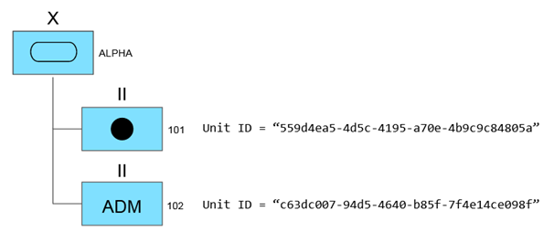

|  |
| --- |
| <?xml version="1.0" encoding="UTF-8"?>  <organisation:OrganisationCommandAndControlAssociation  xmlns:base="https://mip-interop.org/data/v4.3/Base"  xmlns:xsi="http://www.w3.org/2001/XMLSchema-instance"  xmlns:affiliation="https://mip-interop.org/data/v4.3/BattlespaceConcept/Affiliation"  xmlns:object="https://mip-interop.org/data/v4.3/BattlespaceConcept/Object"  xmlns:concept="https://mip-interop.org/data/v4.3/Concept"  xmlns:unit="https://mip-interop.org/data/v4.3/BattlespaceConcept/Object/Actor/Organisation/Unit"  xmlns:battlespaceconcept="https://mip-interop.org/data/v4.3/BattlespaceConcept"  xmlns:organisation="https://mip-interop.org/data/v4.3/BattlespaceConcept/Object/Actor/Organisation"  xsi:schemaLocation="https://mip-interop.org/data/v4.3/IES IES.xsd">  <base:ID>559d4ea5-4d5c-4195-a70e-4b9c9c84805a</base:ID>  <organisation:OrganisationFunctionalAssociationFunctionalObjectOrganisation xsi:type="unit:FieldArtilleryUnitType">  <base:ID>559d4ea5-4d5c-4195-a70e-4b9c9c84805a</base:ID>  <concept:ConceptName>101</concept:ConceptName>  <battlespaceconcept:BattlespaceConceptIsTypeIndicator>true</battlespaceconcept:BattlespaceConceptIsTypeIndicator>  <battlespaceconcept:BattlespaceConceptHostilityCode>Friend</battlespaceconcept:BattlespaceConceptHostilityCode>  <battlespaceconcept:BattlespaceConceptMetadata/>  <object:ObjectAffiliation xsi:type="affiliation:GeopoliticalAffiliationType">  <affiliation:GeopoliticalAffiliationCode>ITA</affiliation:GeopoliticalAffiliationCode>  </object:ObjectAffiliation>  <organisation:OrganisationHasCommandFunctionIndicator>false</organisation:OrganisationHasCommandFunctionIndicator>  <organisation:MilitaryOrganisationServiceCode>Army</organisation:MilitaryOrganisationServiceCode>  <unit:UnitEchelon xsi:type="object:ArmyEchelonType">  <object:ArmyEchelonCode>Battalion</object:ArmyEchelonCode>  </unit:UnitEchelon>  <unit:UnitFormalAbbreviatedName>101</unit:UnitFormalAbbreviatedName>  </organisation:OrganisationFunctionalAssociationFunctionalObjectOrganisation>  <organisation:OrganisationCommandAndControlAssociationCategoryCode>HasFullCommandOf</organisation:OrganisationCommandAndControlAssociationCategoryCode>  </organisation:OrganisationCommandAndControlAssociation>    <organisation:OrganisationCommandAndControlAssociation  xmlns:base="https://mip-interop.org/data/v4.3/Base"  xmlns:xsi="http://www.w3.org/2001/XMLSchema-instance"  xmlns:affiliation="https://mip-interop.org/data/v4.3/BattlespaceConcept/Affiliation"  xmlns:object="https://mip-interop.org/data/v4.3/BattlespaceConcept/Object"  xmlns:concept="https://mip-interop.org/data/v4.3/Concept"  xmlns:unit="https://mip-interop.org/data/v4.3/BattlespaceConcept/Object/Actor/Organisation/Unit"  xmlns:battlespaceconcept="https://mip-interop.org/data/v4.3/BattlespaceConcept"  xmlns:organisation="https://mip-interop.org/data/v4.3/BattlespaceConcept/Object/Actor/Organisation"  xsi:schemaLocation="https://mip-interop.org/data/v4.3/IES IES.xsd">  <base:ID>c63dc007-94d5-4640-b85f-7f4e14ce098f</base:ID>  <organisation:OrganisationFunctionalAssociationFunctionalObjectOrganisation xsi:type="unit:AdministrativeUnitType">  <base:ID>c63dc007-94d5-4640-b85f-7f4e14ce098f</base:ID>  <concept:ConceptName>102</concept:ConceptName>  <battlespaceconcept:BattlespaceConceptIsTypeIndicator>true</battlespaceconcept:BattlespaceConceptIsTypeIndicator>  <battlespaceconcept:BattlespaceConceptHostilityCode>Friend</battlespaceconcept:BattlespaceConceptHostilityCode>  <battlespaceconcept:BattlespaceConceptMetadata/>  <object:ObjectAffiliation xsi:type="affiliation:GeopoliticalAffiliationType">  <affiliation:GeopoliticalAffiliationCode>CAN</affiliation:GeopoliticalAffiliationCode>  </object:ObjectAffiliation>  <organisation:OrganisationHasCommandFunctionIndicator>false</organisation:OrganisationHasCommandFunctionIndicator>  <organisation:MilitaryOrganisationServiceCode>Army</organisation:MilitaryOrganisationServiceCode>  <unit:UnitEchelon xsi:type="object:ArmyEchelonType">  <object:ArmyEchelonCode>Battalion</object:ArmyEchelonCode>  </unit:UnitEchelon>  <unit:UnitFormalAbbreviatedName>102</unit:UnitFormalAbbreviatedName>  </organisation:OrganisationFunctionalAssociationFunctionalObjectOrganisation>  <organisation:OrganisationCommandAndControlAssociationCategoryCode>HasTacticalCommandOf</organisation:OrganisationCommandAndControlAssociationCategoryCode>  </organisation:OrganisationCommandAndControlAssociation> |

## 

#### 8.17.3.10 Example

The following example represents a Friendly ORBAT:

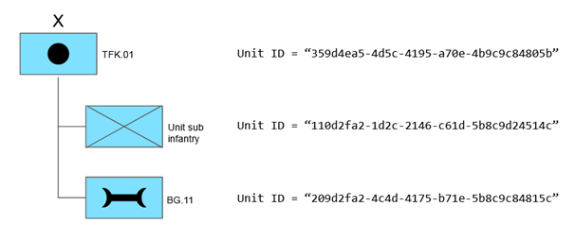

|  |
| --- |
| <?xml version="1.0" encoding="UTF-8"?>  <staffconceptorganisationstructure:FriendlyORBAT  xmlns:base="https://mip-interop.org/data/v4.3/Base"  xmlns:xsi="http://www.w3.org/2001/XMLSchema-instance"  xmlns:generic="https://mip-interop.org/data/v4.3/BattlespaceConcept/Generic"  xmlns:app="https://mip-interop.org/data/v4.3/AppInfo"  xmlns:concept="https://mip-interop.org/data/v4.3/Concept"  xmlns:staffconcept="https://mip-interop.org/data/v4.3/StaffConcept"  xmlns:conceptmetadata="https://mip-interop.org/data/v4.3/Concept/Metadata"  xmlns:unit="https://mip-interop.org/data/v4.3/BattlespaceConcept/Object/Actor/Organisation/Unit"  xmlns:battlespaceconcept="https://mip-interop.org/data/v4.3/BattlespaceConcept"  xmlns:appinfo="https://mip-interop.org/data/v4.3/AppInfo"  xmlns:object="https://mip-interop.org/data/v4.3/BattlespaceConcept/Object"  xmlns:person="https://mip-interop.org/data/v4.3/BattlespaceConcept/Object/Actor/Person"  xmlns:location="https://mip-interop.org/data/v4.3/BattlespaceConcept/Location"  xmlns:staffconceptmetadata="https://mip-interop.org/data/v4.3/StaffConcept/Metadata"  xmlns:staffconceptorganisationstructure="https://mip-interop.org/data/v4.3/StaffConcept/OrganisationStructure"  xmlns:affiliation="https://mip-interop.org/data/v4.3/BattlespaceConcept/Affiliation"  xmlns:organisation="https://mip-interop.org/data/v4.3/BattlespaceConcept/Object/Actor/Organisation" xmlns:confidentialitymetadatalabel="urn:nato:stanag:4774:confidentialitymetadatalabel:1:0"  xsi:schemaLocation="https://mip-interop.org/data/v4.3/IES IES.xsd">  <base:ID>324c8cd3-1c2c-8745-e9cb-7c8a1f37627b</base:ID>  <concept:ConceptName>Friendly ORBAT</concept:ConceptName>  <staffconcept:StaffConceptMetadata>  <conceptmetadata:ConceptMetadataOriginatorConfidentialityLabel>  <confidentialitymetadatalabel:ConfidentialityInformation>  <confidentialitymetadatalabel:PolicyIdentifier>Unmarked</confidentialitymetadatalabel:PolicyIdentifier>  <confidentialitymetadatalabel:Classification>Unmarked</confidentialitymetadatalabel:Classification>  </confidentialitymetadatalabel:ConfidentialityInformation>  <confidentialitymetadatalabel:CreationDateTime>2019-12-24T10:00:00.000Z</confidentialitymetadatalabel:CreationDateTime>  </conceptmetadata:ConceptMetadataOriginatorConfidentialityLabel>  <conceptmetadata:ConceptMetadataValidityTimePeriod xsi:type="generic:AbsoluteTimePeriodType">  <generic:AbsoluteTimePeriodEndDateTime>2019-12-24T10:00:00.000Z</generic:AbsoluteTimePeriodEndDateTime>  <generic:AbsoluteTimePeriodStartDateTime>2019-04-09T16:38:00.000Z</generic:AbsoluteTimePeriodStartDateTime>  </conceptmetadata:ConceptMetadataValidityTimePeriod>  <staffconceptmetadata:StaffConceptMetadataIsAcknowledgementRequiredIndicator>false</staffconceptmetadata:StaffConceptMetadataIsAcknowledgementRequiredIndicator>  <staffconceptmetadata:StaffConceptMetadataIssuingDateTime>2019-12-31T09:41:52.000Z</staffconceptmetadata:StaffConceptMetadataIssuingDateTime>  <staffconceptmetadata:StaffConceptMetadataVersionValue>1.0</staffconceptmetadata:StaffConceptMetadataVersionValue>  <staffconceptmetadata:StaffConceptMetadataRecipient>  <staffconceptmetadata:RecipientDistributionReasonCode>DistributedForInformation</staffconceptmetadata:RecipientDistributionReasonCode>  <staffconceptmetadata:RecipientName>BRIGADE</staffconceptmetadata:RecipientName>  </staffconceptmetadata:StaffConceptMetadataRecipient>  <staffconceptmetadata:StaffConceptMetadataOriginator>  <conceptmetadata:OriginatorName>FORCE COMMAND</conceptmetadata:OriginatorName>  </staffconceptmetadata:StaffConceptMetadataOriginator>  </staffconcept:StaffConceptMetadata>  <staffconceptorganisationstructure:OrganisationStructureComponents xsi:type="organisation:OrganisationCommandAndControlAssociationType">  <base:ID>359d4ea5-4d5c-4195-a70e-4b9c9c84805b</base:ID>  <organisation:OrganisationFunctionalAssociationFunctionalObjectOrganisation xsi:type="unit:MaintenanceUnitType">  <base:ID>209d2fa2-4c4d-4175-b71e-5b8c9c84815c</base:ID>  <concept:ConceptName>BG.11</concept:ConceptName>  <battlespaceconcept:BattlespaceConceptMetadata xsi:nil="true"/>  <object:ObjectAffiliation xsi:type="affiliation:GeopoliticalAffiliationType">  <affiliation:GeopoliticalAffiliationCode>UnitedStatesOfAmerica</affiliation:GeopoliticalAffiliationCode>  </object:ObjectAffiliation>  <organisation:OrganisationHasCommandFunctionIndicator>false</organisation:OrganisationHasCommandFunctionIndicator>  <organisation:MilitaryOrganisationServiceCode>Army</organisation:MilitaryOrganisationServiceCode>  <unit:UnitEchelon xsi:type="object:ArmyEchelonType">  <object:ArmyEchelonCode xsi:nil="true"/>  </unit:UnitEchelon>  </organisation:OrganisationFunctionalAssociationFunctionalObjectOrganisation>  <organisation:OrganisationFunctionalAssociationFunctionalSubjectOrganisationRef>  <base:ID>359d4ea5-4d5c-4195-a70e-4b9c9c84805b</base:ID>  <appinfo:SemanticID>MIM:8ab23975-f1f8-4d22-bfff-45e195d06144</appinfo:SemanticID>  </organisation:OrganisationFunctionalAssociationFunctionalSubjectOrganisationRef>  </staffconceptorganisationstructure:OrganisationStructureComponents>  <staffconceptorganisationstructure:OrganisationStructureComponents xsi:type="organisation:OrganisationCommandAndControlAssociationType">  <base:ID>359d4ea5-4d5c-4195-a70e-4b9c9c84805b</base:ID>  <organisation:OrganisationFunctionalAssociationFunctionalObjectOrganisation xsi:type="unit:InfantryUnitType">  <base:ID>110d2fa2-1d2c-2146-c61d-5b8c9d24514c</base:ID>  <concept:ConceptName>Unit sub infantry</concept:ConceptName>  <battlespaceconcept:BattlespaceConceptMetadata/>  <object:ObjectAffiliation xsi:type="affiliation:GeopoliticalAffiliationType">  <affiliation:GeopoliticalAffiliationCode>UnitedStatesOfAmerica</affiliation:GeopoliticalAffiliationCode>  </object:ObjectAffiliation>  <organisation:OrganisationHasCommandFunctionIndicator>true</organisation:OrganisationHasCommandFunctionIndicator>  <organisation:MilitaryOrganisationServiceCode>Army</organisation:MilitaryOrganisationServiceCode>  <unit:UnitEchelon xsi:type="object:ArmyEchelonType">  <object:ArmyEchelonCode xsi:nil="true"/>  </unit:UnitEchelon>  </organisation:OrganisationFunctionalAssociationFunctionalObjectOrganisation>  <organisation:OrganisationFunctionalAssociationFunctionalSubjectOrganisationRef>  <base:ID>359d4ea5-4d5c-4195-a70e-4b9c9c84805b</base:ID>  <appinfo:SemanticID>MIM:8ab23975-f1f8-4d22-bfff-45e195d06144</appinfo:SemanticID>  </organisation:OrganisationFunctionalAssociationFunctionalSubjectOrganisationRef>  </staffconceptorganisationstructure:OrganisationStructureComponents>  <staffconceptorganisationstructure:OrganisationStructureRootOrganisationRef xsi:nil="true"/>  <staffconceptorganisationstructure:OrganisationStructureRootOrganisation xsi:type="unit:ArtilleryUnitType">  <base:ID>359d4ea5-4d5c-4195-a70e-4b9c9c84805b</base:ID>  <concept:ConceptName>TFK.01</concept:ConceptName>  <battlespaceconcept:BattlespaceConceptMetadata xsi:nil="true"/>  <organisation:OrganisationHasCommandFunctionIndicator>true</organisation:OrganisationHasCommandFunctionIndicator>  <organisation:MilitaryOrganisationServiceCode>Army</organisation:MilitaryOrganisationServiceCode>  <unit:UnitEchelon xsi:type="object:ArmyEchelonType">  <object:ArmyEchelonCode>Brigade</object:ArmyEchelonCode>  </unit:UnitEchelon>  </staffconceptorganisationstructure:OrganisationStructureRootOrganisation>  </staffconceptorganisationstructure:FriendlyORBAT> |

## 8.18 Non-Friendly, Hierarchical Order of Battle

### 8.18.1 Basics

The intent of the non-friendly, hierarchical ORBAT is to exchange organisational information about non-friendly organisations, organised in a hierarchical manner, i.e. not in a mesh relationship.

### 8.18.2 Structure of a Non-friendly, Hierarchical Order of Battle

The Non-friendly, Hierarchical ORBAT elements comprise organisations with units as specialisation.

The Non-friendly, Hierarchical ORBAT has a single root organisation, potentially specialised as a unit.

Persons are not elements in a Non-friendly, Hierarchical ORBAT.

In the Non-friendly, Hierarchical ORBAT, peer organisations may be listed in a specific order.

### 8.18.3 Descriptive Information for a Non-Friendly, Hierarchical Order of Battle

Compared to Friendly ORBAT, Non-Friendly, Hierarchical ORBAT in addition includes following descriptive information is included:

* + Life Cycle Status, as part of Staff Concepts, of Non-Friendly, Hierarchical ORBAT. The status values are limited to ‘Draft’, ‘Obsolete’ and ‘Final’.
  + Chart Type that as free-text provides additional information (e.g. “Black Forces”) about the organisation, described in the Non-Friendly, Hierarchical ORBAT.

Compared to Friendly ORBAT, for each organisation in Non-Friendly, Hierarchical ORBAT, the following descriptive information

* is excluded:
  + Employment Caveat.
* is included:
  + One of following Hostility statuses:
    - ‘Assumed Friend’
    - ‘Friend’[4]
    - ‘Hostile’
    - ‘Neutral’
    - ‘Pending’
    - ‘Suspect’
    - ‘Unknown’
  + Multiple affiliation types, all optional, and in combinations with each other as:
    - One Geo-Political affiliation.
    - Multiple Religious affiliations.
    - Multiple Ethnical affiliations.
    - Multiple Other affiliations.

### 8.18.4 Information Flow

The typical operational flow of Non-Friendly, Hierarchical ORBAT is:

The Intelligence cell at highest coalition command level:

1. Creates a non-friendly, hierarchical ORBAT or receives it from other sources.
2. Within the coalition, disseminates the non-friendly, hierarchical ORBAT on need-to-know basis.
3. Maintains the non-friendly, hierarchical ORBAT
4. Repeats Step 2 and Step 3.

However, in order to provide flexibility by e.g. other Intel cells in the coalition to query or to contribute to a non-friendly, hierarchical ORBAT, same flow as for Friendly ORBAT is supported.

### 8.18.5 Example

The following example represents a Non Friendly ORBAT:

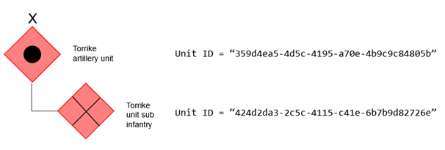

|  |
| --- |
| <?xml version="1.0" encoding="UTF-8"?>  <staffconceptorganisationstructure:NonFriendlyORBAT  xmlns:base="https://mip-interop.org/data/v4.3/Base"  xmlns:xsi="http://www.w3.org/2001/XMLSchema-instance"  xmlns:generic="https://mip-interop.org/data/v4.3/BattlespaceConcept/Generic"  xmlns:app="https://mip-interop.org/data/v4.3/AppInfo"  xmlns:concept="https://mip-interop.org/data/v4.3/Concept"  xmlns:staffconcept="https://mip-interop.org/data/v4.3/StaffConcept"  xmlns:conceptmetadata="https://mip-interop.org/data/v4.3/Concept/Metadata"  xmlns:unit="https://mip-interop.org/data/v4.3/BattlespaceConcept/Object/Actor/Organisation/Unit"  xmlns:battlespaceconcept="https://mip-interop.org/data/v4.3/BattlespaceConcept"  xmlns:appinfo="https://mip-interop.org/data/v4.3/AppInfo"  xmlns:object="https://mip-interop.org/data/v4.3/BattlespaceConcept/Object"  xmlns:person="https://mip-interop.org/data/v4.3/BattlespaceConcept/Object/Actor/Person"  xmlns:location="https://mip-interop.org/data/v4.3/BattlespaceConcept/Location"  xmlns:staffconceptmetadata="https://mip-interop.org/data/v4.3/StaffConcept/Metadata"  xmlns:staffconceptorganisationstructure="https://mip-interop.org/data/v4.3/StaffConcept/OrganisationStructure"  xmlns:affiliation="https://mip-interop.org/data/v4.3/BattlespaceConcept/Affiliation"  xmlns:organisation="https://mip-interop.org/data/v4.3/BattlespaceConcept/Object/Actor/Organisation" xmlns:confidentialitymetadatalabel="urn:nato:stanag:4774:confidentialitymetadatalabel:1:0"  xsi:schemaLocation="https://mip-interop.org/data/v4.3/IES IES.xsd">  <base:ID>110d2fa2-1d2c-2146-c61d-5b8c9d24514c</base:ID>  <concept:ConceptName>Torrike ORBAT</concept:ConceptName>  <staffconcept:StaffConceptMetadata>  <conceptmetadata:ConceptMetadataMetadataConfidentialityLabel>  <confidentialitymetadatalabel:ConfidentialityInformation>  <confidentialitymetadatalabel:PolicyIdentifier>Unmarked</confidentialitymetadatalabel:PolicyIdentifier>  <confidentialitymetadatalabel:Classification>Unmarked</confidentialitymetadatalabel:Classification>  </confidentialitymetadatalabel:ConfidentialityInformation>  <confidentialitymetadatalabel:CreationDateTime>2019-12-24T10:00:00.000Z</confidentialitymetadatalabel:CreationDateTime>  </conceptmetadata:ConceptMetadataMetadataConfidentialityLabel>  <conceptmetadata:ConceptMetadataValidityTimePeriod xsi:type="generic:AbsoluteTimePeriodType">  <generic:AbsoluteTimePeriodEndDateTime>2019-12-24T10:00:00.000Z</generic:AbsoluteTimePeriodEndDateTime>  <generic:AbsoluteTimePeriodStartDateTime>2019-04-09T16:38:00.000Z</generic:AbsoluteTimePeriodStartDateTime>  </conceptmetadata:ConceptMetadataValidityTimePeriod>  <staffconceptmetadata:StaffConceptMetadataIsAcknowledgementRequiredIndicator>false</staffconceptmetadata:StaffConceptMetadataIsAcknowledgementRequiredIndicator>  <staffconceptmetadata:StaffConceptMetadataIssuingDateTime>2019-12-31T09:41:52.000Z</staffconceptmetadata:StaffConceptMetadataIssuingDateTime>  <staffconceptmetadata:StaffConceptMetadataVersionValue>1.0</staffconceptmetadata:StaffConceptMetadataVersionValue>  <staffconceptmetadata:StaffConceptMetadataRecipient>  <staffconceptmetadata:RecipientDistributionReasonCode>DistributedForInformation</staffconceptmetadata:RecipientDistributionReasonCode>  <staffconceptmetadata:RecipientName>BRIGADE</staffconceptmetadata:RecipientName>  </staffconceptmetadata:StaffConceptMetadataRecipient>  <staffconceptmetadata:StaffConceptMetadataOriginator>  <conceptmetadata:OriginatorName>ENEMY FORCE COMMAND</conceptmetadata:OriginatorName>  </staffconceptmetadata:StaffConceptMetadataOriginator>  </staffconcept:StaffConceptMetadata>  <staffconceptorganisationstructure:OrganisationStructureComponents xsi:type="organisation:OrganisationMaintenanceCommandAssociationType">  <base:ID>209d2fa2-4c4d-4175-b71e-5b8c9c84815c</base:ID>  <organisation:OrganisationFunctionalAssociationFunctionalObjectOrganisation xsi:type="unit:InfantryUnitType">  <base:ID>424d2da3-2c5c-4115-c41e-6b7b9d82726e</base:ID>  <concept:ConceptName>Torrike unit sub infantry</concept:ConceptName>  <battlespaceconcept:BattlespaceConceptIsTypeIndicator>true</battlespaceconcept:BattlespaceConceptIsTypeIndicator>  <battlespaceconcept:BattlespaceConceptMetadata xsi:nil="true"/>  <object:ObjectAffiliation xsi:type="affiliation:GeopoliticalAffiliationType">  <affiliation:GeopoliticalAffiliationCode>Iran</affiliation:GeopoliticalAffiliationCode>  </object:ObjectAffiliation>  <object:ObjectAffiliation xsi:type="affiliation:EthnicAffiliationType">  <affiliation:EthnicAffiliationCode>Iran</affiliation:EthnicAffiliationCode>  </object:ObjectAffiliation>  <object:ObjectAffiliation xsi:type="affiliation:ReligiousAffiliationType">  <affiliation:ReligiousAffiliationCode>Muslim</affiliation:ReligiousAffiliationCode>  </object:ObjectAffiliation>  <object:ObjectAffiliation xsi:type="affiliation:OtherAffiliationType">  <affiliation:OtherAffiliationCode>Other</affiliation:OtherAffiliationCode>  </object:ObjectAffiliation>  <organisation:OrganisationHasCommandFunctionIndicator>false</organisation:OrganisationHasCommandFunctionIndicator>  <organisation:MilitaryOrganisationReadiness xsi:nil="true"/>  <organisation:MilitaryOrganisationServiceCode>Army</organisation:MilitaryOrganisationServiceCode>  <unit:UnitEchelon xsi:type="object:ArmyEchelonType">  <object:ArmyEchelonCode xsi:nil="true"/>  </unit:UnitEchelon>  </organisation:OrganisationFunctionalAssociationFunctionalObjectOrganisation>  <organisation:OrganisationFunctionalAssociationFunctionalSubjectOrganisationRef>  <base:ID>359d4ea5-4d5c-4195-a70e-4b9c9c84805b</base:ID>  <appinfo:SemanticID>MIM:8ab23975-f1f8-4d22-bfff-45e195d06144</appinfo:SemanticID>  </organisation:OrganisationFunctionalAssociationFunctionalSubjectOrganisationRef>  </staffconceptorganisationstructure:OrganisationStructureComponents>  <staffconceptorganisationstructure:OrganisationStructureRootOrganisationRef xsi:nil="true"/>  <staffconceptorganisationstructure:OrganisationStructureRootOrganisation xsi:type="unit:ArtilleryUnitType">  <base:ID>359d4ea5-4d5c-4195-a70e-4b9c9c84805b</base:ID>  <concept:ConceptName>Torrike artillery unit</concept:ConceptName>  <battlespaceconcept:BattlespaceConceptIsTypeIndicator>false</battlespaceconcept:BattlespaceConceptIsTypeIndicator>  <battlespaceconcept:BattlespaceConceptMetadata xsi:nil="true"/>  <organisation:OrganisationHasCommandFunctionIndicator>true</organisation:OrganisationHasCommandFunctionIndicator>  <organisation:MilitaryOrganisationServiceCode>Army</organisation:MilitaryOrganisationServiceCode>  <unit:UnitEchelon xsi:type="object:ArmyEchelonType">  <object:ArmyEchelonCode>Brigade</object:ArmyEchelonCode>  </unit:UnitEchelon>  </staffconceptorganisationstructure:OrganisationStructureRootOrganisation>  <staffconceptorganisationstructure:NonFriendlyORBATTypeName>Torrike ORBAT</staffconceptorganisationstructure:NonFriendlyORBATTypeName>  </staffconceptorganisationstructure:NonFriendlyORBAT> |

## 8.19 Task Organisation

### 8.19.1 Use Case Step 1 – Deployment

The Multinational Coalition has defined its ORBAT as depicted below.

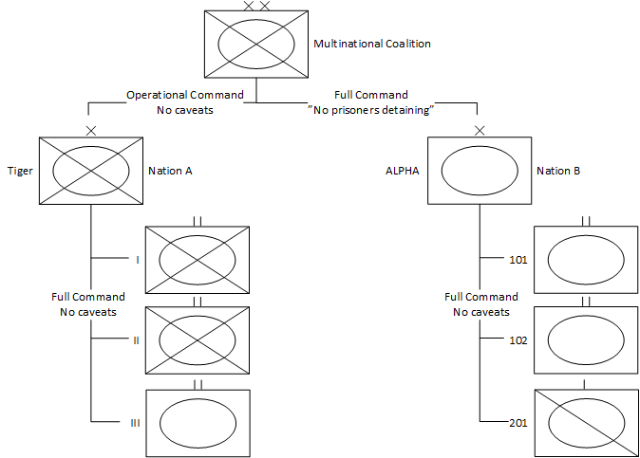

The diagram above illustrates the current Multinational Coalition ORBAT forming the basis from which future Task Organisations will be derived. The ORBAT possibly includes details to lowest possible echelon level (not depicted here).

### 8.19.2 Use Case Step 2 – Outlining the Concept of an Operation

The Multinational Coalition Command is planning a two-phase offensive operation, where:

* Phase 1: Penetration.
  + ALPHA Brigade, by use of its reconnaissance assets, is to locate the weak point of enemy defence.
  + Tiger Brigade to penetrate through the weak point.
* Phase 2: Clean-up operation.
  + From seized objectives, Tiger Brigade is to secure an entry point.
  + ALPHA Brigade to continue offensive in depth and destroying Enemy lines of communication and logistic assets.

### 8.19.3 Use Case Step 3 – Planning an Operation

During the planning process, the Multinational Coalition Command determines that, for Phase 1, Tiger Brigade does not have sufficient penetration capability in terms of armour (tanks). For this reason, Tiger Brigade will be reinforced with an armoured battalion from ALPHA Brigade.

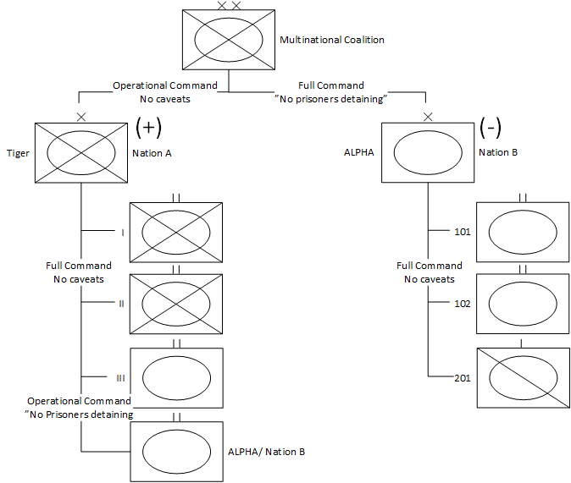

Planned TaskOrg for Phase 1

In the above planned TaskOrg, Tiger Brigade is reinforced, indicated by ‘(+)’, and ALPHA Brigade is reduced, indicated by ‘(-)’.

The Multinational Coalition Command is planned to have “Operational Command”, thus the logistic responsibility belongs to Tiger Brigade. ALPHA Brigade remains responsible for administrative matters. The “Operational Command” relationship allows Tiger Brigade to split up the attached battalion and attach its subordinate units to Tiger Brigade’s battalions. Nation B’s national caveat will be preserved.

In Phase 2, ALPHA Brigade may pass through close terrain and pass by build-up areas. In terms of infantry, the brigade in its current form is not capable of securing own tanks at close distances. For this reason, Tiger Brigade is to reinforce ALPHA Brigade with one of its mechanised infantry battalions. Specifically which one, is up to Tiger Brigade commander’s discretion and to the actual operational status at the time of reinforcement.

Planned TaskOrg for Phase 2

In the above planned TaskOrg, ALPHA Brigade is reinforced with a mechanised battalion from Tiger Brigade. As ALPHA Brigade is given “Operational Control” over the battalion, the commander of ALPHA Brigade will not be allowed to split up the attached battalion and will not have logistic responsibility over the attached battalion.

End state, Use Case Step 3:

The commanders of Tiger and ALPHA Brigade know their available resources for the operation and may start their planning processes, including developing their own TaskOrgs.

As for time or event of effectiveness, each TaskOrg may be time-stamped (as is the case for ORBAT). However, because a TaskOrg strictly supports a specific plan or order, other time values may be provided, as:

* Relative time to execution, e.g. “H Hour +3:30” (i.e. 3 hours and 30 minutes after H Hour).
* In the context of a planned or predicted task or event, stated by the plan/order, e.g. “When reaching Phase Line LISA”.

### 8.19.4 Use Case Step 4 – Executing the Operation

The TaskOrg for Phase 1 is now in effect, by absolute time, by relative time, by task or by event.

The commander of ALPHA Brigade decides to provide 101 Battalion to Tiger Brigade. By phone, radio or other means of communication, the headquarters of the ALPHA and Tiger brigades mutually coordinate, and 101 Battalion physically relocates to a position, assigned by Tiger Brigade.

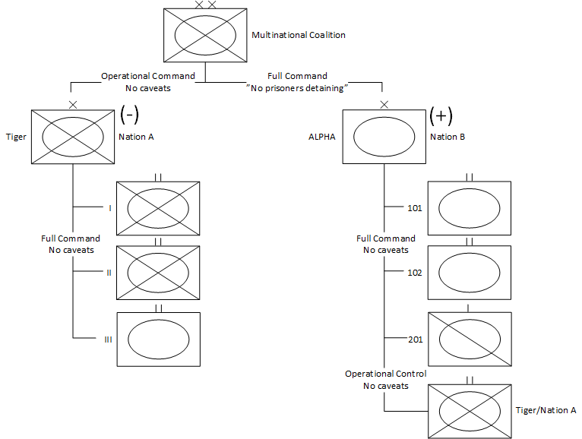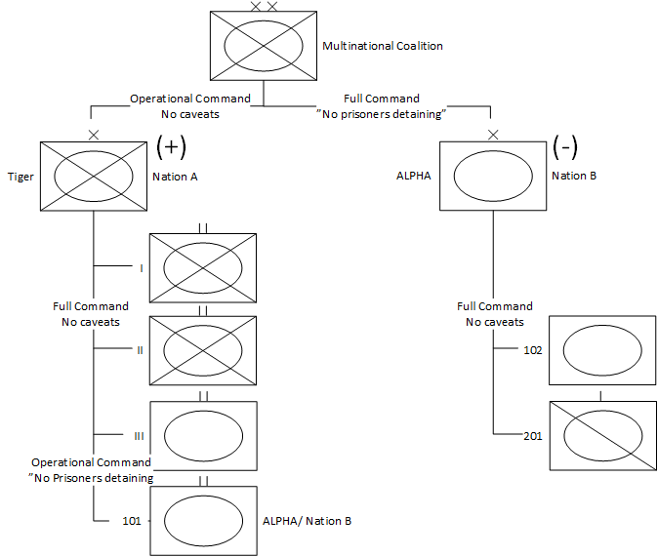

Executed TaskOrg for Phase 1

The ALPHA (‘101’) battalion has now been assigned (‘101’) to Tiger Brigade, and therefore is temporarily no longer depicted in ALPHA Brigade’s organisation. In order to be able to uniquely identify 101 Battalion, its higher formation (ALPHA Brigade of Nation A) is depicted to the right of the battalion symbol.

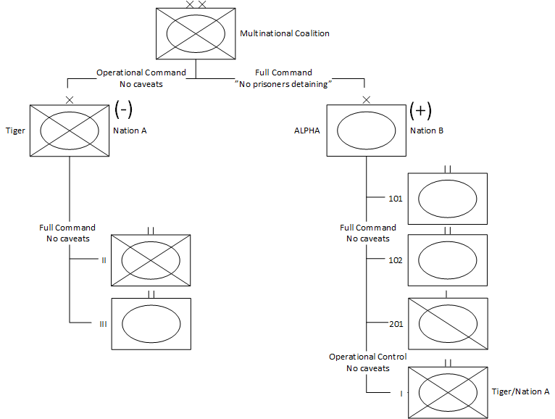

Executed TaskOrg for Phase 2

The two brigades of the Multinational Coalition physically stop to reorganise, and 101 Battalion is to return to ALPHA Brigade.

The commander of Tiger Brigade assigns I Battalion to be attached to ALPHA Brigade. The headquarters of the ALPHA and Tiger brigades mutually coordinate, and I Battalion physically relocates to a position, assigned by ALPHA Brigade.

### 8.19.5 Task Organisation Examples

The following snippets show how it is possible to express that a unit within a Task Organisation has been reinforced with a unit which has not yet been specified.

The reinforcement of a unit can be expressed using the unit:UnitReinforcementCode as shown in the following example:

|  |
| --- |
| <?xml version="1.0" encoding="UTF-8"?>  <unit:UnitReinforcementCode  xmlns:xsi="http://www.w3.org/2001/XMLSchema-instance"  xmlns:unit="https://mip-interop.org/data/v4.3/BattlespaceConcept/Object/Actor/Organisation/Unit"  xsi:schemaLocation="https://mip-interop.org/data/v4.3/IES IES.xsd">ReinforcedOnly</unit:UnitReinforcementCode> |

The fact that a unit’s depiction in the Task Organisation has not yet been specified and only limited information is specified, is expressed using the unit_4.2:IsNotionalIndicator as depicted in the following snippet.

|  |
| --- |
| <?xml version="1.0" encoding="UTF-8"?>  <unit:UnitIsNotionalIndicator  xmlns:xsi="http://www.w3.org/2001/XMLSchema-instance"  xmlns:unit="https://mip-interop.org/data/v4.3/BattlespaceConcept/Object/Actor/Organisation/Unit"  xsi:schemaLocation="https://mip-interop.org/data/v4.3/IES IES.xsd">true</unit:UnitIsNotionalIndicator> |

### 8.19.6 Display of a Task Organisation

The order of the sibling unit in a Task Organisation may have operational relevance. In order to keep the same visualization among different systems the order of sibling units in any part of the hierarchy should be interpreted as “left to right” or “up to down”. It must be taken into account that due to the selected exchange mechanism or national systems requirements, different systems may display the same Task Organisation using a different order for the sibling units as long as the association among the units within the Task Organisation is respected.

# 9 Requirements

## 9.1 Traceability

The MIP4-IES addresses the traceability of semantics back to an authoritative source. The authoritative source of semantics for the MIP4-IES is the MIP Information Model. To facilitate the tracing of the semantics back to the MIP Information Model, a semantic identifier is used to uniquely identify concepts.

Example semantic identifier for MilitaryOrders:

|  |
| --- |
| <?xml version="1.0" encoding="UTF-8"?>  <xsd:schema  xmlns:xsd="http://www.w3.org/2001/XMLSchema"  targetNamespace="https://mip-interop.org/xsds/data/v4.3/BattlespaceConcept/Object/Actor/Person"  xmlns:person="https://mip-interop.org/xsds/data/v4.3/BattlespaceConcept/Object/Actor/Person"  xmlns:app="https://mip-interop.org/data/v4.3/AppInfo.xsd">  <xsd:simpleType name="PersonIdentificationDocumentCategoryCodeType">  <xsd:annotation>  <xsd:documentation xml:lang="en">The type of document used to identify a Person.</xsd:documentation>  <xsd:appinfo>  <app:SemanticID>MIM:7e3c7d1b-bcf0-4346-a5da-fd06001315a9</app:SemanticID>  </xsd:appinfo>  </xsd:annotation>  <xsd:restriction base="xsd:token">  <!-- BEGIN -->  <xsd:enumeration value="MilitaryOrders">  <xsd:annotation>  <xsd:documentation xml:lang="en">The Person is identified by military orders.</xsd:documentation>  <xsd:appinfo>  <app:SemanticID>MIM:a23a8925-ee19-4d93-90d4-3f6a3d3af265</app:SemanticID>  <app:DisplayName>Military orders</app:DisplayName>  <app:PhysicalName>MILORD</app:PhysicalName>  </xsd:appinfo>  </xsd:annotation>  </xsd:enumeration>  <!-- END -->  </xsd:restriction>  </xsd:simpleType>  </xsd:schema> |

The SemanticID in the example XML Schema snippet maps to the MilitaryOrders concept within the MIP Information Model from v4.0 onwards.

A key purpose of the semantic identifier is to facilitate the comparison, as well as tracing, of concepts between different versions of the MIP Information Model and derived specifications (e.g. MIP4-IES). This traceability facilitates the efficient Change Management of the MIP4-IES.

# 

# Annex A: Concept and Its Subclasses

## A.1 Introduction

The MIP Information Model (MIM) provides the semantic foundation for information exchange in the Command and Control (C2) domain. Its development is driven by the needs of the warfighter and its scope is defined by military information exchange requirements for multiple echelons in joint/combined operations. The MIM consolidates concepts from authoritative sources such as NATO standards to produce a «semantic reference» for the C2 domain.

Based on a few basic notions, such as «Object», «Action», and «Metadata», the model provides semantically rich taxonomies of militarily relevant concepts. The MIM has been designed to support readability, modularity, extensibility, semantic strictness, and model consistency.

The MIM employs state-of-the-art modelling techniques and tools based on open standards and industry best practices. The model is platform-independent, i.e., it is not tied to a specific exchange technology. It supports the Model-Driven Architecture (MDA) approach, which facilitates the efficient development of data exchange schemas such as the schemas for MIP4-IES. At the same time, the semantic reference model enables communication between and among operational subject matter experts and system engineers.

This annex presents the key concepts of the MIP4-IES model derived from MIM version 5.1. An overview of all packages used by MIP4-IES is shown below. For each package, a short summary and a high-level diagram depicting the main classes and data types is given. The diagrams were designed to show the key elements on a single page. Thus, not all subclasses are depicted.

Some details have been removed for the sake of readability (i.e. removing associations or aggregations links) and some others are differing between MIM and the diagrams, depicted in this annex (i.e. differing in the name, the order or the presence of namespaces, classes or attributes).

More detailed diagrams can be found in the Sparx Enterprise Architect repository that contains the MIM and in the documentation auto-generated from it (see [https://www.mimworld.org](https://www.mimworld.org/)).

Annex A describes the overall meaning of key Business Objects and related ancillary types. For a detailed description the reader should refer to either MIM documents or the MIP XML Schemas.

The main relationships between UML Entities and XML Schema Entities is described in section §3.

The description of translation rules between UML Diagrams and related XML Schemas are out of the scope of this Annex A.

## A.2 Primitives

This package contains the primitive data types used by the MIP Information Model.

## 

## A.3 Concepts

The diagram below depicts Concept and its subclasses :

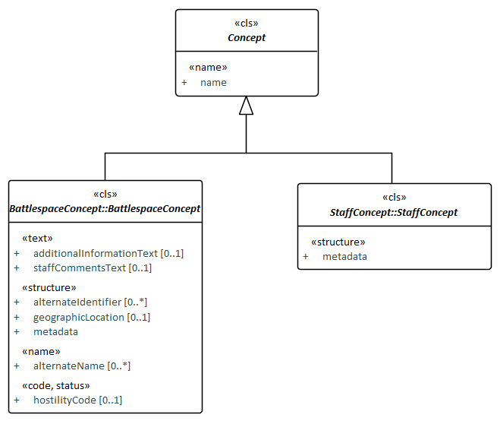

Concept and its subclasses

### A.3.1 Concept Metadata

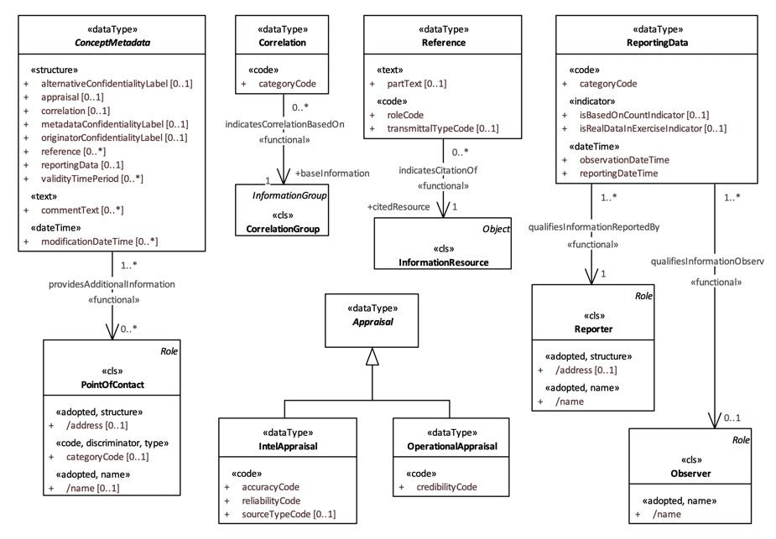

### A.3.2 BattlespaceConcept

The diagram below depicts BattlespaceConcept, its subclass Object and the subclasses of the Object:

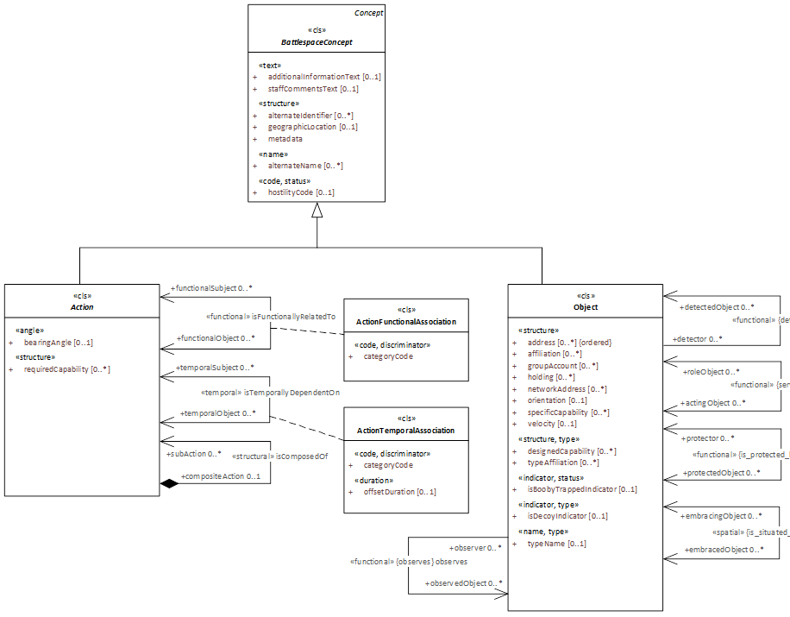

BattlespaceConcept, Object and its subclasse.

#### A.3.2.1 Action

This package specifies activities, or the occurrence of activities, that may utilise resources and may be focused against an objective.

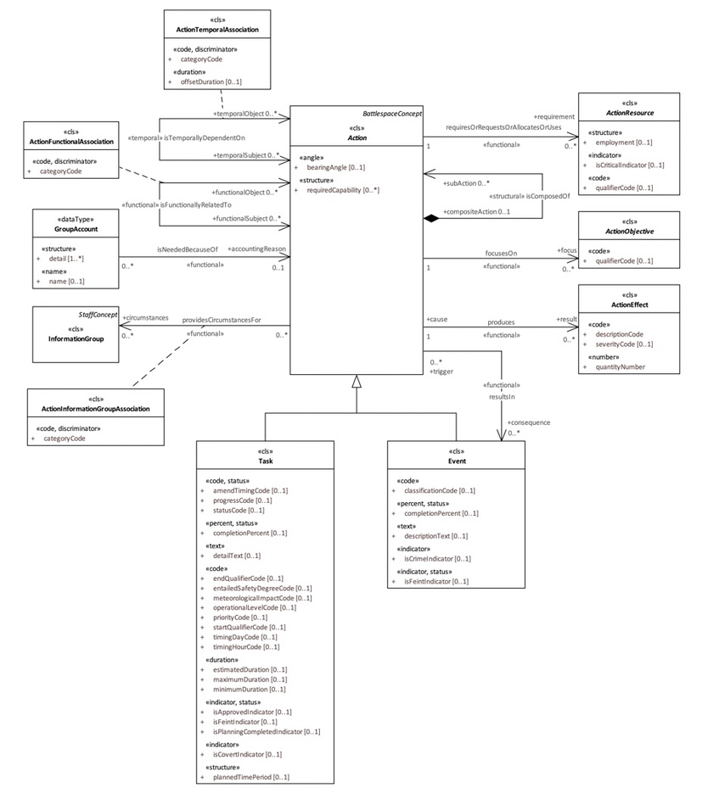

#### A.3.2.2 Address

This package specifies precise information on the basis of which a physical or electronic destination may be accessed. Subclasses ElectronicAddress and PhysicalAddress derive from Address.

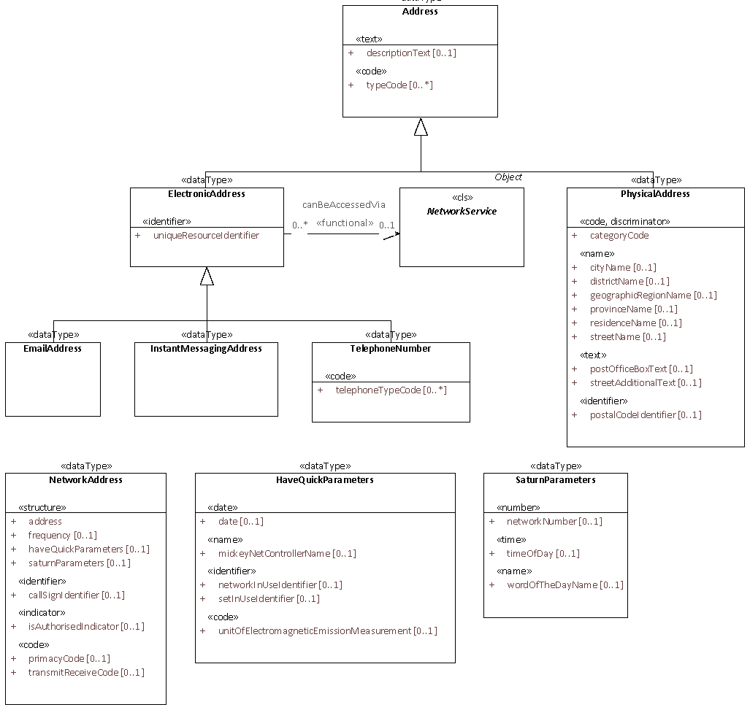

#### A.3.2.3 Affiliation

This package specifies the affiliation of an object, detailed by the subclasses Geopolitical, Ethnic, Religious and Other.

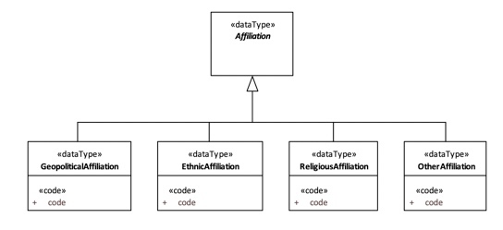

#### A.3.2.4 Generic

This package contains data types used throughout the model.

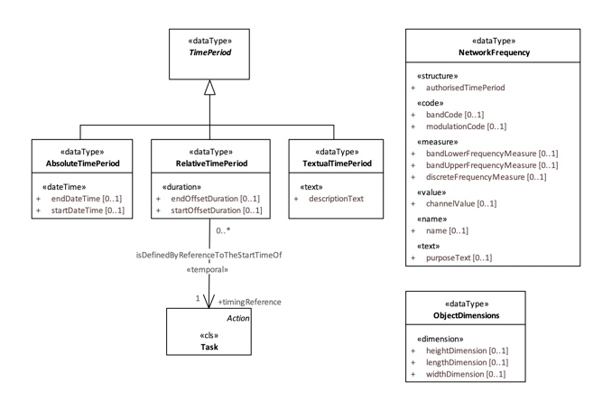

#### A.3.2.5 Location

The Location package contains the artefacts, which allows setting an object or action position, the geometry required to describe objects/actions and to graphically represent them. The diagram shows the Geometry taxonomy and the relation between the data types Location and Geometry, where Geometry is a Location attribute.

There are several Geometry subclasses, which define different shapes, which describe the objects and actions. These subclasses go from the basic element, which is a Point, to Line, Surface, Geometric Volume and Graphic. Graphic and its subtypes allow describing the graphical representation of different types of objects.

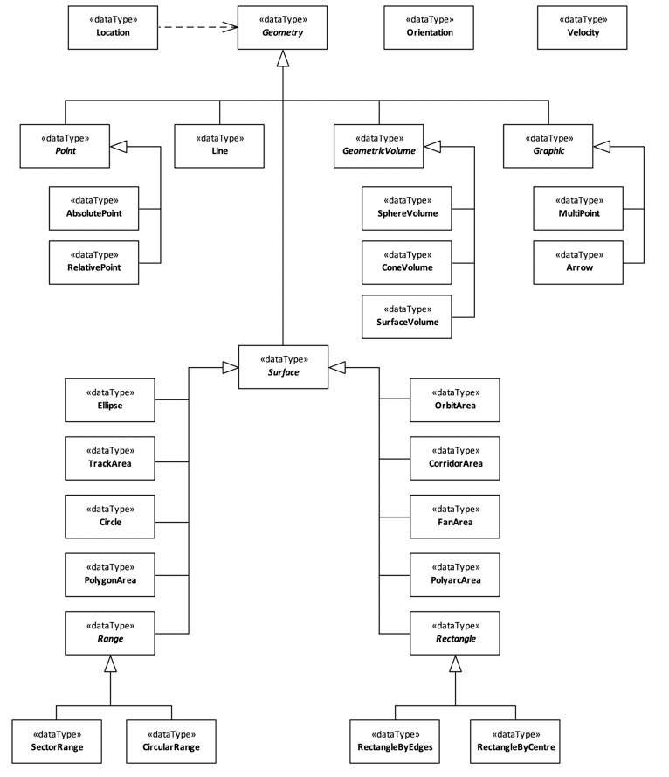

#### A.3.2.6 BattlespaceConcept Metadata

This package provides a descriptive information about information given in a BattlespaceConcept. This data type does not describe physical characteristics of objects and actions but characteristics of the information available for a BattlespaceConcept.

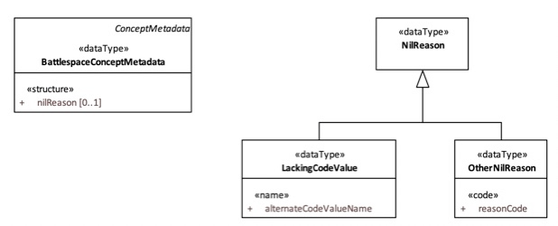

#### A.3.2.7 Mobility

The package Mobility specifies mobility for the domains Land, Air, Maritime and Amphibious, with separate mobility codes for each domain.

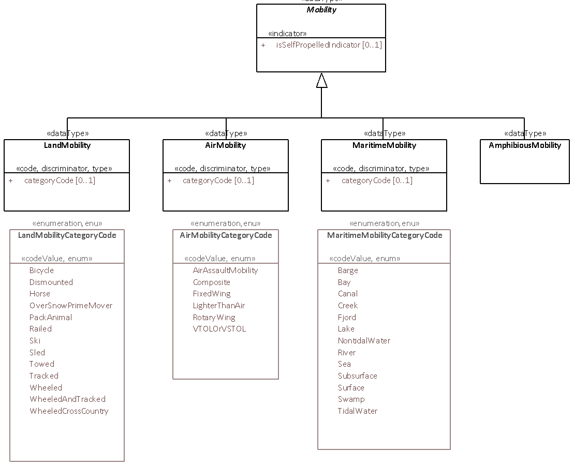

#### A.3.2.8 Object

This package includes the class “Object” which is the root of a taxonomy of individual identified objects with military or civilian significance. Actor, Facility, Feature, InformationResource, Material and NetworkService, specified in their respective sub-packages, derive from Object.

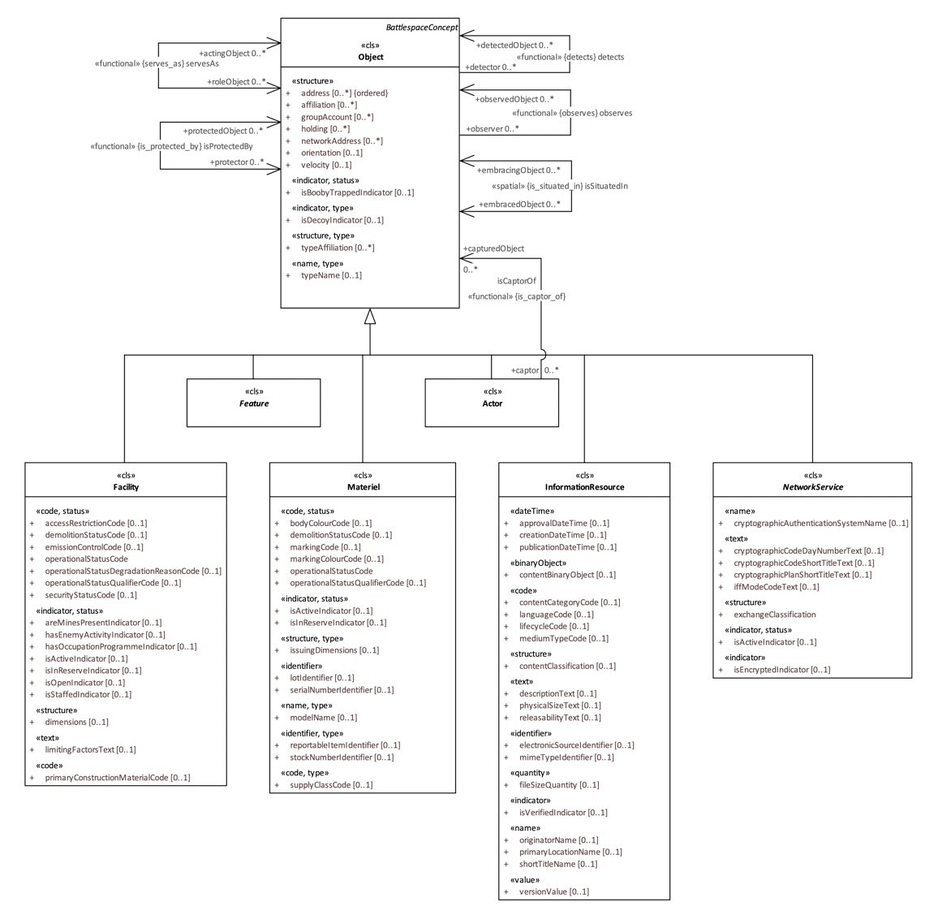

##### *A.3.2.8.1 Actor*

This package contains the artefacts regarding a person or a group of persons that are able to perform actions. The diagram depicts class Actor and its immediate subclasses, Person and Organisation, specified in their own sub-packages.

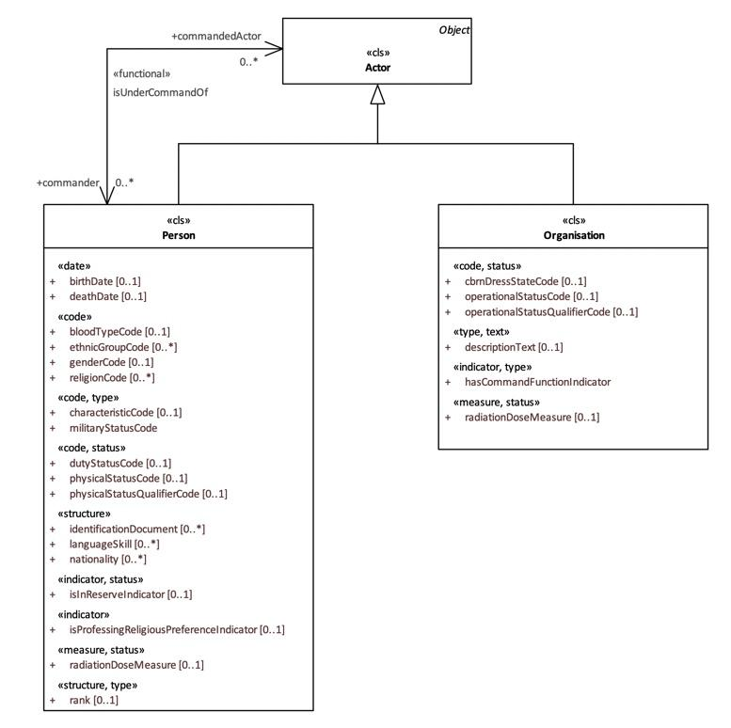

###### **A.3.2.8.1.1 Organisation**

This package contains artefacts related to an administrative or functional structure. The Organisation taxonomy is defined in the package, where PrivateSectorOrganisation, GovermentOrganisation, CivilianPost and GroupOrganisation are Organisation inheriting classes.

MilitaryOrganisation is one of the main concepts in the Organisation package. This class defines a government organisation that is officially sanctioned, trained and equipped to exert force. This organisation refers to four different military organisation types including MilitaryPost and Unit, defined in sub-packages.

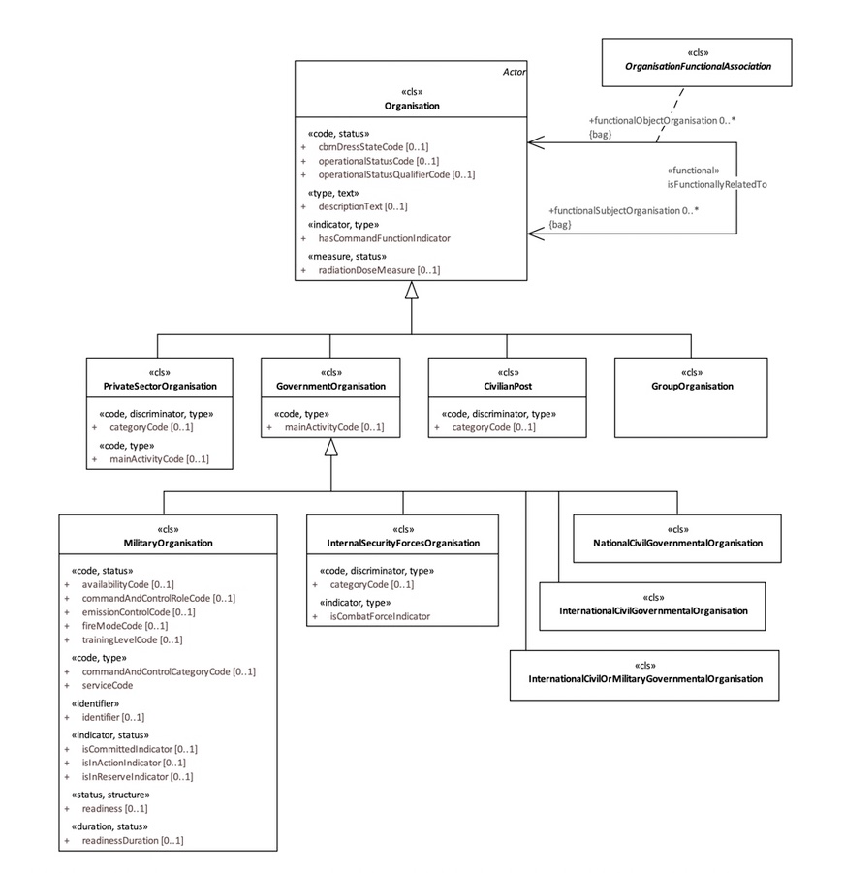

*A.3.2.8.1.1.1 MilitaryOrganisationReadiness*

This package is an Organisation sub-package. It includes all the readiness level data types of a MilitaryOrganisation.

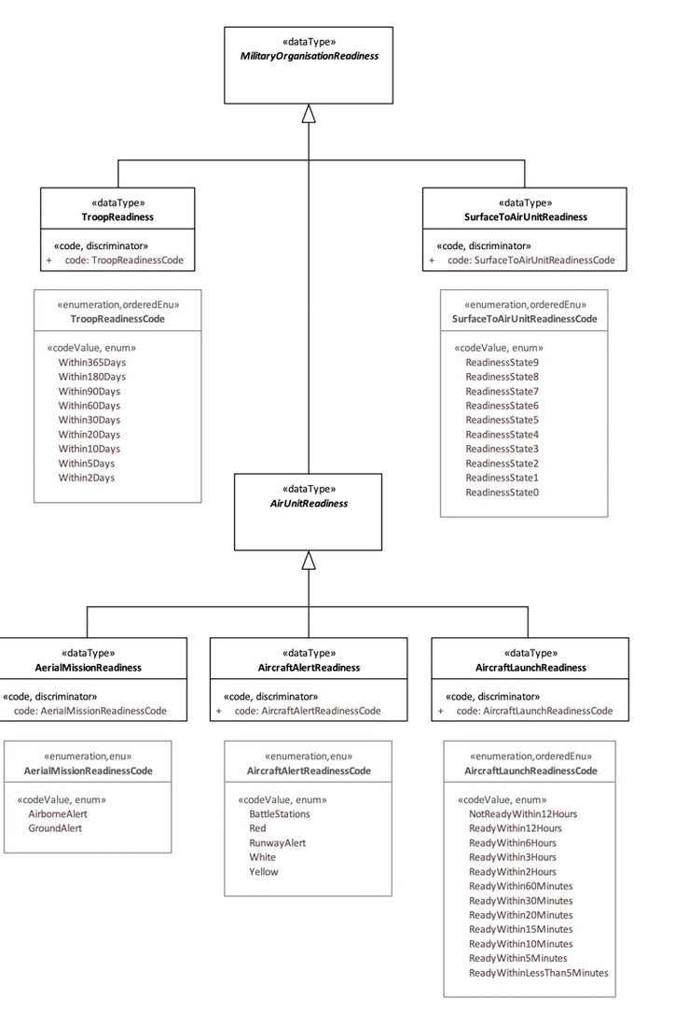

###### **A.3.2.8.1.1.2 MilitaryPost**

This package is an Organisation sub-package and contains the MilitaryPost taxonomy. The MilitaryPost class and its subclasses, define the government organisations that are officially sanctioned and are trained and equipped to exert force.

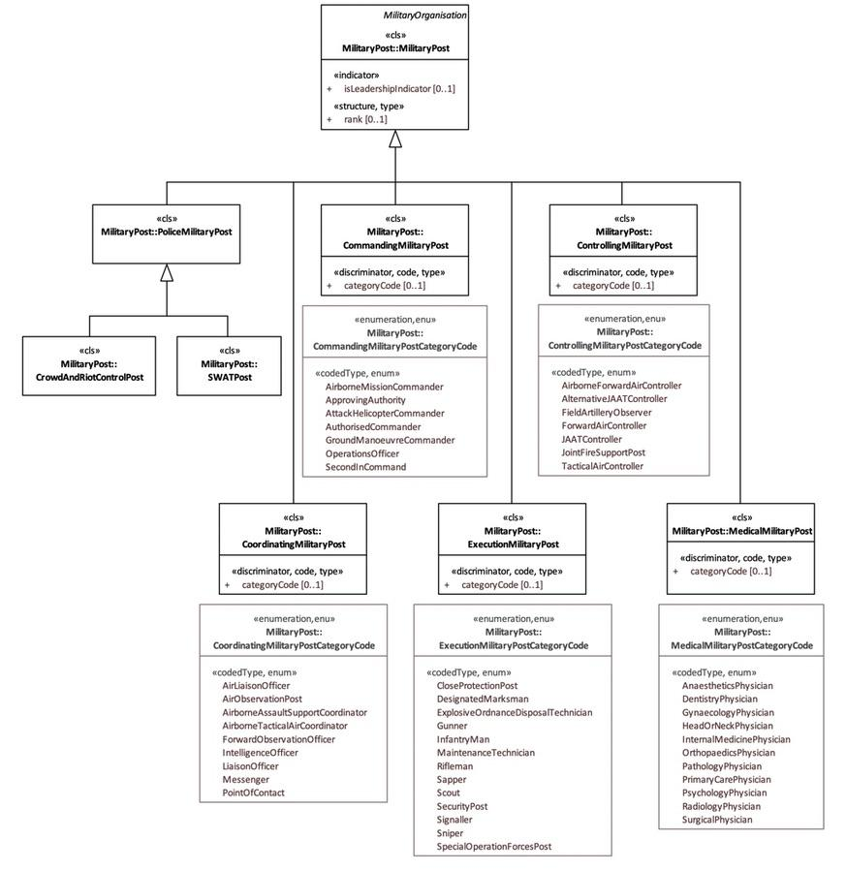

###### **A.3.2.8.1.1.3 Unit**

This package is an Organisation sub-package, which includes the Unit Taxonomy. Unit is a Military Organisation type whose structure is prescribed by the competent authority.

The taxonomy supports the representation of as many types of Units as possible; the manner of classifying units may not correspond to national classification policy. However, national implementations for external displays for operational users can be built to support the national doctrine and naming conventions.

The diagram shows the first Unit taxonomy level which subclasses are: CombatUnit, CombatSupportUnit, CombatServiceSupportUnit, CommandSupportUnit and SpecialOperationsForcesUnit. Each of these subclasses has their own taxonomy with more specialised unit types.

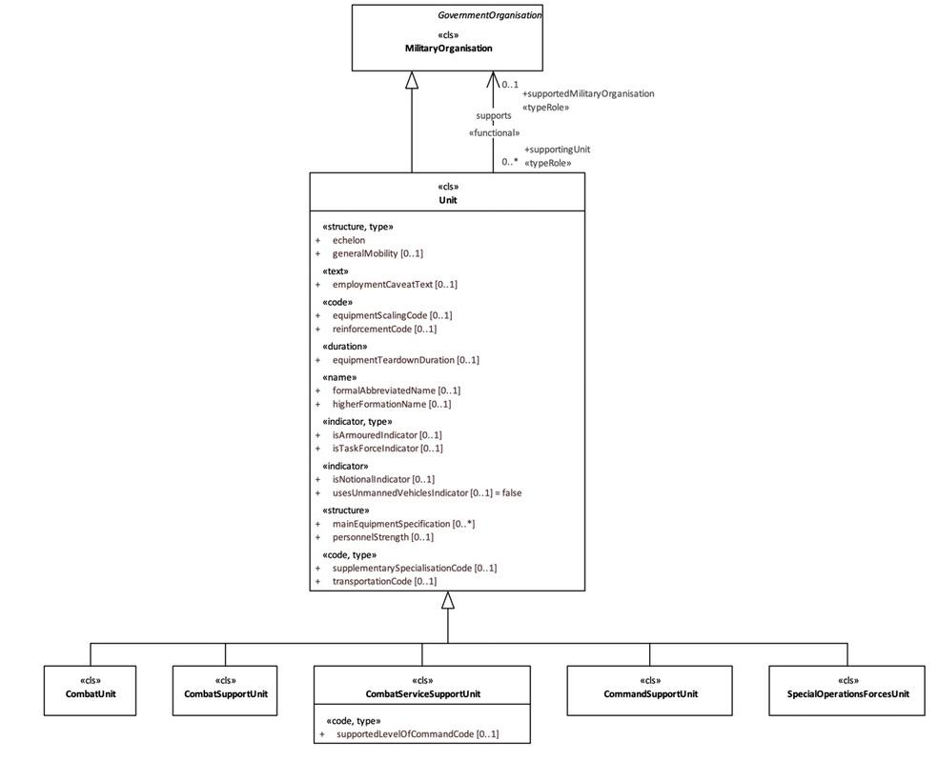

###### **A.3.2.8.1.2 Person**

The package contains details regarding individual persons, of military or civilian significance. Basic artefacts for example birth (and death) date, blood type etc. are accompanied by status related to military service.

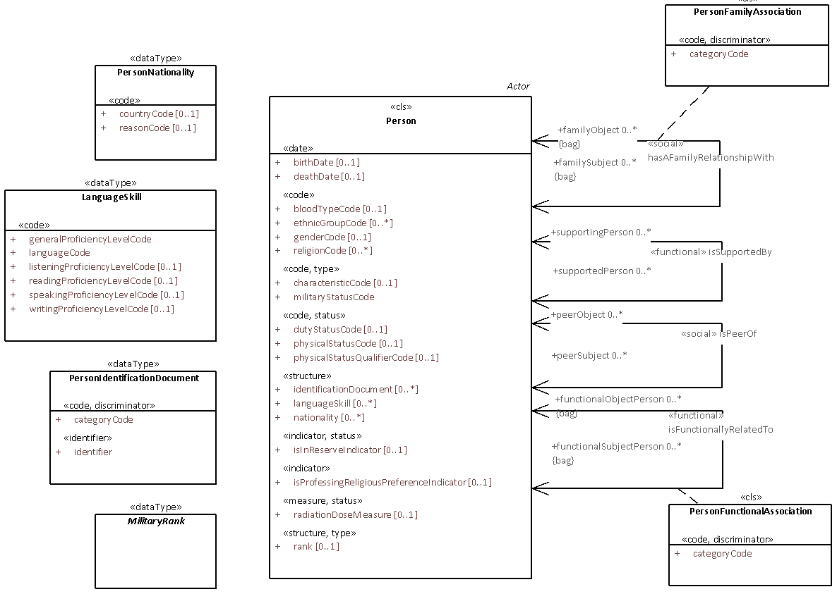

##### *A.3.2.8.2 Facility*

The package contains man-made objects, both military and non-military. The diagram depicts class Facility and its immediate subclasses.

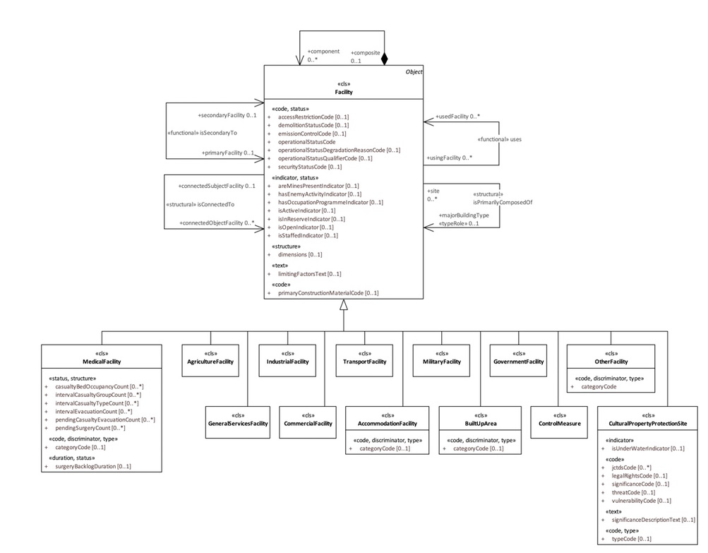

###### **A.3.2.8.2.1 CulturalPropertyProtectionSite**

This package is a Facility sub-package. It contains the facilities types under Cultural Property Protection. There are the CulturalPropertyProtection taxonomy and all the category codes regarding these properties.

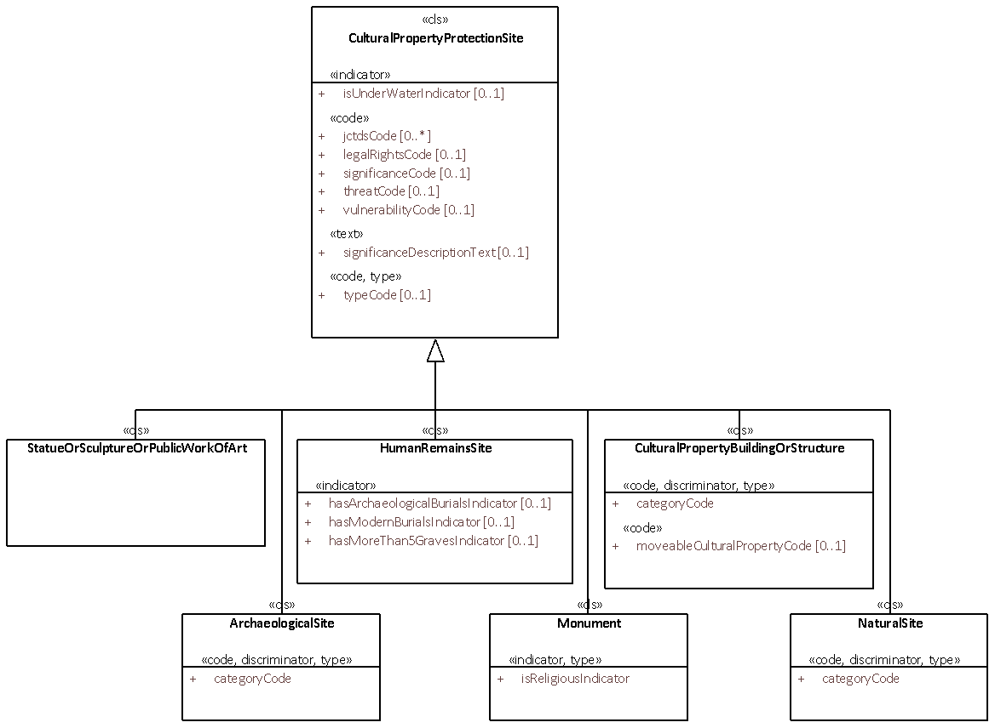

##### *A.3.2.8.3 Feature*

The package contains objects that encompass meteorological, geographic, or control features of military significance.

The diagram shows the Feature taxonomy and its immediate subclasses, MeteorologicFeature, GeographicFeature and ControlFeature, specified in their own sub-packages.

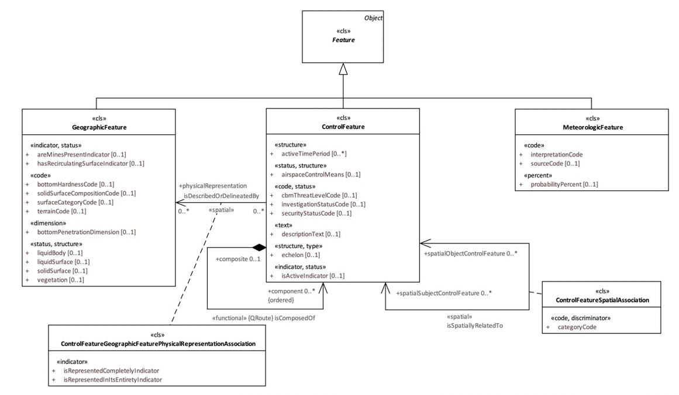

###### **A.3.2.8.3.1 ControlFeature**

The package contains non-tangible features of military interest that are administratively specified. They may be represented by geometric figures and associated with the conduct of military operations.

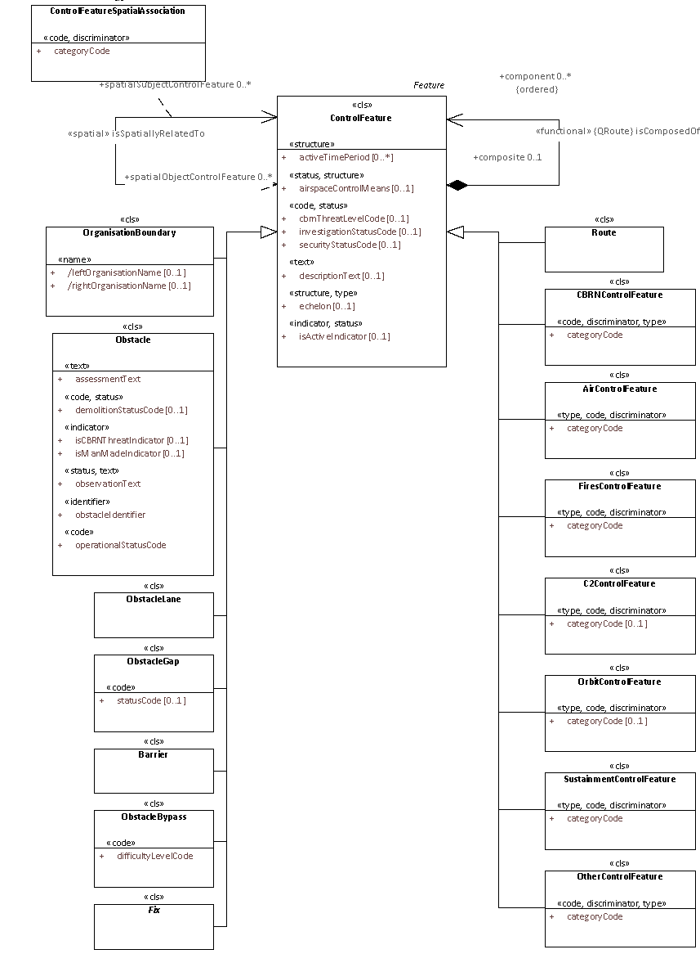

###### **A.3.2.8.3.2 GeographicFeature**

The package contains terrain characteristics of military significance that are permanent or durable natural features. In general, it represents any natural object or configuration of ground or water represented on a map or chart.

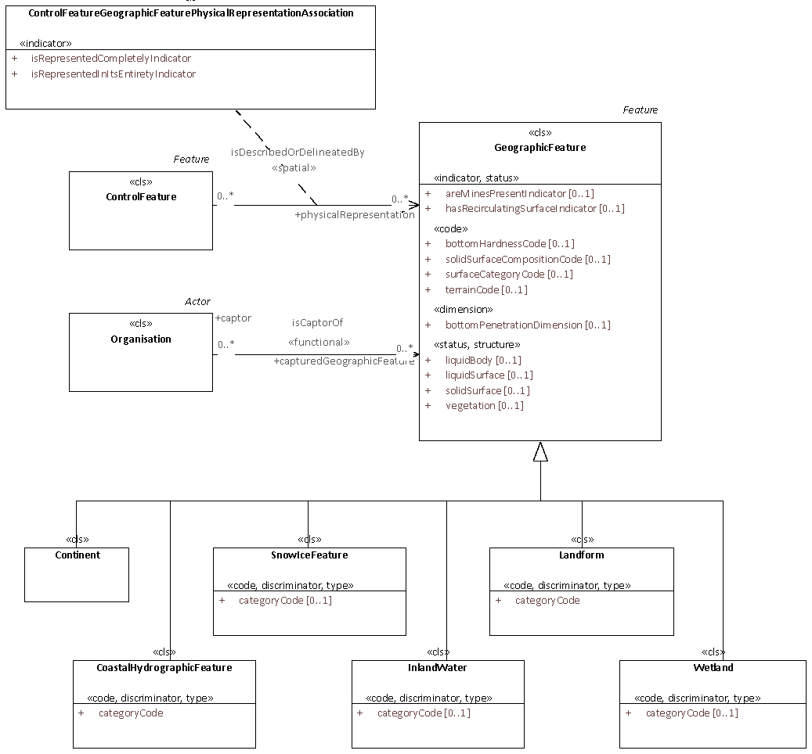

###### **A.3.2.8.3.2.1 Vegetation**

The package contains plants considered collectively, especially those found in a particular area or habitat. The diagram depicts class Vegetation and its subclasses.

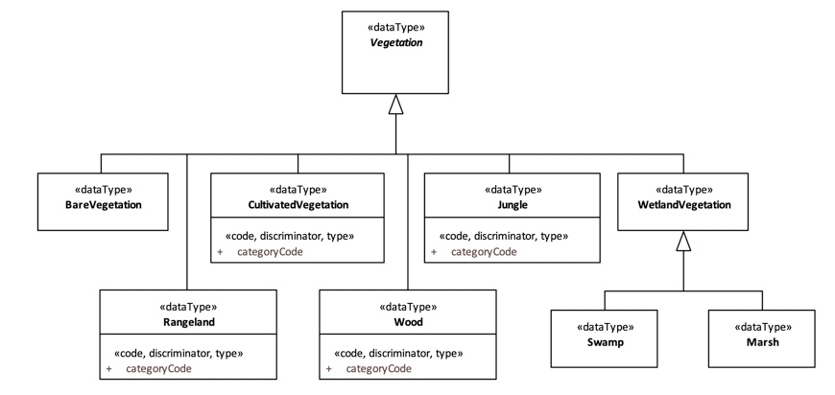

###### **A.3.2.8.3.3 MeteorologicFeature**

The package contains reported or forecast weather or light conditions. The diagram shows MeteorologicFeature and its subclasses Atmosphere, CloudCover, Light, Wind, Icing, Precipitation and OtherMeteorologicFeature.

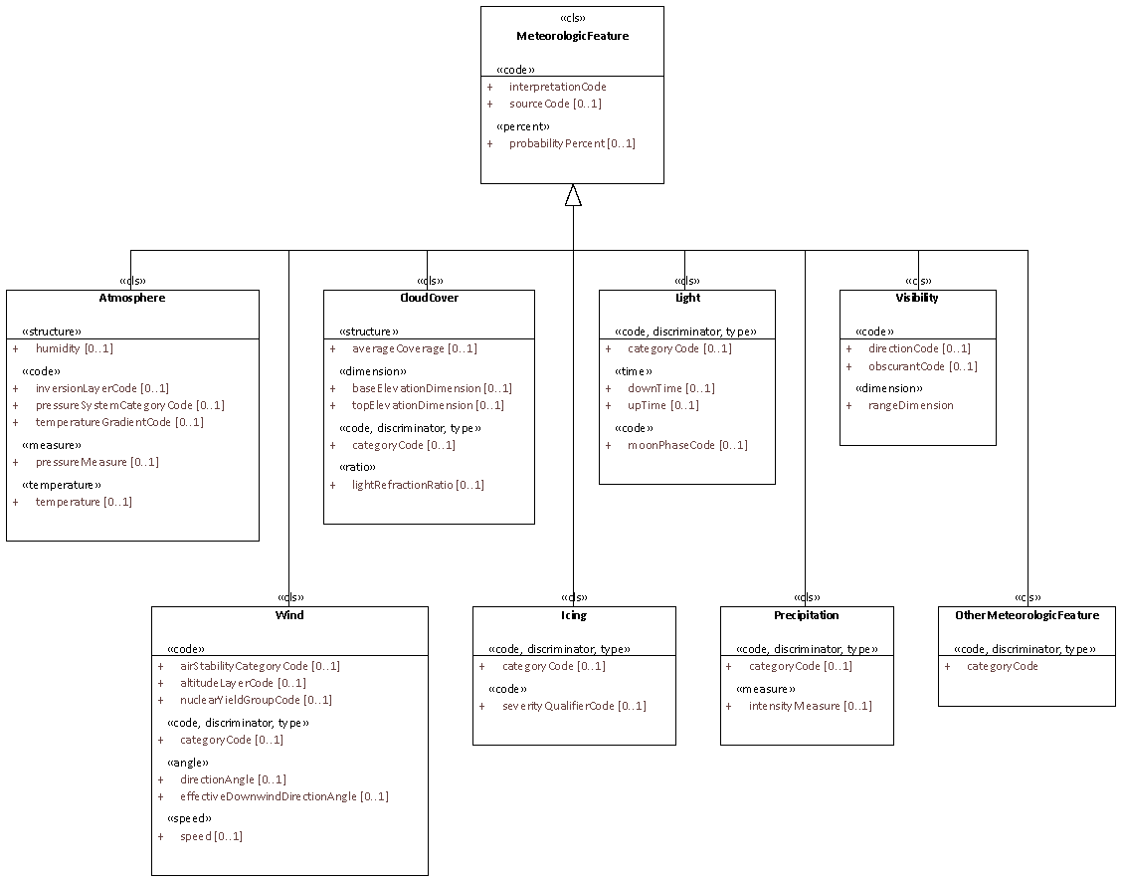

##### *A.3.2.8.4 InformationResource*

The package contains objects that convey meaning and which is broadly conceived as a 'document'. This includes the full range of web resources (video, images, web pages, etc.) and physical resources such as books and objects, e.g. artworks.

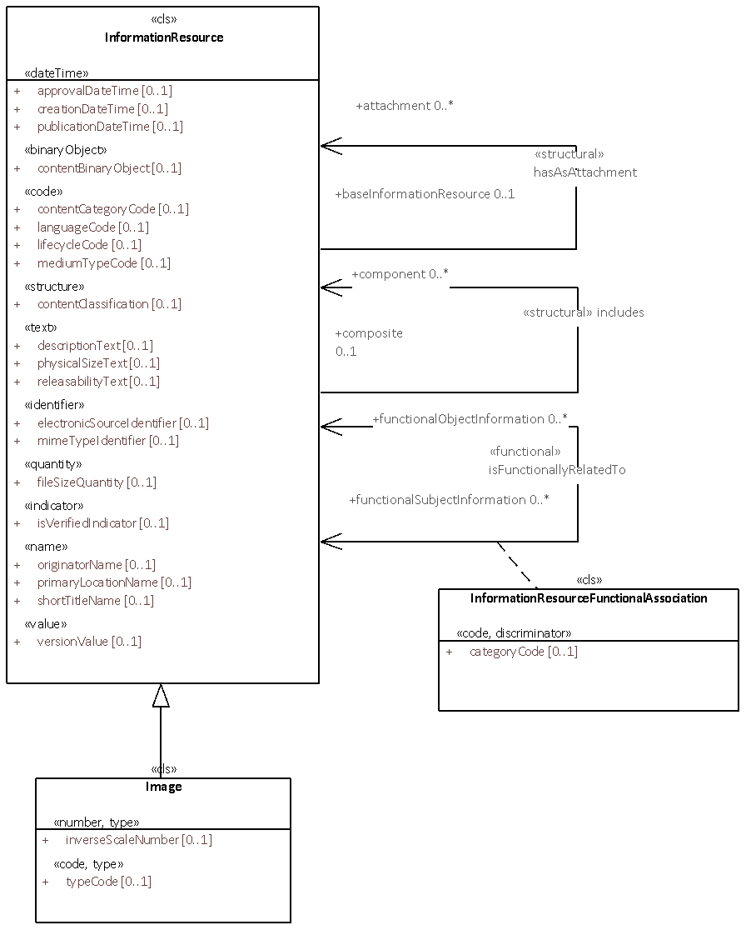

##### *A.3.2.8.5 Materiel*

The package contains apparatus, equipment or supply of military interest without distinction as to its application for administrative or combat purposes.

The diagram shows the Materiel taxonomy and its immediate subclasses, Equipment, ConsumableMateriel and UnexplodedOrdnance, specified in their own sub-packages.

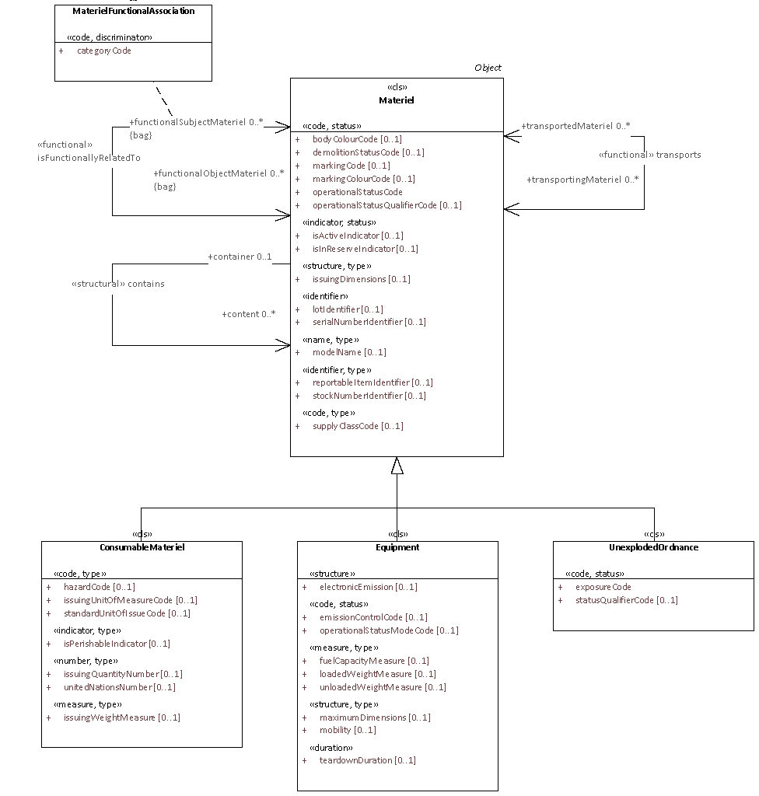

###### **A.3.2.8.5.1 ConsumableMateriel**

The package contains expendable supplies, designed to be used up in the normal conduct of operations other than through attrition. They can generally be issued in different standard quantities, each having its own packaging.

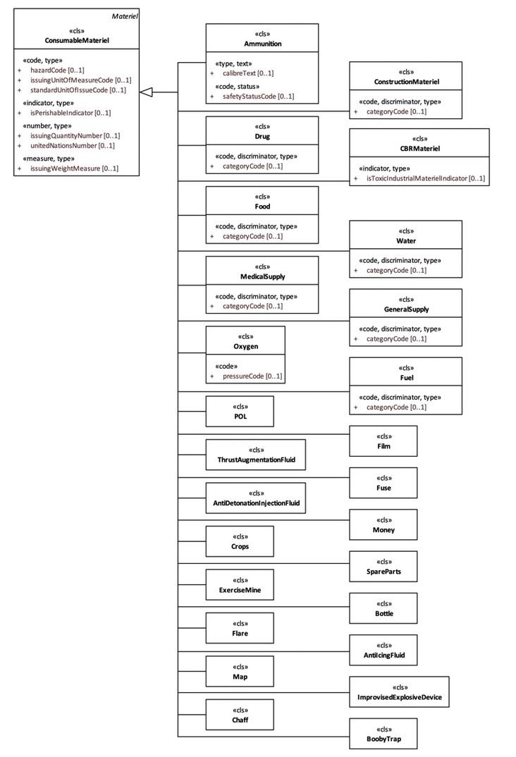

###### **A.3.2.8.5.2 Equipment**

The package contains Materiel that is neither intended for consumption nor an unexploded piece of ordnance. Equipment are durable goods or items and not intended for consumption.

The diagram shows the Equipment taxonomy and its immediate subclasses, some of which have its own packaging.

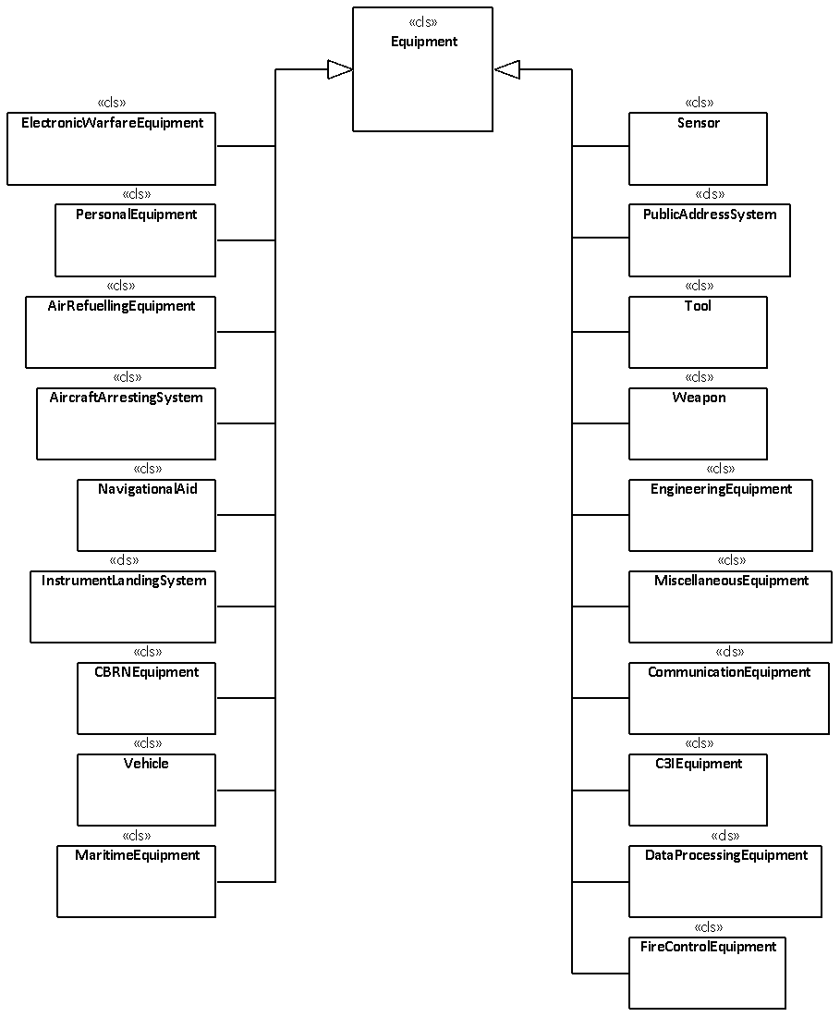

###### **A.3.2.8.5.2.1 Aircraft**

The package contains vehicles designed to fly within the earth's atmosphere.

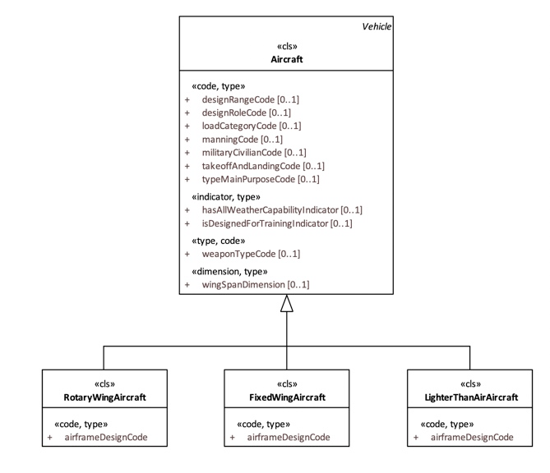

###### **A.3.2.8.5.2.2 LandVehicle**

The package contains vehicles designed to operate on the ground.

The diagram shows class LandVehicle and its immediate subclasses, CivilianTypeVehicle and MilitaryTypeVehicle.

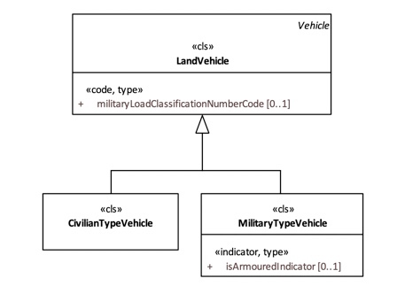

###### **A.3.2.8.5.2.3 Sensor**

The package contains devices that detect or measure a physical property and record, indicate, or otherwise respond to it.

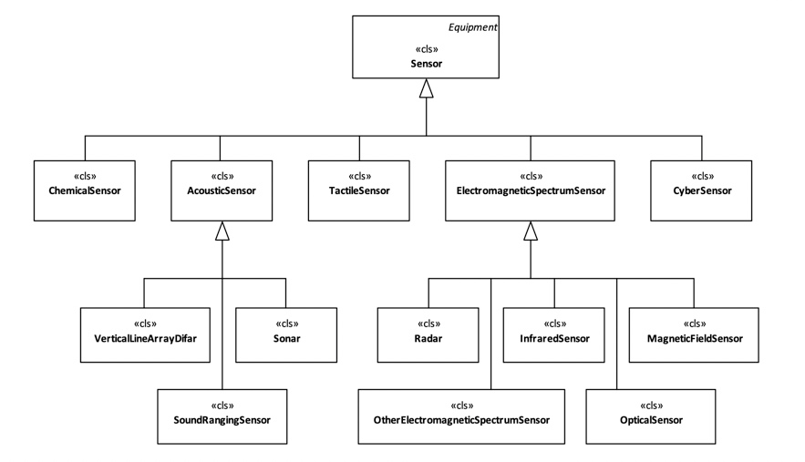

###### **A.3.2.8.5.2.4 Vessel**

The package contains vehicles designed to operate on or under the water surface.

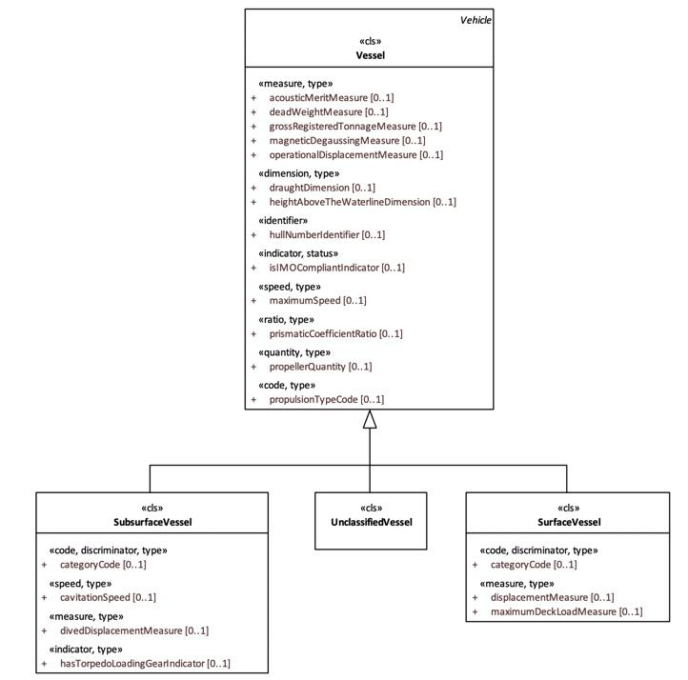

###### **A.3.2.8.5.2.5 Weapon**

The package contains equipment of any item used in warfare or combat to attack and overcome an enemy.

The diagram shows the Weapon taxonomy and its immediate subclasses.

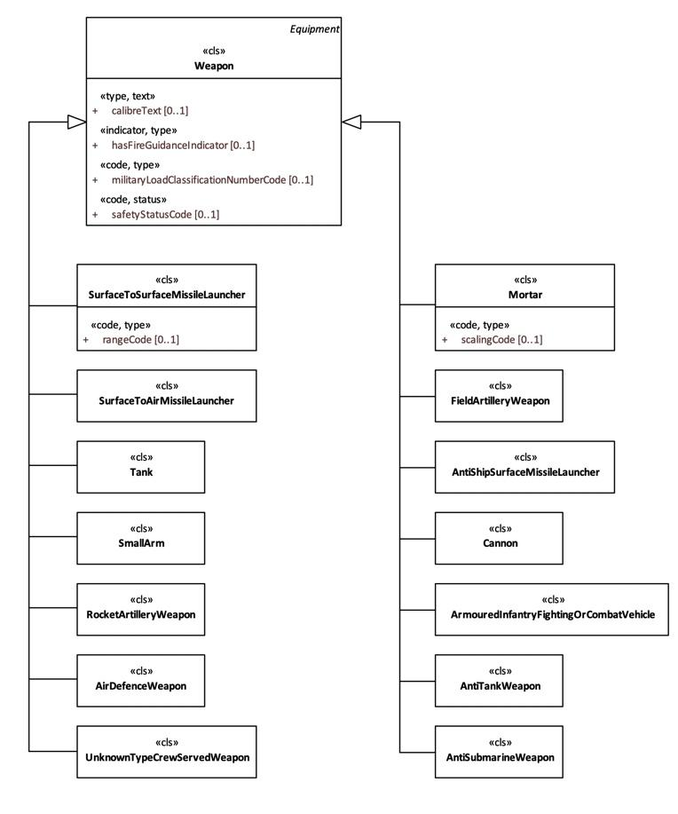

###### **A.3.2.8.5.3 UnexplodedOrdnance**

The package contains explosive ordnances that have been primed, fused, armed, or otherwise prepared for action, and which have been fired, dropped, launched, placed in such a manner, as to constitute a hazard to operation, and remains unexploded either by malfunction or for any other cause. It is commonly abbreviated as UXO.

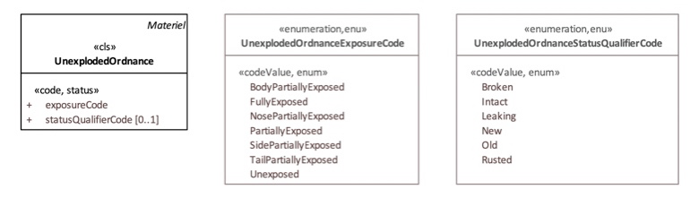

##### *A.3.2.8.6 NetworkService*

The package contains communications services provided by a Network. The diagram shows the Network taxonomy and its immediate subclasses.

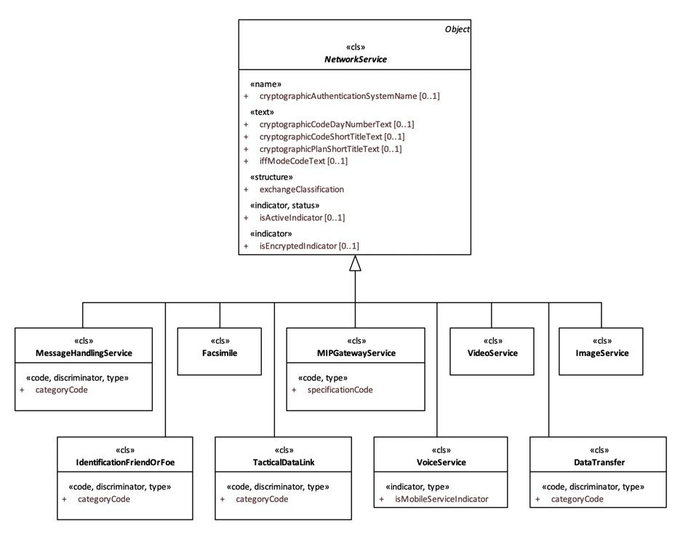

### A.3.3 StaffConcept

The package shows structures defined in support of a specific operational process. A StaffObject is typically defined by means of a selection process applied to BattlespaceConcepts, for example 'Order of Battle'.

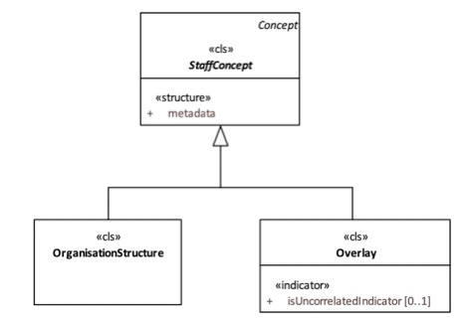

#### A.3.3.1 StaffConcept Metadata

This package contains the specifications of staff objects.

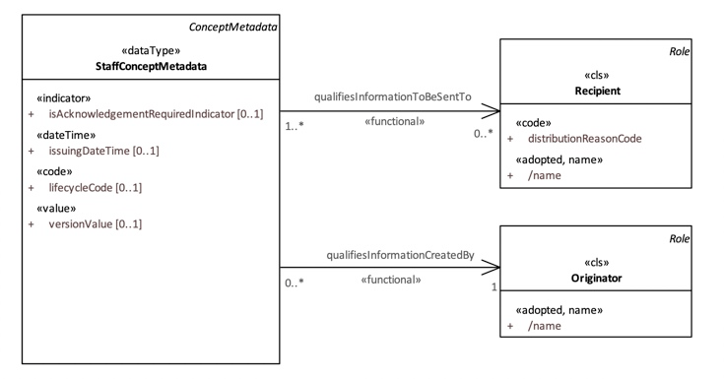

#### 

#### A.3.3.2 OrganisationStructure

This package contains artefacts to enable appropriate relationships to be collected explicitly as part of a recognised group, such as an order-of-battle (ORBAT) and TaskOrganisation.

The OrderOfBatte applies to the grouping of forces for a specific campaign. There are two types defined in this package, FriendlyORBAT and NonFriendlyORBAT, where the main difference is whether the structural organization is constituted by its own forces or not.

The diagram shows the OrganisationStructure taxonomy and their relations with other classes where Organisation is the root of the OrganisationStructure and OrganisationStructure is composed of the OrganisationFunctionalAssociation as a component. An OrganisationFunctionalAssociation represents the relation between an Organisation and one of its subordinates.

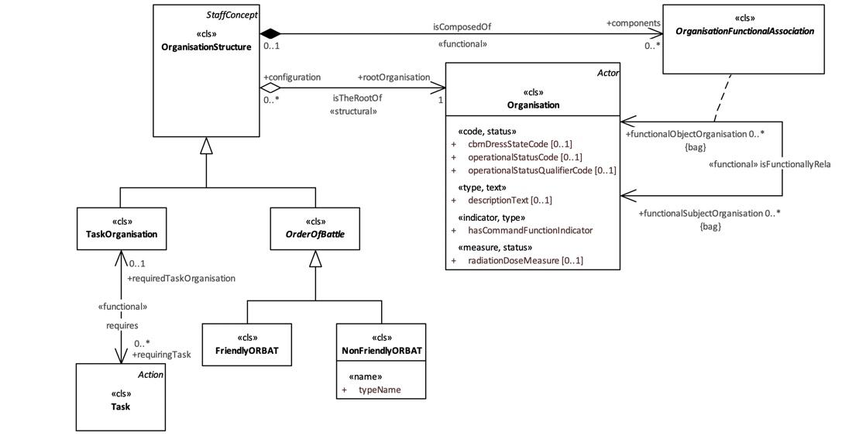

#### A.3.3.3 Overlay

The package contains situational information related to force disposition (potentially of friendly, hostile, neutral and unknown forces), coordination measures related to battle space management (known as battlespace geometry), and associated activities, designed primarily to share an understanding of a current, predicted, prescribed, or past situation in a defined geographical area of a theatre of operation.

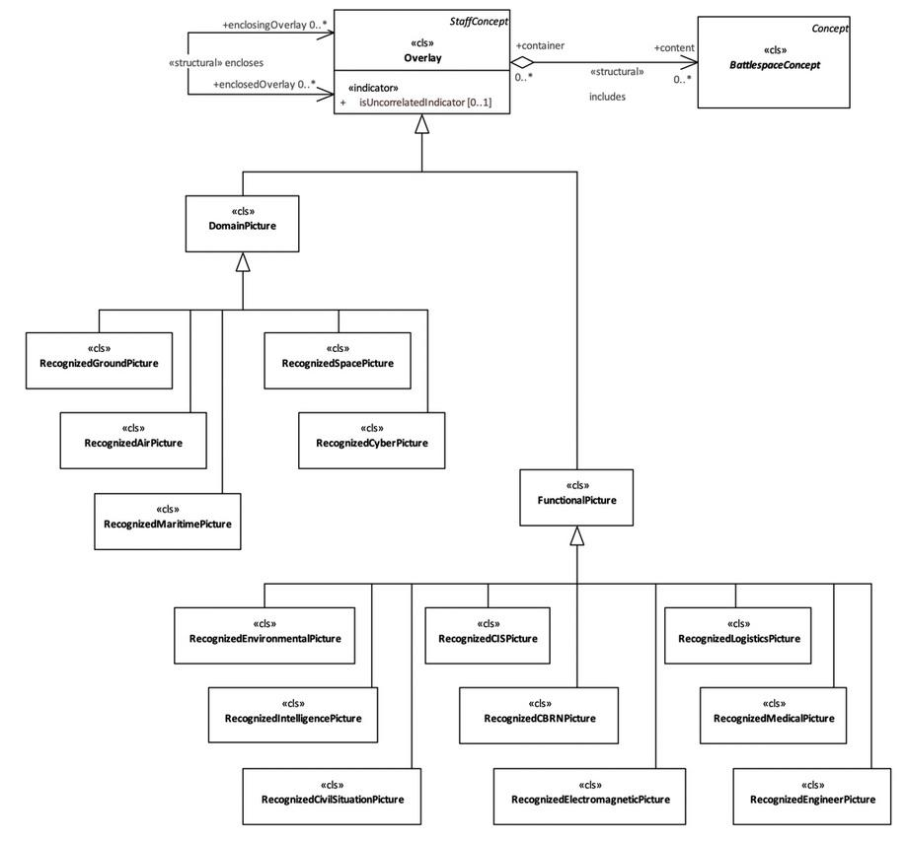

1. The term *“thing”* is used to denote an activity, event, phenomena, logical or physical object, as well as, larger information constructs built upon multiple of these. A thing is relevant to the achievement of Situational Awareness.
2. Intent is a sort of 'bridge' between resolving an object, [once associate is applied] in detail, and expressing the more complex relationships between more than one object. Because Intent expresses the desired outcome or the 'why' an object is exchanged in the first place, it is a necessary [but very difficult concept to capture in machines] step to allow or enable SA.
3. The {OverlayID} shall be replaced with the actual id of the overlay. E.g. an overlay with id ced4a667-42e4-415d-a5b3-979caad7abb1 would create a ContextIdentifier /Overlay/ced4a667-42e4-415d-a5b3-979caad7abb1/Content
4. This means that a friendly organisation may belong to a non-friendly, hierarchical ORBAT and even be root organisation in that ORBAT.